FRONTLINE “My Brother’s Bomber”
Biographies
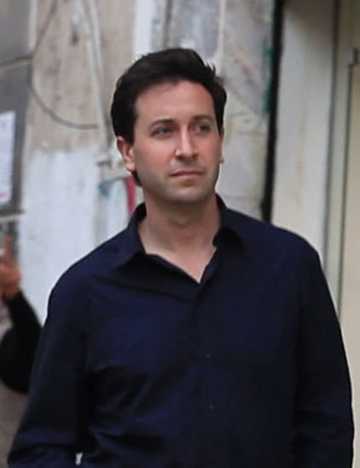
Ken Dornstein
Ken Dornstein has been involved in the production of more than 50 documentary films, including Emmy-award winners such as “Sex Slaves” and “A Death in Tehran”. As a senior producer at PBS FRONTLINE, Dornstein has also received a duPont-Columbia Award, an Overseas Press Club Award and other major industry honors.
Dornstein produced Happy Valley, which premiered at Sundance in 2014, and is currently producing a documentary about the Grateful Dead.
In addition to filmmaking, Dornstein is the author of several works of nonfiction, including The Boy Who Fell Out of the Sky: A True Story (Random House, 2006). Dornstein worked as a private investigator in Los Angeles after graduating from Brown University in 1991.
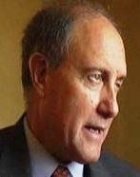
Richard A. Marquise
Richard A. Marquise is a retired FBI senior executive who has been involved in teaching law enforcement officers methods of preventing terrorism in the United States and abroad since his retirement. He was employed by the Federal Bureau of Investigation (FBI) for 31 years. During his last 3½ years with the FBI, he was the special agent in charge of the Oklahoma City, Oklahoma, division.
Marquise’s expertise is in the fields of counterterrorism and crisis management as an investigator and a manager. During the late 1980s, he was chief of the Terrorist Research and Analytical Center (TRAC) at FBI Headquarters. He also led a Middle Eastern terrorism unit that managed FBI investigations worldwide.
Following the bombing of Pan Am Flight 103 over Lockerbie, Scotland, in 1988, Marquise was named to lead the American task force. He led the task force through the indictments in 1991 and continued to play an active role through the trial’s successful resolution in 2001. In August 2001, he received the Attorney General’s Award for Distinguished Service for this investigation. Marquise is the author of Scotbom: Evidence and the Lockerbie Investigation, an inside account of the Pan Am Flight 103 investigation, which was published in 2006.
Marquise holds a master’s degree from The George Washington University in Washington, DC, and an undergraduate degree from Saint Michael’s College in Vermont. He has also attended numerous professional FBI training courses in the fields of leadership, management and crisis management.


Raney Aronson-Rath, Executive Producer, FRONTLINE
Raney Aronson-Rath runs FRONTLINE, PBS’ flagship investigative journalism series, and is a leading voice on the future of journalism. She has been internationally recognized for her work to expand FRONTLINE’s reporting capacity and reimagine the documentary form across multiple platforms. From the emergence of ISIS in Syria to the hidden history of the NFL and concussions to the secret reality of rape on the job for immigrant women, Aronson-Rath oversees FRONTLINE’s acclaimed reporting and directs the series’ evolution and editorial vision. She has developed and managed nearly 30 in-depth, cross-platform journalism partnerships with outlets including ProPublica, The New York Times and Univision. Under her leadership, FRONTLINE has won every major award in broadcast journalism and dramatically expanded its digital footprint. Prior to FRONTLINE, Aronson-Rath worked at ABC News, The Wall Street Journal and MSNBC. She earned her bachelor’s degree from the University of Wisconsin and her master’s from Columbia Journalism School.

