PBS’ “GENEALOGY ROADSHOW” SEASON THREE VISITS
SIX NEW CITIES TO UNCOVER FAMILY SECRETS

Premieres May 17 at 8 p.m. ET on PBS
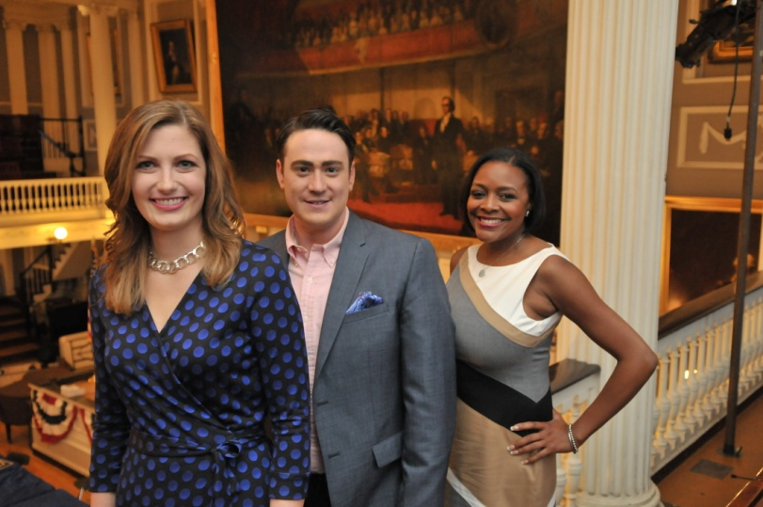
L-R: GENEALOGY ROADSHOW hosts Mary Tedesco, Joshua Taylor and Kenyatta D. Berry at the show’s taping in Boston’s historic Faneuil Hall.
Credit: Craig Bailey

ArLINGTON, VA; April 18, 2016 – From possible links to the accused in the Salem Witch Trials to heroes of the Wild West, PBS’ GENEALOGY ROADSHOW uncovers more family secrets in the series’ third season, which premieres Tuesday, May 17, 2016, at 8:00 p.m. ET and airs Tuesdays through June 28 (check local listings). Part detective story, part emotional journey, GENEALOGY ROADSHOW combines history and science to uncover fascinating stories of diverse Americans this season in and around Albuquerque, Miami, Houston, Boston, Providence and Los Angeles. Each story links to the larger regional (and often, national) history, to become part of America’s rich cultural tapestry. See a season three clip here.

GENEALOGY ROADSHOW’s professional genealogists Kenyatta D. Berry, Joshua Taylor and Mary Tedesco are matched with everyday people whose unique family claims are explored in each episode. Among this season’s mysteries: A man seeks to find out if he is descended from Boston’s key founders; a woman explores connections to an ancestor’s participation in the Manhattan Project; a couple hopes to recover the true story of their family pharmacy during Hollywood’s Golden Age; and a woman learns of her family’s involvement in the Trail of Tears.

Over the course of the series and from coast-to-coast, Berry, Taylor and Tedesco work with participants’ anecdotal clues, documents and family heirlooms to reveal surprising turns and incredible personal histories, filling in lost family details and in some cases, introducing them to relatives and other important people they never knew existed.

Albuquerque, Miami, Houston, Boston, Providence and Los Angeles were chosen this season as representative of America’s cultural crossroads for diversity, industry and history, as well as for deep pools of riveting stories. GENEALOGY ROADSHOW’s hosts and experts add color and context to the investigations, ensuring every artifact and every name becomes part of solving the mystery.

“Our third season of GENEALOGY ROADSHOW visits six of America’s history-rich cities and unearths engaging stories, dark mysteries and emotional reveals that link to the very founding of our country,” said Beth Hoppe, Chief Programming Executive and General Manager of General Audience Programming for PBS. “This series illustrates that no matter one’s culture and background, everyone is part of the diverse American story.”

Below are descriptions for each of GENEALOGY ROADSHOW’s six episodes this season. For images and screeners, please visit PBS PressRoom.

Albuquerque – The Old Airport Terminal
Premieres May 17, 2016 at 8:00 p.m. ET
A team of genealogists uncovers fascinating family stories at the Old Albuquerque Airport Terminal. A woman seeking a connection to a Native-American code talker learns that a missing branch of her family tree has been searching for her; a man is shocked to find out just how deep his New Mexican roots go; a woman finds out that her ancestor’s life was straight out of a Wild West tale; another questions her family connection to the explosive Trinity Test; one man is linked to a famous comic book heroine; and a woman looks to verify family lore about a connection to Pancho Villa.

Miami – History Miami Museum
Premieres May 24, 2016 at 8:00 p.m. ET
At the History Miami Museum, one woman suspects she is related to Pocahontas; another explores the mystery of her Cuban roots, uncovering her grandfather’s secret past; a man learns more about his Filipino heritage and the impact of World War II on his ancestors; the team reveals how the history of the tragic Tuskegee experiment changed a woman’s family forever; and a woman comes to the Roadshow thinking her ancestor was a villain, only to learn he was a hero.

Houston – Downtown Houston Public Library
Premieres May 31, 2016 at 8:00 p.m. ET
A woman seeks to find out if her roots in Texas are as deep as the character she portrays in her historical re-enactments; at the Julia Ideson Building of the Houston Public Library, the Roadshow team investigates the notorious Andersonville prison; a man wants to know if his African-American ancestors fought for the Confederacy in the Civil War; a woman uncovers her link to a prominent figure in Texas history; another learns of her connection to the Cherokee Freedmen; and one man traces his roots to the conflicts that shaped early American history.

Boston – Faneuil Hall
Premieres June 14, 2016 at 8:00 p.m. ET
At an iconic Boston landmark, Faneuil Hall, a team of genealogists unravels the haunting mystery of one woman’s ties to the Salem Witch Trials. Another woman seeks to understand her family’s connection to the historic orphan trains; a woman seeks to find out whether the Great Boston Fire of 1872 or the small pox epidemic claimed the lives of one branch of her family tree; for one man, the team researches a link to the founders of Boston; and one woman learns that her family’s remarkable route went from the Caribbean through Ellis Island.

Providence – Providence Public Library
Premieres June 21, 2016 at 8:00 p.m. ET
At the Providence Public Library, the passport of a woman’s ancestor reveals how her family survived the Holocaust and ended up halfway around the world; a woman discovers more about an African-American relative who served in World War I; experts unlock the mystery of one man’s Amish ties; a woman discovers how deep her roots run in the New England whaling industry; a Rhode Island macaroni company takes a woman all the way back to Italy; and one man’s search for his ancestor reveals a scandal that made headlines.

Los Angeles – Union Station
Premieres June 28, 2016 at 8:00 p.m. ET
A team of genealogists uncovers fascinating family stories at Los Angeles Union Station. A woman questions her family’s connection to the legendary Hollywood hot-spot, Schwab’s Pharmacy; another seeks a connection to one of the first African-American college graduates; a woman’s family tree is wrapped in a genealogical web that has captivated the Roadshow team for years; one man’s ancestor lived in the right places at the right times, finding himself connected to historic events and iconic companies; a woman discovers a scoundrel in her family tree; and a Roadshow host shares a unique insight on the Ellis Island immigration experience.

GENEALOGY ROADSHOW is proudly sponsored by Ancestry.

GENEALOGY ROADSHOW is part of PBS’ commitment to high-quality programming highlighting American culture, diversity, history and heritage, which provides viewers with a greater understanding of our communities, our country and our world. PBS history and heritage programs in the primetime schedule have included Finding Your Roots and other titles by Henry Louis Gates, Jr., The Italian Americans, Latino Americans and more.

GENEALOGY ROADSHOW is produced by Krasnow Productions. President and owner Stuart Krasnow is a longtime television industry veteran, having worked for all the country’s top news and entertainment broadcasters, as well as numerous cable networks as a creator and executive producer. Under his banner, Krasnow has developed and produced series in almost every genre of unscripted television. This series is executive-produced by TV veteran Carlos Ortiz, who has produced mega-hits for nearly every major television network. He brings 20 years of development and producing experience to the table and returns to PBS for his third season on the series.

About Big Mountain Productions
Big Mountain originated the GENEALOGY ROADSHOW format for Irish public broadcaster RTÉ Television. Run by husband-and-wife team and former BBC/RTÉ executive producers Jane Kelly and Philip McGovern, Big Mountain produces non-scripted series for national broadcasters, specializing in shows that combine great content and entertainment value, including Generation Foundation, Addicts Symphony and award-winning Wild Ireland. For more information: bigmountainproductions.com.

About Krasnow Productions
Krasnow Productions is named for its founder and president, Stuart Krasnow, a 30-year veteran television producer. Under his banner, Krasnow has developed and produced series in almost every genre of unscripted television for broadcast and cable networks, including The Weakest Link, Average Joe, Dog Eat Dog and The Janice Dickinson Modeling Agency. Krasnow Productions also sold and produced Searching For…, one of the first original series to be produced for Oprah Winfrey’s OWN network. Additionally, Krasnow Productions has sold and produced original projects for NBC, A&E, TBS, GSN, MTV, HGTV, E! and Fremantlemedia.

About PBS
PBS, with 350 member stations, offers all Americans the opportunity to explore new ideas and new worlds through television and online content. Each month, PBS reaches nearly 100 million people through television and nearly 33 million people online, inviting them to experience the worlds of science, history, nature and public affairs; to hear diverse viewpoints; and to take front row seats to world-class drama and performances. PBS’ broad array of programs has been consistently honored by the industry’s most coveted award competitions. Teachers of children from pre-K through 12th grade turn to PBS for digital content and services that help bring classroom lessons to life. PBS’ premier children’s TV programming and its website, pbskids.org, are parents’ and teachers’ most trusted partners in inspiring and nurturing curiosity and love of learning in children. More information about PBS is available at www.pbs.org, one of the leading dot-org websites on the Internet, or by following PBS on Twitter, Facebook or through our apps for mobile devices. Specific program information and updates for press are available at pbs.org/pressroom or by following PBS Pressroom on Twitter.

– PBS –

MEDIA CONTACTS:
Chelsey Saatkamp, Goodman Media for PBS; PBSGR@goodmanmedia.com or 212-576-2700
Michaé Godwin, PBS; mmgodwin@pbs.org or 703-739-8483

