GENERATION 9/11
TCA Panelists
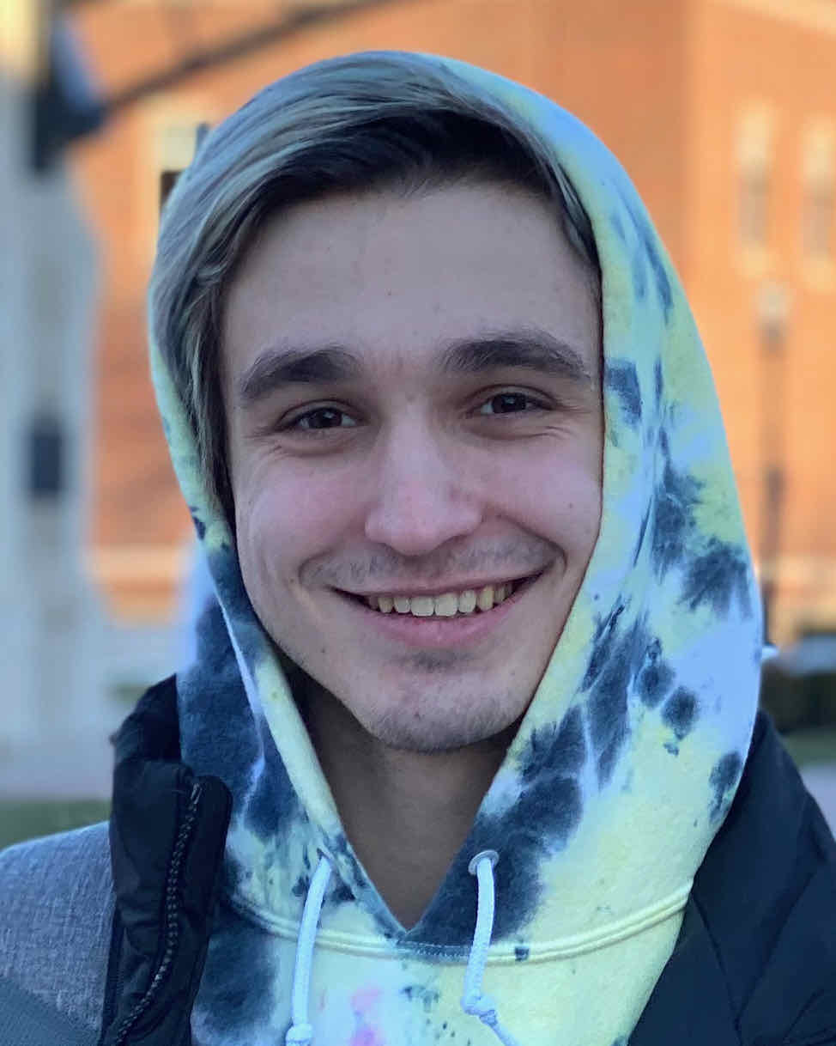
Nick Gorki (Subject) is from New York’s Westchester County and has just begun studying at Purdue University. His mother, Paula, worked in the South Tower. On 9/11, her morning sickness made her late to work; she was standing outside the building when she witnessed the first crash. Her partner, Sebastian, had an unexpected meeting in the South Tower and did not survive. Nick is a cheerleader at heart but is passionate about working with computers.

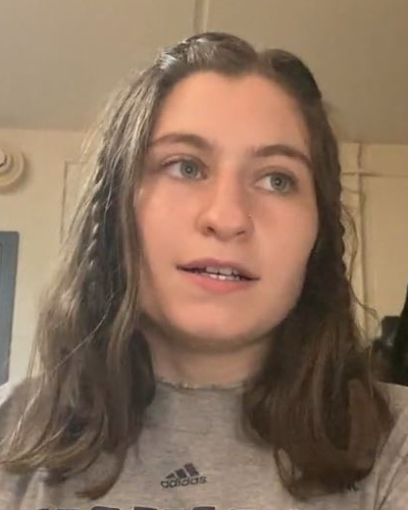
Dina Retik (Subject) hails from Massachusetts and is currently attending the University of Vermont. Her father was a venture capitalist and was killed on hijacked flight AA11. Dina grew up in a big, loving family though she was always aware of the gap left by her father. Her mother, Susan, became involved in charity work soon after the attacks, supporting widows in Afghanistan. She is a role model for Dina, who plans to become an educator.

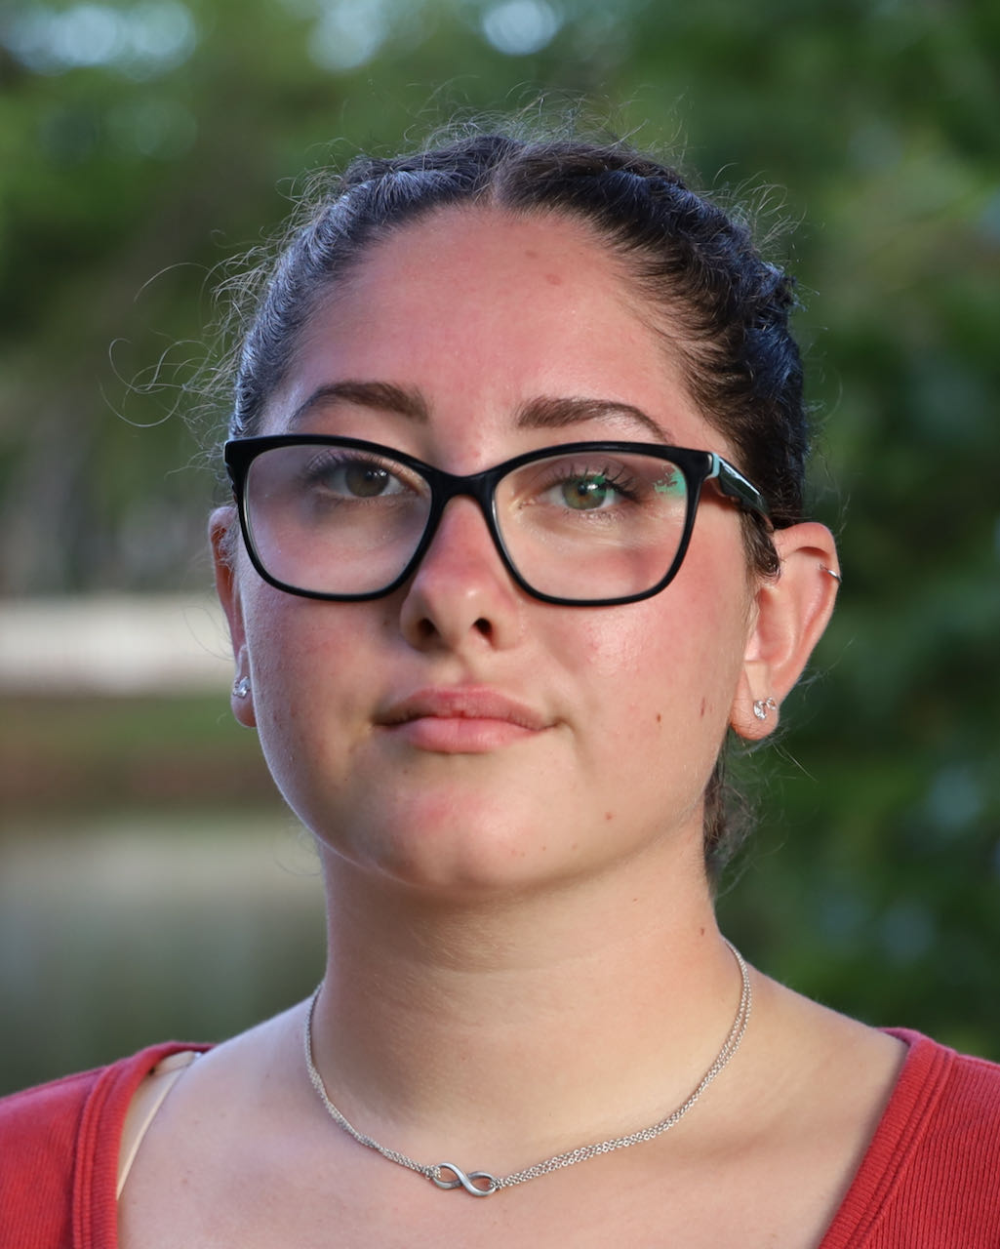
Claudia Szurkowski (Subject) was born in New York. Her father, who worked for the union of painters and wallpaper hangers, was in the North Tower on 9/11. After his death, her mother brought Claudia and her sister down to Florida, where she grew up and still lives today. Working as a secretary on a cardiac unit at the local hospital has given her a front-row view of the pandemic. She is also studying at Florida SouthWestern State College in Naples and is particularly interested in law and criminal justice.

Filmmakers

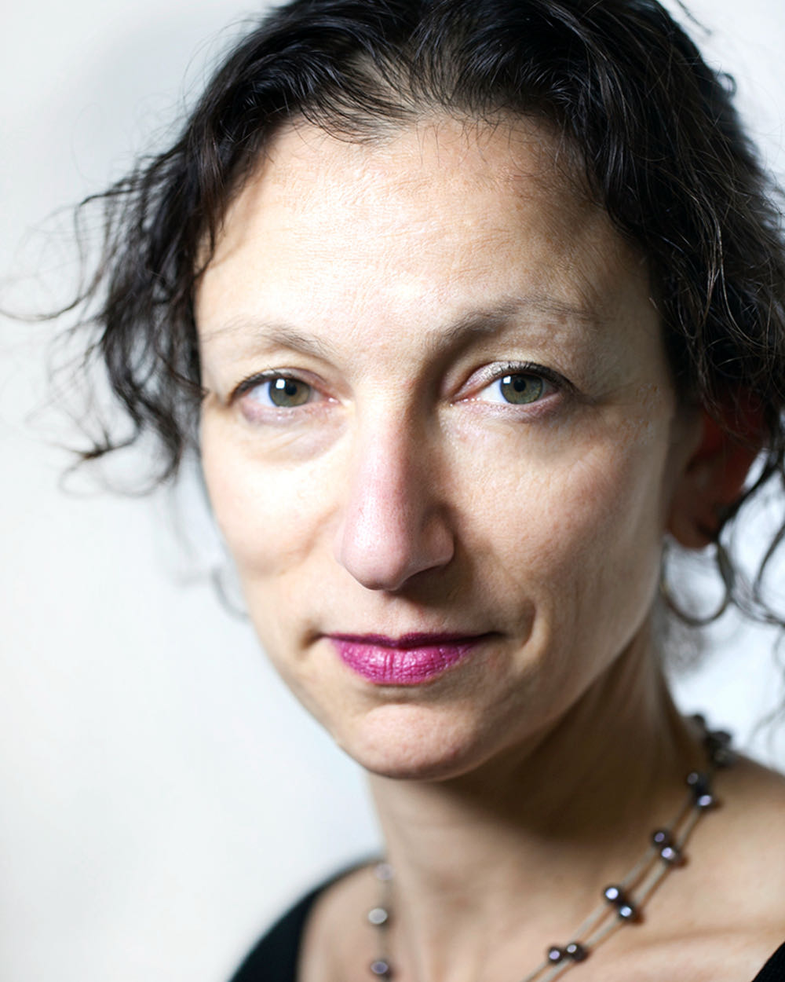
Liz Mermin (Director) is a filmmaker with seven feature documentaries and countless hours of broadcast and streaming docs and shorts to her name. She specializes in creative, character-driven films which tell stories from around the world—from the inner lives of Irish racehorses (Horses) to strange encounters between Afghan and American hairdressers in Kabul (The Beauty Academy of Kabul), to Eurovision-inspired violence against journalists in Baku (Amazing Azerbaijan). She wrote and directed two episodes of First Ladies (CNN Originals, 2020), including an extended episode on Michelle Obama, and was a director on the Netflix series Babies. She recently completed an episode of the BBC series New Labour, about UK politicians and civil servants, including Tony Blair.

Liz began her filmmaking career in New York, where she made many hours of television for PBS, ABC, Discovery and other cable channels, including an ABC special about first responders at the World Trade Center following the 9/11 attacks. She moved to London in the mid-2000s, where she now lives. In 2014, the Thomson Reuters Foundation hired her to introduce documentary to their editorial coverage. As Director of Visual, Liz built up and oversaw a team creating short docs and interactive features on global humanitarian topics. While it was important work, she missed directing, to which she returned in 2017.

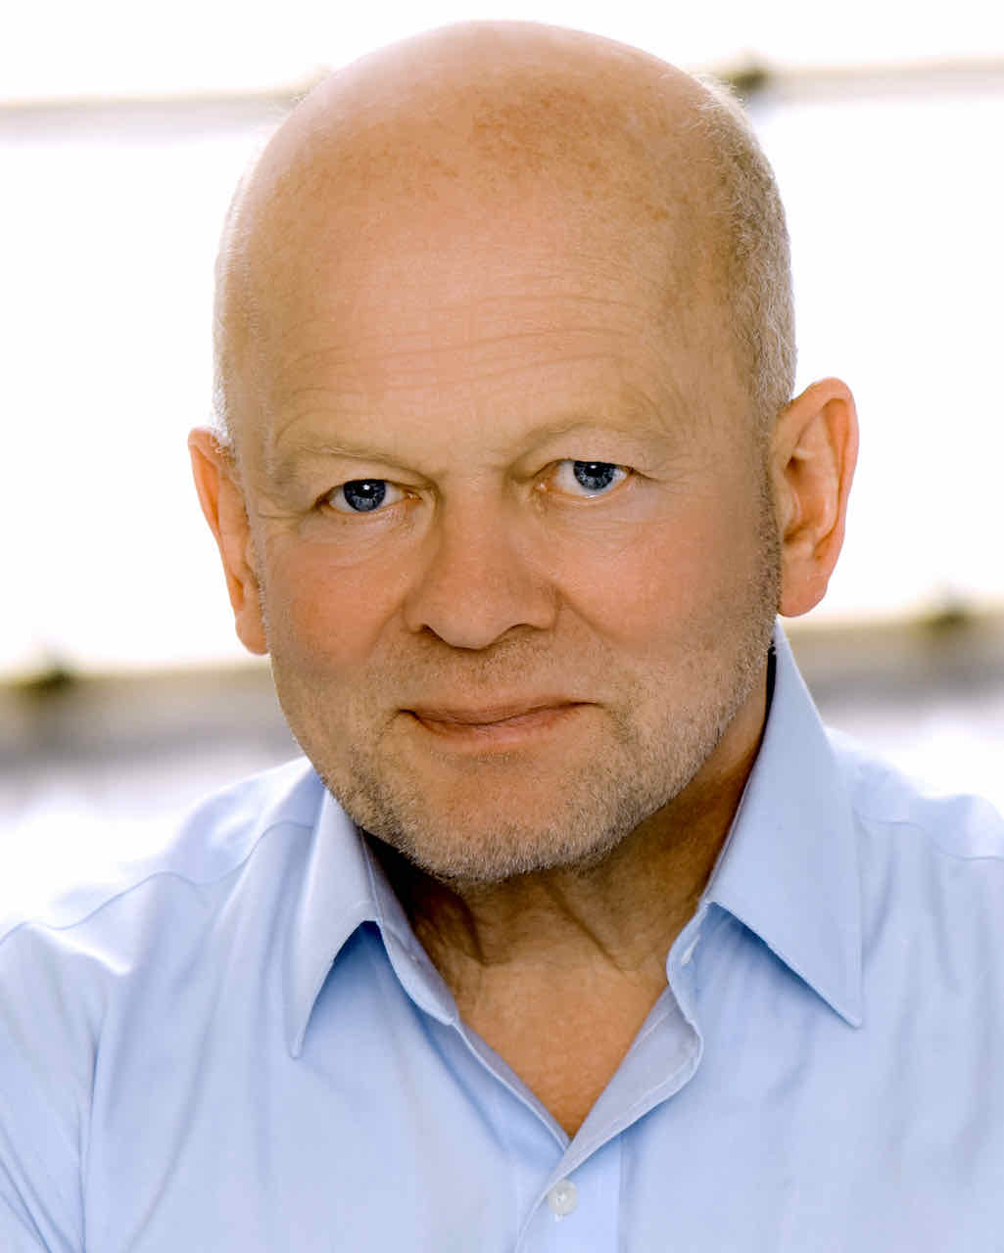
John Smithson (Creative Director, Arrow Pictures) is an Oscar-nominated and Emmy Award-winning producer responsible for a distinguished slate of high-quality films and groundbreaking series which have received global acclaim. John was an Oscar® nominee for Best Motion Picture of the Year for Danny Boyle’s 127 Hours, a film he originated and produced, which was also nominated for 86 awards, including six Oscars and nine BAFTAs. His theatrical documentary, Touching the Void, won the BAFTA for Outstanding British Film and broke box-office records. He also jointly produced Sherpa, which picked up five awards, including Best Documentary at the London Film Festival and a Best Documentary nomination at the BAFTA Film Awards.

John’s documentary credits include The Beckoning Silence, winner of the International Emmy for Outstanding Achievement in Documentary; BAFTA-nominated The Falling Man; Best Cinema Documentary winner Deep Water in the Grierson Awards; Emmy-nominated Time Travel with Stephen Hawking; the HBO documentary Thrilla in Manilla, winner of a Peabody Award; and the critically acclaimed A Year of British Murder and Apocalypse Cow both for Channel 4.

