PBS to air GOING TO WAR, a New Documentary About the Veteran Experience, on Memorial Day

Monday, May 28, 2018
9:00-10:00 p.m. ET on PBS Stations

War Correspondent and Author Sebastian Junger, Vietnam War Veteran and Author Karl Marlantes, and Other Veterans Share Candid Accounts of Life Before, During and After Combat

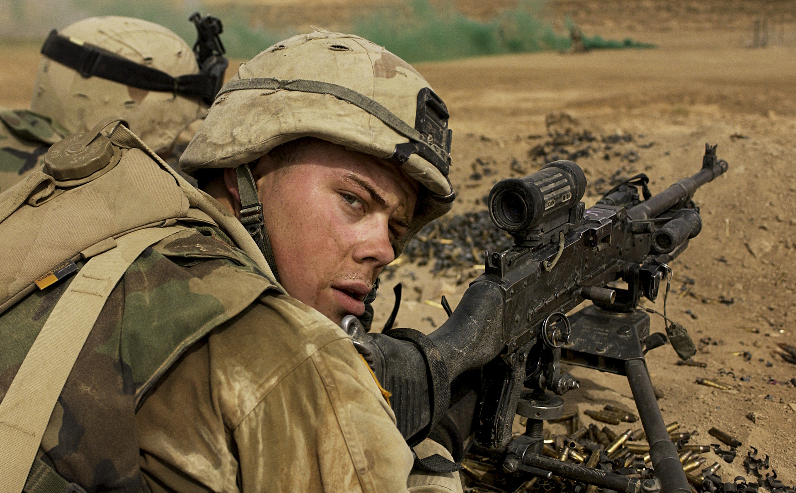
Caption: A US Army infantry soldier in Iraq, 2003.
Credit: Stacy L. Pearsall
MINNEAPOLIS/ST. PAUL, MN (APRIL 19, 2018) — GOING TO WAR, a new 60-minute documentary about what it means to serve in and return from war, will air on Memorial Day, Monday, May 28, at 9:00 p.m. ET on PBS stations (check local listings).

Produced by Michael Epstein (LennoNYC; The Battle Over Citizen Kane) and Twin Cities PBS in association with Paul G. Allen’s Vulcan Productions, GOING TO WAR explores the paradox of war: a painful and horrific experience that also brings exhilaration, purpose, connection — and even love. The film features two acclaimed storytellers of war—journalist and author Sebastian Junger, author of The Perfect Storm and director of the Academy Award-nominated documentary Restrepo; and Vietnam War veteran Karl Marlantes, author of the best-selling Vietnam combat novel Matterhorn and What It Is Like to Go to War.

A trailer is available at pbs.org/goingtowar

Joining Junger and Marlantes are veterans from various American wars who bring first-hand accounts and an abiding commitment to telling the warrior’s story with sensitivity and candor. GOING TO WAR captures the gritty mental and physical transformation of troops in training and follows them into the transformative experience of combat. By delving into the psychologically complex world of warfare and its aftermath, the film reveals the challenges service members face when they return home and rejoin civilian society, revisit their life goals and aspirations, and ultimately redefine themselves.

GOING TO WAR illuminates the deep human responses that transcend battles and cultures and are universal throughout history. “We like to think of war as an aberration — but there’s scarcely been a time or a culture when humankind has not been at war. It’s universal,” said Junger. “We try really hard to keep combat at a distance, but when we talk about war, we are talking about what it means to be human.”

Paired with community engagement resources and compelling digital extras, GOING TO WAR will break new ground on how war impacts the lives of those who have served and the people who love them.

“The experience of war is difficult to fathom for those who’ve never seen combat,” said Michael Rosenfeld, Executive Producer and Vice President of National Production for Twin Cities PBS. “GOING TO WAR reveals what combat is really like through the words of remarkably candid service men and women.”

“GOING TO WAR is laser-focused on the importance of storytelling as a way to honor our veterans,” said Carole Tomko, General Manager and Creative Director for Vulcan Productions. “To try to understand their experience is our first step toward honoring those who have gone to war to protect our freedom.”

Produced by Michael Epstein, GOING TO WAR is a production of Twin Cities PBS in association with Paul G. Allen’s Vulcan Productions and PBS. Major funding is provided by the Corporation for Public Broadcasting, which supports public content on military and veterans issues including the Veterans Coming Home project to bridge the military and civilian divide. Additional funding is provided by The Weber Family.

About Twin Cities PBS (TPT):
Twin Cities PBS, the PBS affiliate for Minneapolis/St. Paul, is a prominent content producer for the national public television system. TPT’s major national documentaries include the Emmy Award-winning The Forgetting: A Portrait of Alzheimer’s, Peabody Award recipient Depression: Out of the Shadows, and 2012 official Sundance Film Festival selection Slavery by Another Name. Additional recent projects include CONSTITUTION USA, Alzheimer’s: Every Minute Counts and the groundbreaking children’s program SciGirls. TPT co-produced the classic feature documentary Hoop Dreams, a Peabody and Sundance Film Festival winner. More information at national.tpt.org.

About Vulcan Productions:
Vulcan Productions is dedicated to the power of storytelling. The company produces content and large-scale campaigns that entertain, inspire and change the way people understand the world's toughest challenges. The films, television series and digital content spark ideas and turn action into measurable impact. Founded by Paul G. Allen and Jody Allen, Vulcan Productions creates content across all formats and genres, and spotlights Mr. Allen's impact work in biodiversity, science, climate, technology, current social issues, history and the arts. Vulcan Productions uses cutting edge technology to create unique experiences for its audiences, by incorporating virtual, mixed and augmented reality. The team’s award-winning projects include USS Indianapolis: Live from the Deep, STEP, The Ivory Game, Unseen Enemy, Racing Extinction, Naledi: A Baby Elephants Tale, Academy Award®-nominated Body Team 12, Mind of a Giant, We the Economy, We the Voters, Ocean Warriors, #ISurvivedEbola, and Girl Rising. Upcoming releases include Ghost Fleet, Ballet Now and Oliver Sacks. For information on Vulcan Productions and our leadership in generating change through impact storytelling, visit vulcanproductions.com.

About PBS
PBS, with nearly 350 member stations, offers all Americans the opportunity to explore new ideas and new worlds through television and digital content. Each month, PBS reaches nearly 100 million people through television and nearly 28 million people online, inviting them to experience the worlds of science, history, nature and public affairs; to hear diverse viewpoints; and to take front row seats to world-class drama and performances. PBS’ broad array of programs has been consistently honored by the industry’s most coveted award competitions. Teachers of children from pre-K through 12th grade turn to PBS for digital content and services that help bring classroom lessons to life. Decades of research confirms that PBS’ premier children’s media service, PBS KIDS, helps children build critical literacy, math and social-emotional skills, enabling them to find success in school and life. Delivered through member stations, PBS KIDS offers high-quality educational content on TV – including a new 24/7 channel, online at pbskids.org, via an array of mobile apps and in communities across America. More information about PBS is available at www.pbs.org, one of the leading dot-org websites on the internet, or by following PBS on Twitter, Facebook or through our apps for mobile and connected devices. Specific program information and updates for press are available at pbs.org/pressroom or by following PBS Pressroom on Twitter.

About CPB
The Corporation for Public Broadcasting (CPB), a private, nonprofit corporation created by Congress in 1967, is the steward of the federal government’s investment in public broadcasting. It helps support the operations of nearly 1,500 locally owned and operated public television and radio stations nationwide. CPB is also the largest single source of funding for research, technology and program development for public radio, television and related online services. For more information, visit www.cpb.org, follow us on Twitter @CPBmedia, Facebook and LinkedIn, and subscribe for email updates.

– PBS –

CONTACTS: Carolyn Petschler, DKC Public Relations, Tel.: 212-981-5166; carolyn_petschler@dkcnews.com

Brian Moriarty, DKC Public Relations, Tel.: 212-981-5252; brian_moriarty@dkcnews.com

For images and additional up-to-date information on this and other PBS programs, visit PBS PressRoom at pbs.org/pressroom.

