GORONGOSA PARK: REBIRTH OF PARADISE
Brings to Life an Historic Rejuvenation of an African Wildlife Oasis

Three-part adventure series airs on PBS Tuesdays September 22 – October 6, 2015, 8:00-10:00 p.m. ET

Family Sneak Preview Week September 16-22;
PBS will offer the entire series across all streaming platforms

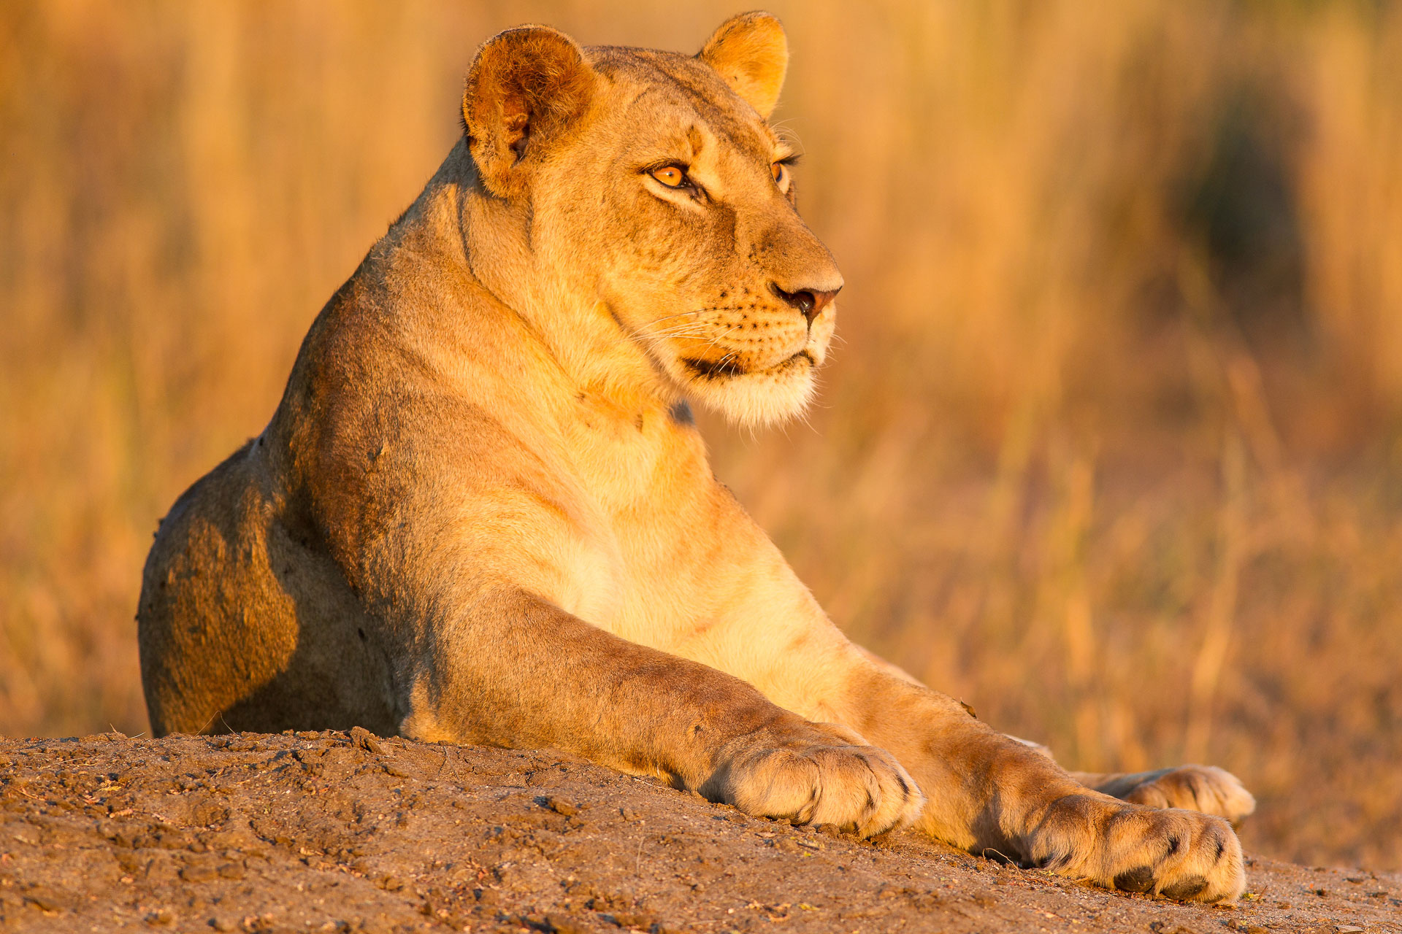

Lioness in Gorongosa Park. Photo courtesy of Mike Dos Santos / Off the Fence B.V
ARLINGTON, VA; Aug. 10, 2015 – Gorongosa National Park in Mozambique is one of Africa’s greatest wildlife restoration stories, living proof that nature can recover from near collapse, so long as humans protect it and help it to heal. In GORONGOSA PARK: REBIRTH OF PARADISE, airing Tuesdays, September 22 to October 6, 8:00 -10:00 p.m. ET on PBS, viewers will join Emmy-winning filmmaker Bob Poole on an incredible adventure exploring Gorongosa, as “rewilding” efforts are made to restore populations of magnificent creatures after a civil war nearly destroyed the park.

The success of “re-wilding” Gorongosa National Park is crucial to this East African ecosystem and to the global conservation community. Poole has made it his life’s work to communicate the beauty and importance of Gorongosa to the world. He is joined in the effort by specialists who include his sister, renowned elephant researcher Joyce Poole, philanthropist Greg Carr, who is founding president of the project’s oversight committee, and renowned scientist and conservationist Edward O. Wilson, who serves as a scientific advisor to the park. Together they explore its most remote areas and make new scientific discoveries while telling dramatic stories of war-traumatized elephants who charge humans on sight, lions that are fighting dynastic battles as well as poachers’ snares, and tiny yet epic struggles in the insect world that affect the entire ecology. Every creature plays a part in the rebirth of this complex ecosystem.

“Our deep dive into the return of GORONGOSA PARK is important because of how crucial its conservation effort is to the ecosystem of Africa – and to the world,” said Bill Gardner, VP, Programming and Development, PBS. “It’s also an epic adventure and an inspiring story of how dedicated people, working together, can make a difference in rehabilitating ecosystems thought to be lost.”

GORONGOSA PARK provides an experience unlike that available to any other tourist or visitor. Viewers will see Poole’s vivid re-enactment of an unusually aggressive elephant attack; ride along with the research team at night as they fit GPS trackers onto the manes of lions, bracing for possible attacks from others in the pride; and discover a huge aggregation of some of the largest crocodiles in Africa.

PBS invites families to experience the series together and will be making all six episodes available for preview beginning Wednesday, September 16 through Tuesday, September 22 across several platforms, including pbs.org; iPhone; iPad; Android; AppleTV; Roku; Fire TV and Xbox360. For information on where to watch other PBS and local member station content anytime, visit pbs.org/anywhere.

Bob Poole is an authoritative and passionate voice in the scientific and natural film world. He has filmed and directed award-winning documentaries for PBS series NATURE and NOVA, as well as for BBC and Discovery Networks, and nearly 40 programs for National Geographic Television. In 2011, Poole won an Emmy for Outstanding Cinematography on National Geographic's landmark series “Great Migrations.”

“My childhood in the wilds of Africa inspired my career, but Gorongosa is special for me; this time I will be in front of the camera as well as behind it, capturing the incredible biodiversity and herculean conservation efforts taking place,” said Poole. “The two years I spent filming the park’s transformation fulfills a life-long dream of mine. I was able to combine my passion for animal conservation with my love of documentary filmmaking.”

Episodes 1 & 2, “Lion Mystery” and “Elephant Whisperer”
In the premiere episodes, Bob Poole joins Gorongosa scientist Paola Bouley as she tries to solve a baffling mystery: Why isn’t Gorongosa’s lion population growing? Poole’s lens captures five cheeky lion cubs on their journey to adulthood. Then, he and his sister Joyce, a renowned elephant expert, face charging elephants to gain insights into their behavior. Viewers get a sense of the park’s ongoing, real danger, as Mt. Gorongosa is taken over by a group of rebel soldiers. September 22, 8:00 pm – 10:00 pm ET

Episodes 3 & 4, “New Blood” and “Hidden Worlds”
In these next two hours, Bob Poole and the lion team find one of the cubs with a grave wound and race to save her. A massive relocation mission is launched to bring back zebra and eland, Africa’s largest antelope. Then, Poole and a team of scientists estimate that the park may hold Africa’s largest crocodile population. Rappelling into deep gorges, they discover forests full of new species and unexplored caves. September 29, 8:00 pm – 10:00 pm ET

Episodes 5 & 6,“Battle Lines” and “Roaring Back”
In the final episodes, Joyce Poole makes a breakthrough with the elephants in Gorongosa, while her brother Bob spends a night chasing a group of crop-raiding elephants. A new lion arrives, sparking a conflict among Gorongosa’s dominant lions. Then, after many sleepless nights, the team is relieved to find a pair of lion cubs that had gone missing. These two are the future of lions in Gorongosa. October 6, 8:00 pm – 10:00 pm ET

The GORONGOSA PARK: REBIRTH OF PARADISE website (pbs.org/gorongosa) goes beyond the broadcast by taking a close look at the captivating stories featured in the series, and showcases web-exclusive video clips, photo galleries, a lion audio recording and a virtual reality video experience.

PBS Learning Media, in partnership with Howard Hughes Medical Institute (HHMI), will also launch a website, http://www.pbslearningmedia.org/collection/gorongosa-park/, with several innovative features, including an interactive map focusing on key components of the conservation strategy, a timeline of the history of the park and videos of Gorongosa scientists at work for viewing the park’s researchers in their natural habitat.

For wildlife fans who want to get involved in the action, HHMI and Zooniverse have developed WildCam Gorongosa, a new citizen science interactive launching in September with links from pbs.org/gorongosa and the PBS Learning Media site, giving users the chance to identify the park’s charismatic animal residents using never-before-seen photographs from 52 trail cameras in Gorongosa National Park. Identified animals will provide critical information for park scientists, and the most impressive images will be used in social materials to create awareness about the park and its amazing story of resilience.

GORONGOSA: REBIRTH OF PARADISE will be available on DVD from PBS Distribution online at ShopPBS.org; 800-PLAY-PBS, 24 hours a day, 7 days a week. The film also will be available for digital download.

About PBS
PBS, with over 350 member stations, offers all Americans the opportunity to explore new ideas and new worlds through television and online content. Each month, PBS reaches more than 103 million people through television and over 33 million people online, inviting them to experience the worlds of science, history, nature and public affairs; to hear diverse viewpoints; and to take front row seats to world-class drama and performances. PBS’ broad array of programs has been consistently honored by the industry’s most coveted award competitions. Teachers of children from pre-K through 12th grade turn to PBS for digital content and services that help bring classroom lessons to life. PBS’ premier children’s TV programming and its website, pbskids.org, are parents’ and teachers’ most trusted partners in inspiring and nurturing curiosity and love of learning in children. More information about PBS is available at www.pbs.org, one of the leading dot-org websites on the Internet, or by following PBS on Twitter, Facebook or through our apps for mobile devices. Specific program information and updates for press are available at pbs.org/pressroom or by following PBS Pressroom on Twitter.

– PBS –

For additional information, photos, interviews and more, contact Goodman Media or PBS:

Maryellen Mooney Ellen Stanley Booth
Goodman Media International for PBS PBS
212-576-2700 703-739-5120
PBSGorongosa@goodmanmedia.com esbooth@pbs.org

For images and additional up-to-date information on this and other PBS programs, visit PBS PressRoom at pbs.org/pressroom.

