From New England to the West Coast, the Midwest to the South, Meet the Ten Home Cooks Putting Their Culinary Skills to the Test in
THE GREAT AMERICAN RECIPE

New Eight-Part Competition Series Premieres Fridays, June 24-August 12, 2022

Hosted by “TODAY” Food and Lifestyle Contributor Alejandra Ramos with Judges Leah Cohen, Tiffany Derry and Graham Elliot

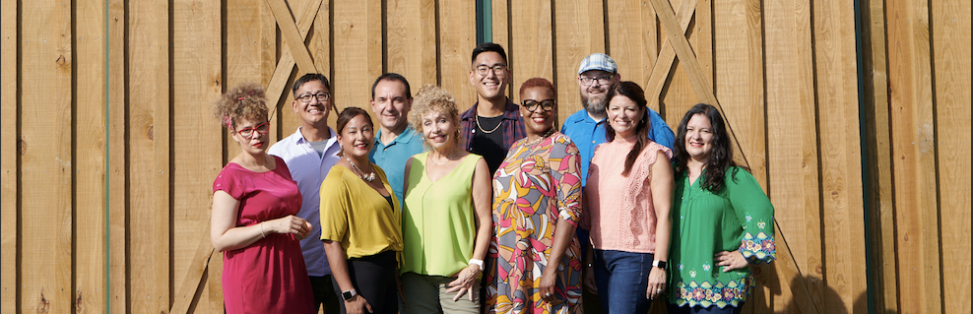
The Ten Home Cooks from The Great American Recipe. Credit: PBS/VPM

ARLINGTON, VA – PBS today announced the ten talented home cooks who will be showcasing their culinary expertise in THE GREAT AMERICAN RECIPE, a new eight-part uplifting competition series that celebrates the multiculturalism that makes American food so vibrant and unique. With a range of culinary styles infused by their backgrounds — from Syrian to Hungarian, Vietnamese to Mexican, Italian to Puerto Rican, Southern soul food to Filipino, the ten contestants represent the delicious diversity of American home cooking.

Hosted by Alejandra Ramos, each episode of the series gives the cooks the opportunity to showcase two of their beloved signature dishes as they compete to win the national search for “The Great American Recipe.” Judges Leah Cohen, Tiffany Derry and Graham Elliot bring their professional insights and deep culinary knowledge to encourage and support the contestants along the way. THE GREAT AMERICAN RECIPE premieres Fridays, June 24-August 12, 9:00-10:00 pm ET (check local listings) on PBS, PBS.org and the PBS Video app.

About the Contestants

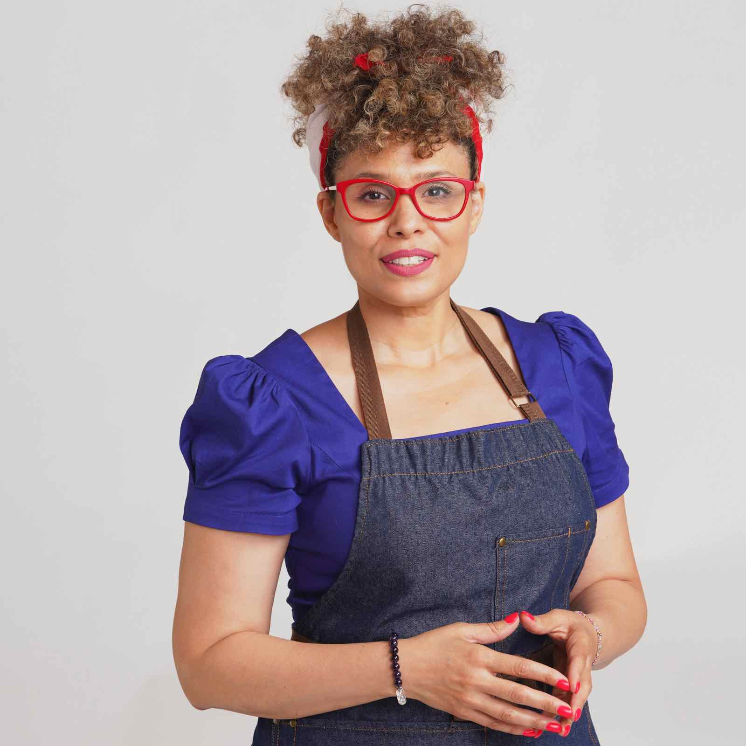
IRMA CÁDIZ (New York, NY) grew up eating Dominican and Puerto Rican food and loves to prepare her mother’s recipes as a tribute to her family’s Caribbean heritage. Raised in a multicultural environment in Rochester, New York, she experienced a wide range of cuisines but wasn’t always a fan of cooking. Her mother encouraged her to join her in the kitchen, but it wasn’t until Irma had her own children that she learned to love it. For the past decade, she has lived in New York City’s Harlem with its diverse culinary scene. Irma recently completed her college degree and has started her own business, where she specializes in Latin-inspired cocktails. Irma is an actor and current member of the Chelsea Repertoire Theatre, where she continues to hone her craft. Her signature dish is mofongo con camarones, a popular Caribbean comfort food made from mashed plantains and shrimp.

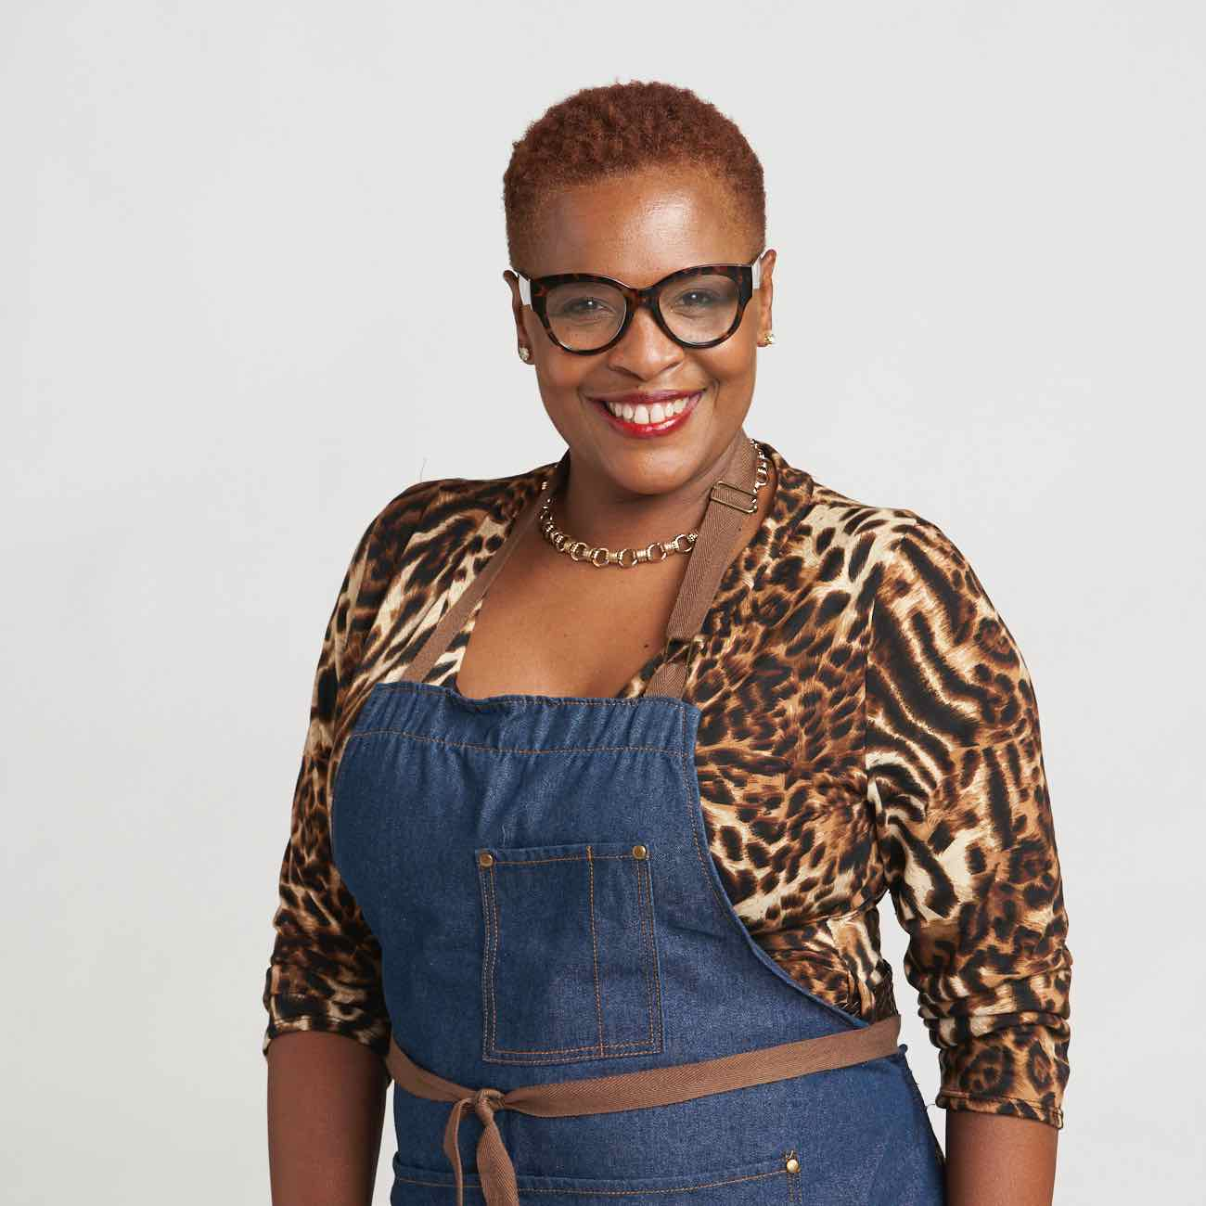
BAMBI DANIELS (Winston-Salem, NC) describes her cooking as Southern “Heart & Soul” food — everything has a hint of her South Carolina roots and lots of love. She grew up on her family’s farms in South Carolina — her maternal grandparents’ in Chester and her homestead, Davis Farm, in Blair, where meals were prepared using what they grew and raised. She still incorporates fresh ingredients in her recipes, and when she visits her Blair homestead, family and neighbors drop by to share fruits and vegetables from their gardens. Bambi loves cooking for her family, children and their friends and believes authentic connections are made and walls broken down when people sit down together at the dinner table. Her mother, Mary Emma, is her inspiration, but recent health issues have kept the matriarch from cooking. Bambi’s goal is to keep the family recipes — which carry the voices of her ancestors — alive. Her signature dish has been passed down from generation to generation: smoked mac and cheese with bacon.

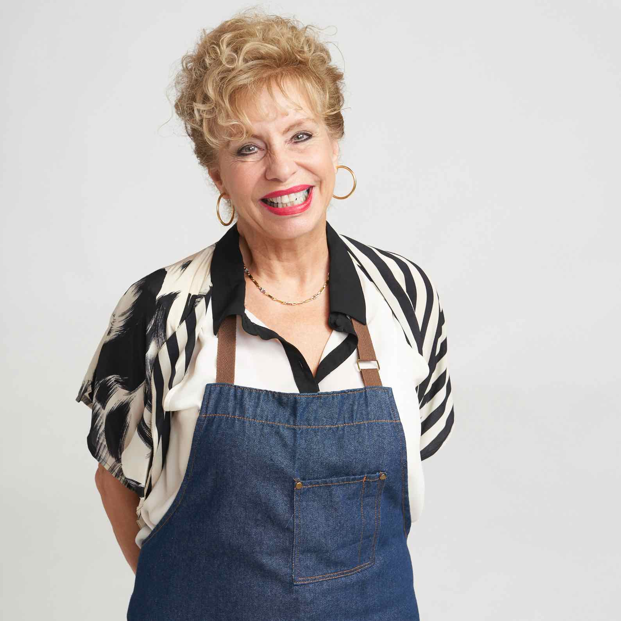
ROBIN DAUMIT (Annapolis, MD) developed a cooking style that combines Mediterranean and Middle Eastern influences from her mother’s Syrian heritage and the regional cuisine of her home state of Maryland. Living in the Chesapeake Bay area, she loves to cook with fresh seafood, especially blue crab and oysters. Growing up, many of her friends were Greek and Italian, and through them, she learned to cook a wider range of Mediterranean food. As a single parent of four and now grandmother, she loves whipping up recipes she collected throughout a lifetime of experiences and has made it her life’s purpose to pass on the traditions of her Mediterranean cuisine with her family, through her cookbooks and her blog. Robin’s signature dish is salmon in a fig leaf because fig trees represent prosperity, health and well-being, and she has had one at every home she has owned.

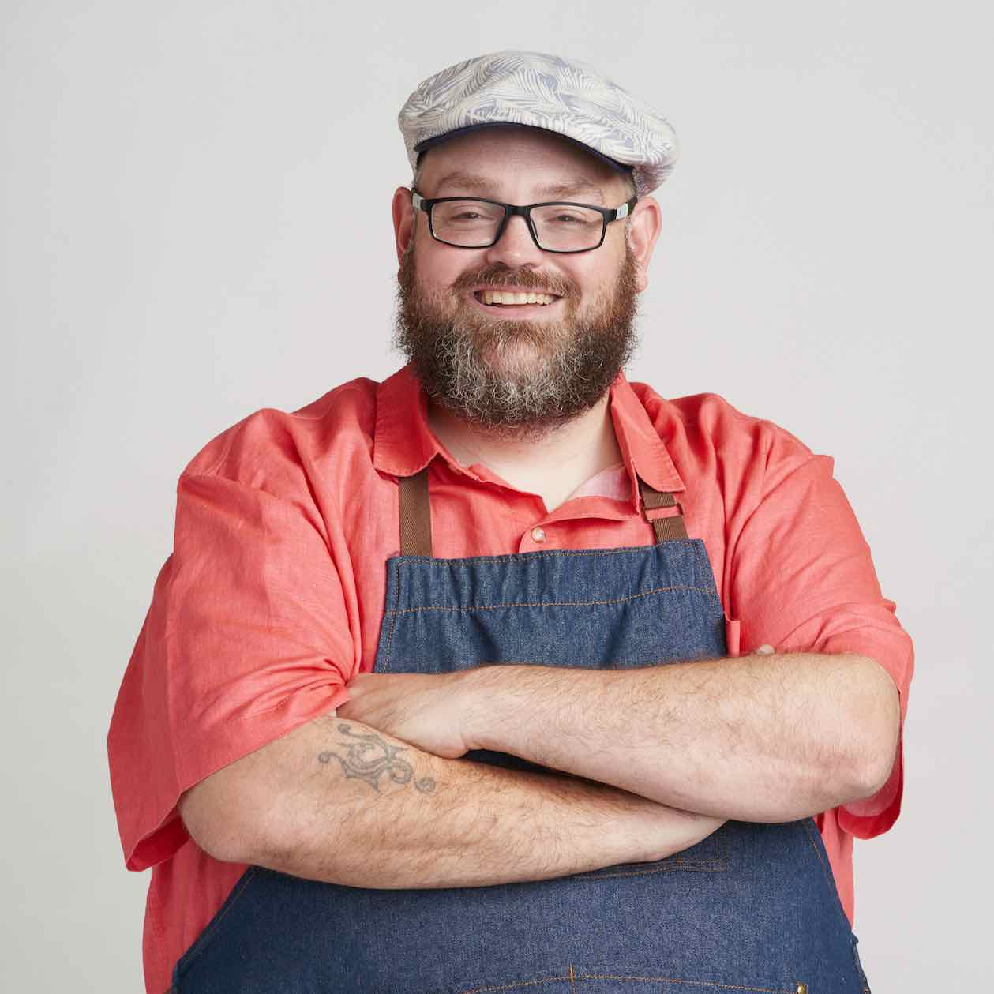
BRIAN LEIGH (Bowling Green, KY) prides himself on his rustic home cooking infused with his Hungarian and German heritage. Born and raised in Ohio, he now calls Kentucky home, where he cooks hearty, homestyle meals for his wife and family. Growing up in a family of farmers, Brian learned cooking from his mother and grandmother, making everything from scratch, including beef stroganoff, blintzes, oatmeal cookies and marinated cucumbers. Brian developed his cooking techniques as a teenager when he worked in a friend’s Italian restaurant and credits his father for his passion for barbecue, which led him to start his own award-winning company that makes sauces and rubs. His signature dish is a rib eye with blue cheese and BBQ brussels sprouts.

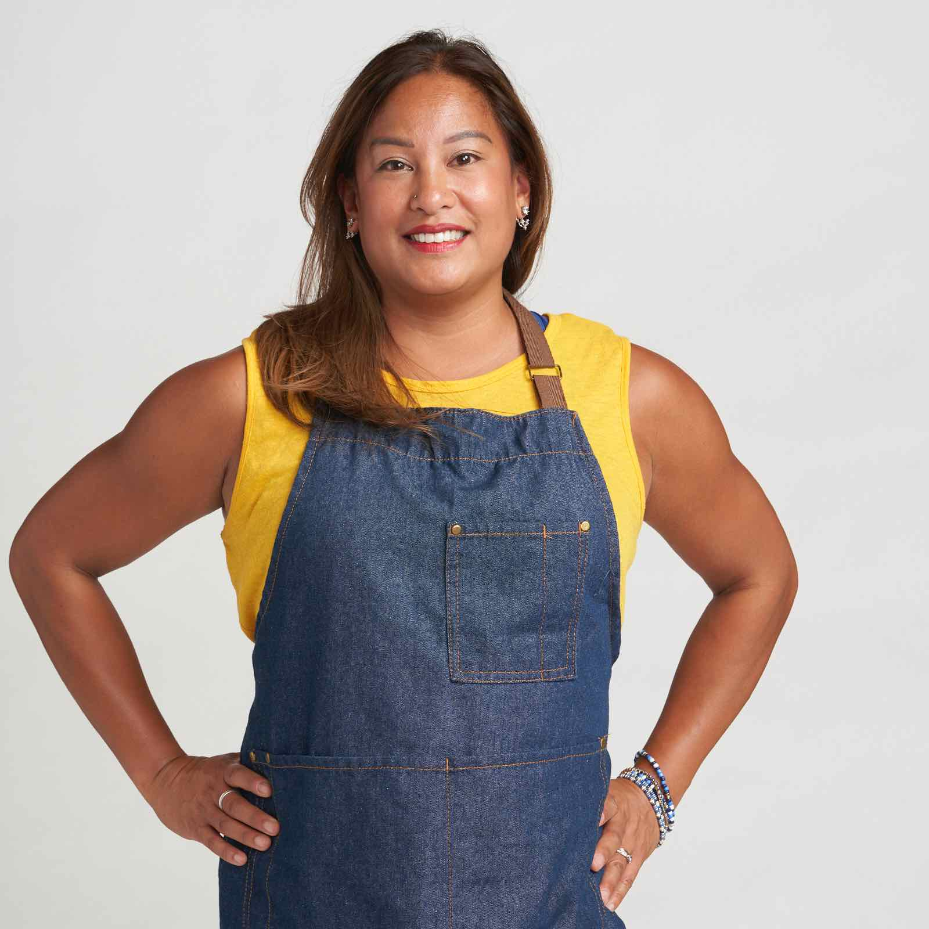
CHRISTINA MCALVEY (Portland, OR) calls her food “Fili-fusion,” a mash-up of Filipino flavors blended with her favorite cuisines. She was born in Michigan shortly after her parents emigrated to the United States from the Philippines in the late 1970s. From an early age, she helped her parents in the kitchen, making Filipino dishes and taking home-cooked meals to school for lunch. Christina’s signature dish is Chicken Adobo which she learned to make from her dad as a child. Now living in Portland, Christina finds that the area’s outdoor lifestyle encourages her to cook healthy, environmentally sustainable meals using locally sourced organic and gluten-free ingredients. As a small business banker with a busy professional and personal life, she doesn’t always have time to tackle complicated recipes and has learned to make simple yet delicious dishes using whatever she has on hand. With a lifelong interest in fitness, she loves to create healthier versions of her family’s favorite Filipino recipes.

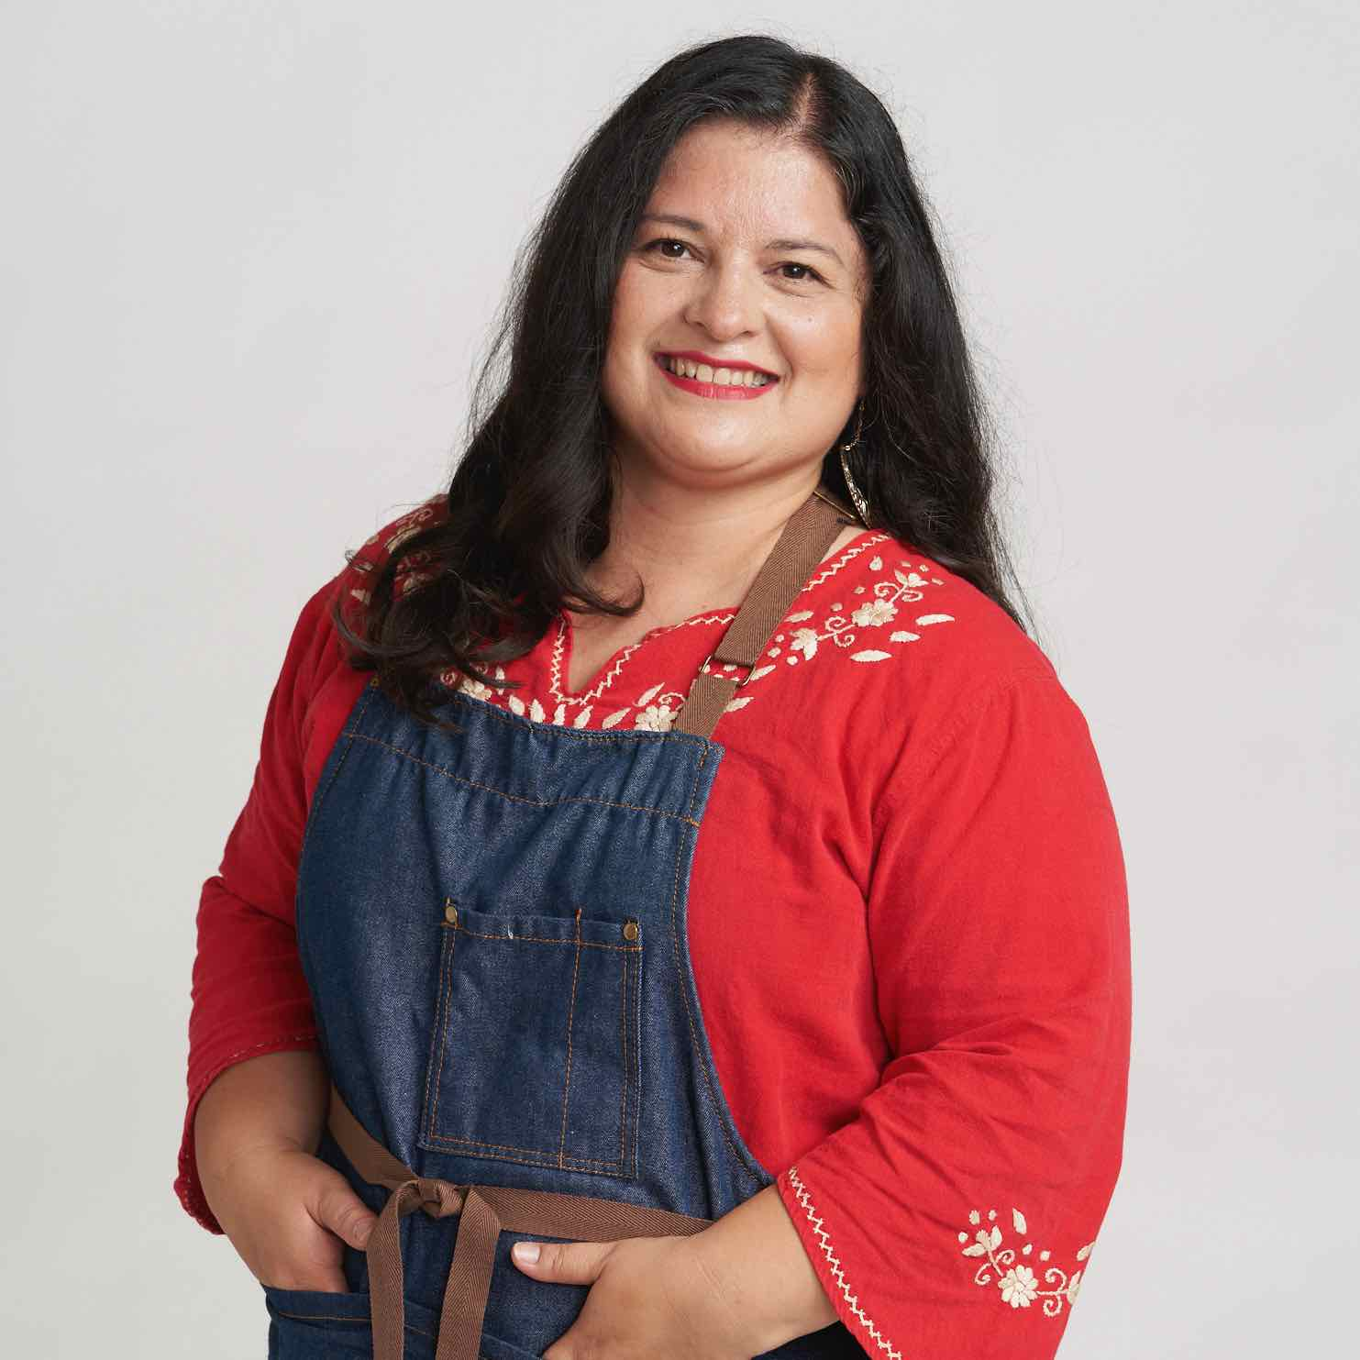
SILVIA MARTINEZ (San Luis Obispo, CA) grew up in Guanajuato in central Mexico, cooking authentic dishes she learned from her grandmother, aunts and mother. After college, Silvia had a successful career as a human resources executive and university instructor. She met and married an American and they moved to California’s Central Coast. Silvia’s transition to life in the U.S. was challenging, but once she became a mother, she connected with other Latinx parents by sharing her favorite recipes and bicultural life through her popular bilingual website. Silvia has adapted some of her Mexican recipes to reflect a California lifestyle while also keeping many traditional Mexican dishes. One of her signature dishes is Sopa Tarasca, a pinto bean-based soup with tomatoes and chile ancho topped with crispy tortilla strips, avocado and queso fresco.

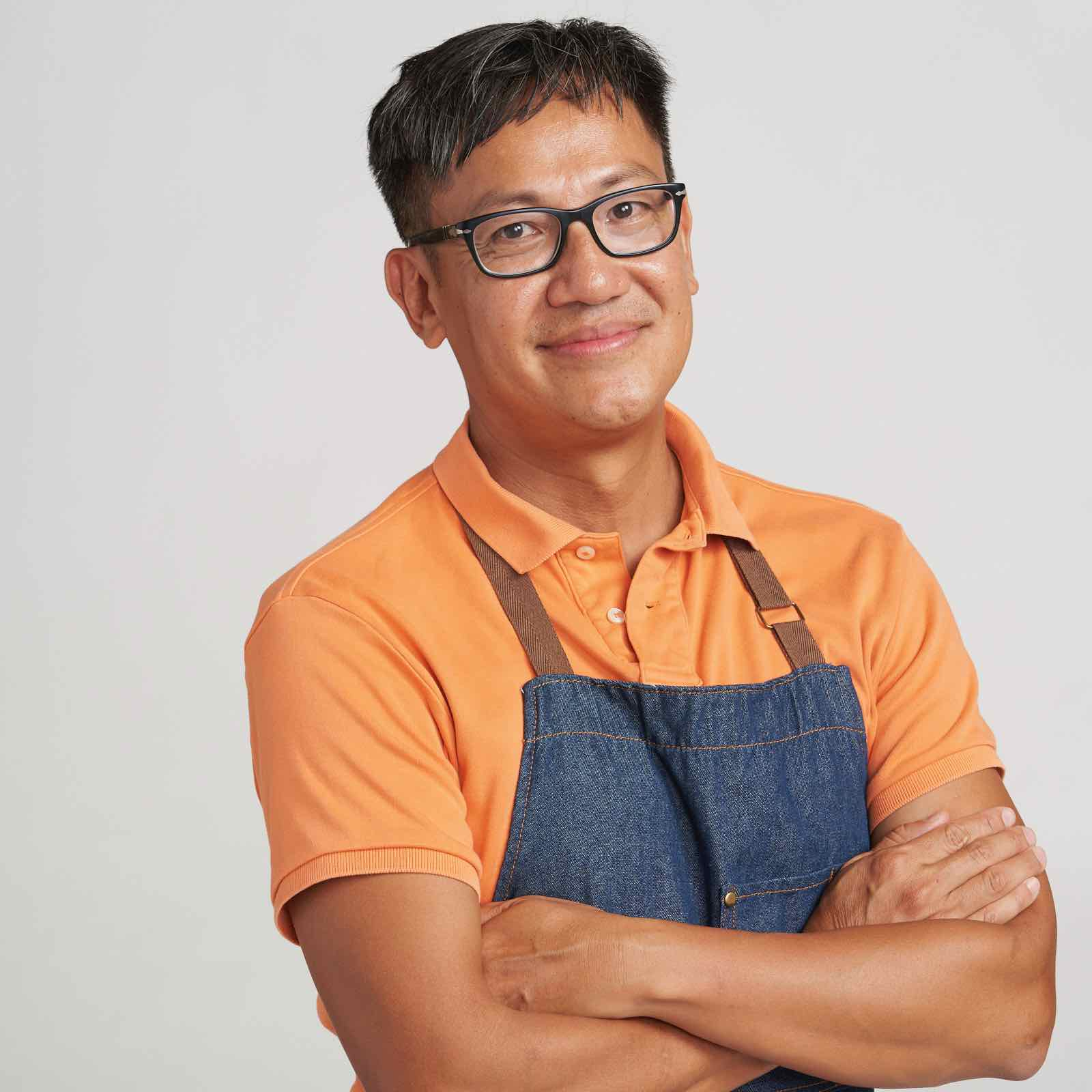
FOO NGUYEN (Orange County, CA) loves to prepare his family’s favorite recipes and considers his Vietnamese heritage his greatest culinary influence. His family emigrated to the US and settled in Cincinnati, Ohio, where he lived from the age of three until he was 22. Foo’s large family — he’s one of eight children — rarely ate out because of the expense so his mother always served home-cooked meals. As he began to cook, he would combine Asian flavors with Midwestern comfort food classics. When his mother was diagnosed with dementia, Foo was motivated to continue her Vietnamese cooking traditions for his Korean American wife and their two daughters. He now lives in Orange County, California, where there is a large Asian community and easy access to amazing ingredients. Foo is also a stand-up comic and believes that food and comedy are the two things that can put a smile on anyone’s face. His signature dish is egg rolls stuffed with pork, crab and shrimp, a family tradition started by his mother.

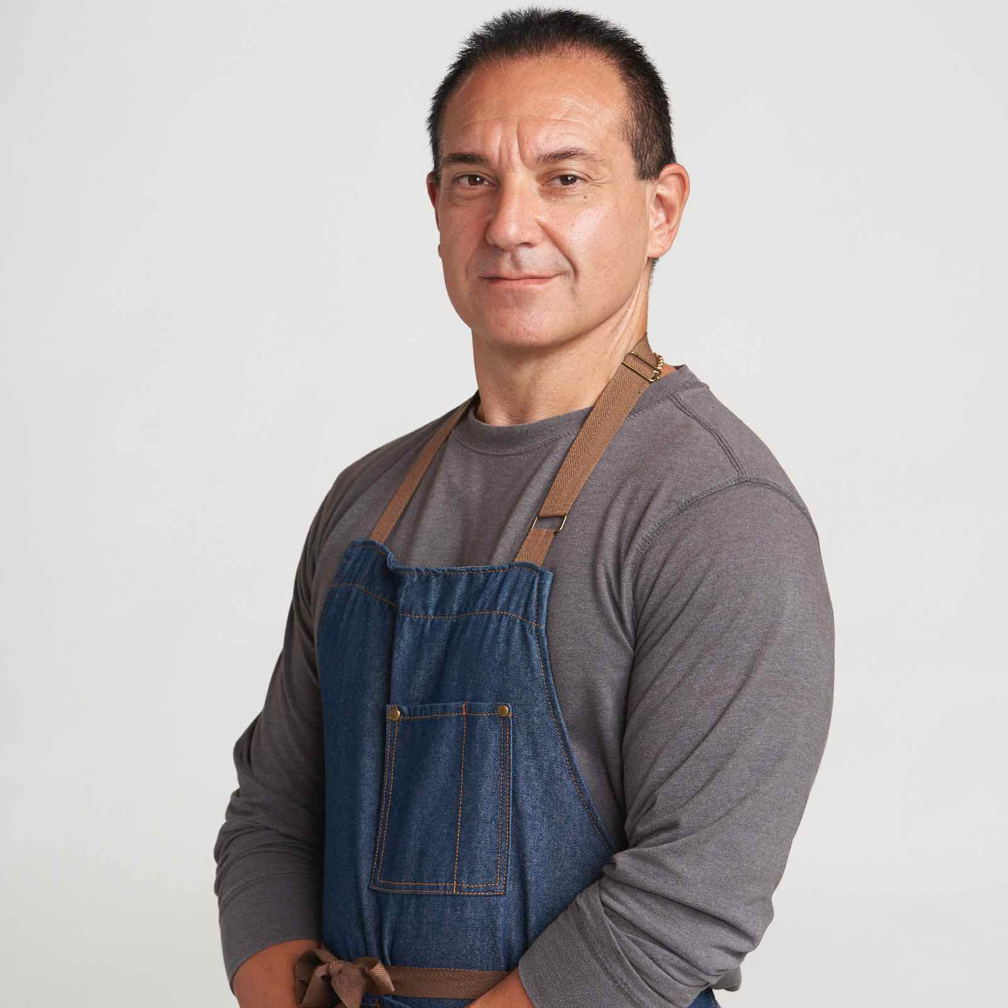
DAN RINALDI (Providence, RI) was raised in a multi-generational Italian family and takes pride in sharing his family recipes. He learned to cook in his grandmother’s kitchen, where Sunday dinners were a staple of his childhood. He loves to make homemade pasta and is continuing the tradition with his wife, daughter and grandkids. The secret to his cooking is heirloom Calabrian chilis, originally brought over from Italy, and he tries to work them into as many dishes as possible. A firefighter for 33 years, Dan enjoys preparing hearty meals for his colleagues at the firehouse. While on duty, Dan became trapped inside a burning house, suffering third-degree burns and crushed limbs before being rescued by his fellow firefighters. After recovering from his injuries, he came back even stronger and has continued to thrive in the job he loves so much. Dan’s signature dish is his grandmother’s meat sauce recipe — Sunday gravy with meatballs — a firehouse favorite.

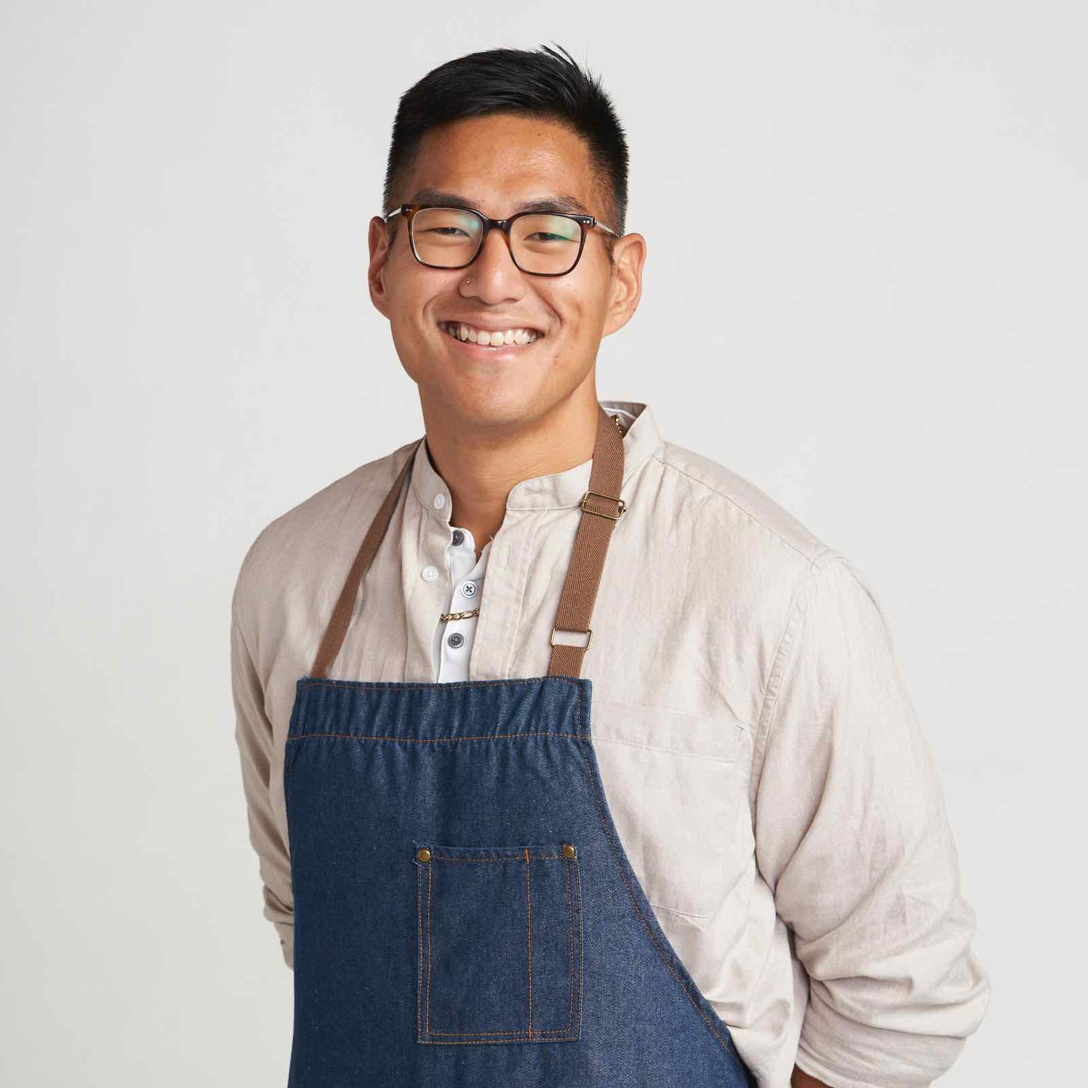
TONY SCHERBER (Minneapolis, MN) was born in South Korea and raised in Minneapolis. When he and his adopted brother arrived in the U.S., they were instantly immersed in two cultures. Tony’s adoptive mother cooked dishes from an old Korean cookbook to help him stay connected to his birth culture. Although he cooked throughout his life and aspired to be a chef, culinary school was not a feasible/realistic option for him. Tony now works as a Social Media Manager in Minneapolis, loves to blog about food and entertain friends and family with home-cooked meals or discovering a new restaurant. The burgeoning food scene in Minneapolis, and throughout his travels, has opened his eyes to the world of international cuisines. Tony’s signature dish — Korean Gochujang chicken tacos with kimchi — reflects his love of big, bold flavors.

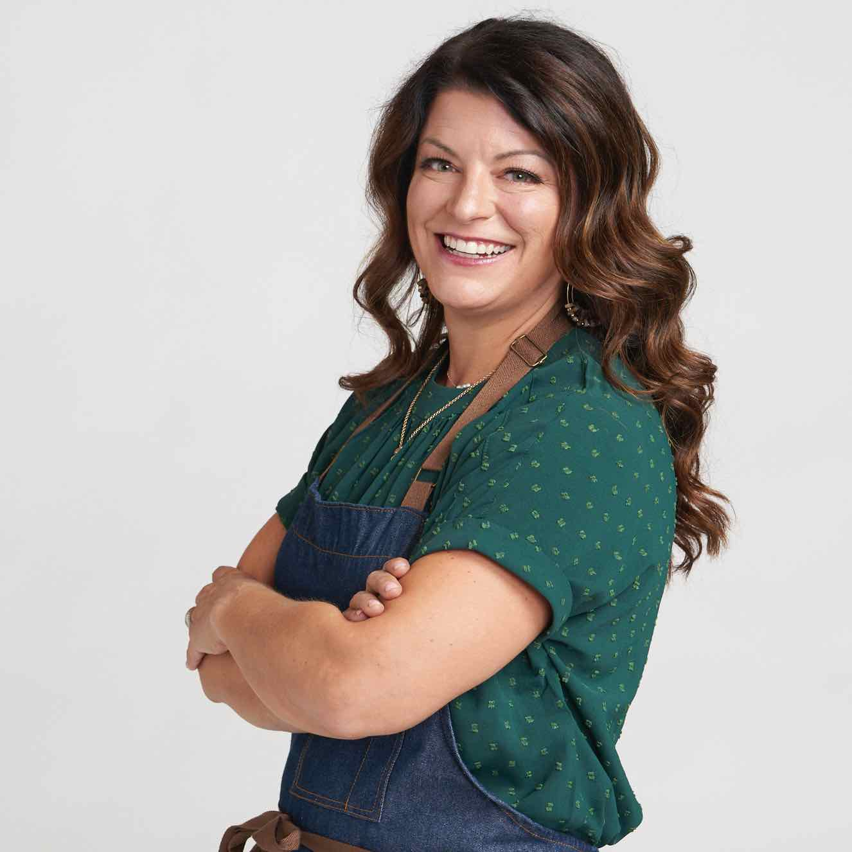
NIKKI TOMAINO-ALLEMAND (Boise, Idaho) was raised in the Seattle area but now lives in Boise with her husband and two sons, where she runs her own meal prep delivery service for other busy parents. Her cooking combines her family’s Italian roots with her Pacific Northwest upbringing. Her most cherished recipes are those passed down from her relatives, including her grandfather, who taught her many of his favorite dishes. Nikki’s love of world travel has inspired her to infuse a variety of international influences in her cooking. To give back to the community, Nikki hosts an annual Thanksgiving dinner for families in need and works with a program that helps local youth receive culinary and life skills training and job placement in the food industry. Nikki’s signature dish is baccala, a salted cod stew that kicks off the traditional Feast of the Seven Fishes in Italy, a recipe brought over by her family when they emigrated to the US.

Co-produced by VPM, Virginia’s home for public media, and Objective Media Group America, THE GREAT AMERICAN RECIPE blends food, family and fun, highlighting the amazing variety of tastes and traditions found across the U.S., while capturing the roots of America’s diverse cuisine. From family favorites passed down through generations, to internationally influenced recipes that are quickly becoming mainstays of American cuisine, the series mixes camaraderie with competition, revealing rich personal stories and the inspiration behind the contestant’s favorite recipes. THE GREAT AMERICAN RECIPE will culminate in a finale that features the finalists preparing an entire meal for the judges to make their ultimate decision. One of the winner’s dishes will grace the cover of The Great American Recipe Cookbook, which will also feature recipes from all of the contestants and the show’s host and judges.

THE GREAT AMERICAN RECIPE will be available to stream on all station-branded PBS platforms, including PBS.org and the PBS Video app, available on iOS, Android, Roku, Apple TV, Amazon Fire TV, Android TV, Samsung Smart TV, Chromecast and VIZIO.

THE GREAT AMERICAN RECIPE is co-produced for PBS by VPM and Objective Media Group America. Steve Humble is the Executive in Charge for VPM. Zara Frankel is the Executive in Charge for PBS. At Objective Media Group America, Layla Smith and Jilly Pearce are Executive Producers, and Saterah Moore is SVP of Current Programming. Funding for THE GREAT AMERICAN RECIPE, including PBS station engagement activities, is provided by VPM and the Corporation for Public Broadcasting (CPB).

About VPM
As Virginia’s home for public media, VPM connects nearly 2 million people across Central Virginia and the Shenandoah Valley to insightful programming in arts and culture, history, science, news and education. VPM operates public television stations VPM PBS, VPM Plus, VPM PBS KIDS, lifestyle channel VPM Create and international program channel VPM WORLD, as well as Richmond NPR station VPM News (88.9 FM) and VPM Music (107.3 FM, 93.1 FM and 88.9-HD2). In the Northern Neck (89.1 FM) and Southside Virginia (90.1 FM), listeners receive a combination of news and music. Audiences can access VPM online at VPM.org and on Facebook, Twitter, Instagram and YouTube.

About OBJECTIVE MEDIA GROUP AMERICA
Objective Media Group America is the US arm of Objective Media Group. An LA-based All3Media America company, OMG America is led by President, Jilly Pearce in creating and producing original entertainment and factual formats, including “12 Dates of Christmas” (HBO Max), “Worst Cooks in America” (The Food Network), “Spring Baking Championship: Easter” (The Food Network), “Great Balloon Bomb Invasion” (discovery+), as well as all new and upcoming series including “Lingo” for CBS, “Phrogger: Hider in My House” (Lifetime) and more. OMG America also adapts formats created and produced by Objective Media Group in the UK, which is headquartered in London and headed up by CEO Layla Smith, including the U.S. version of popular gameshow “The Cube” on TBS, which is returning this year for a second season.

About CPB
The Corporation for Public Broadcasting, a private, nonprofit corporation created by Congress in 1967, is the steward of the federal government’s investment in public broadcasting. It helps support the operations of more than 1,500 locally managed and operated public television and radio stations nationwide. CPB is also the largest single source of funding for research, technology and program development for public radio, television, and related online services. For more information, visit cpb.org, follow us on Twitter @CPBmedia, Facebook and LinkedIn and subscribe for email updates.

About PBS
PBS, with more than 330 member stations, offers all Americans the opportunity to explore new ideas and new worlds through television and digital content. Each month, PBS reaches over 120 million people through television and 26 million people online, inviting them to experience the worlds of science, history, nature and public affairs; to hear diverse viewpoints; and to take front row seats to world-class drama and performances. PBS’ broad array of programs has been consistently honored by the industry’s most coveted award competitions. Teachers of children from pre-K through 12th grade turn to PBS for digital content and services that help bring classroom lessons to life. Decades of research confirms that PBS’ premier children’s media service, PBS KIDS, helps children build critical literacy, math and social-emotional skills, enabling them to find success in school and life. Delivered through member stations, PBS KIDS offers high-quality educational content on TV – including a 24/7 channel, online at pbskids.org, via an array of mobile apps and in communities across America. More information about PBS is available at www.pbs.org, one of the leading dot-org websites on the internet, or by following PBS on Twitter, Facebook or through our apps for mobile and connected devices. Specific program information and updates for press are available at pbs.org/pressroom or by following PBS Communications on Twitter.

– PBS –

CONTACTS:

Atiya Frederick, PBS, anfrederick@pbs.org

Cara White / Mary Lugo, CaraMar, Inc.
cara.white@mac.com; lugo@negia.net

For images and additional up-to-date information on this and other PBS programs, visit PBS PressRoom at pbs.org/pressroom.

