On Your Mark, Get Set – BAKE!

THE GREAT BRITISH BAKING SHOW
Returns With Original Judges and Hosts in a Season Never Seen in the U.S.

Join Mary, Paul, Sue and Mel in the Tent for a Delightful Season of Plucky Contestants, Silly Puns and Great Bakes

Premieres Fridays, June 22-August 17, 2018

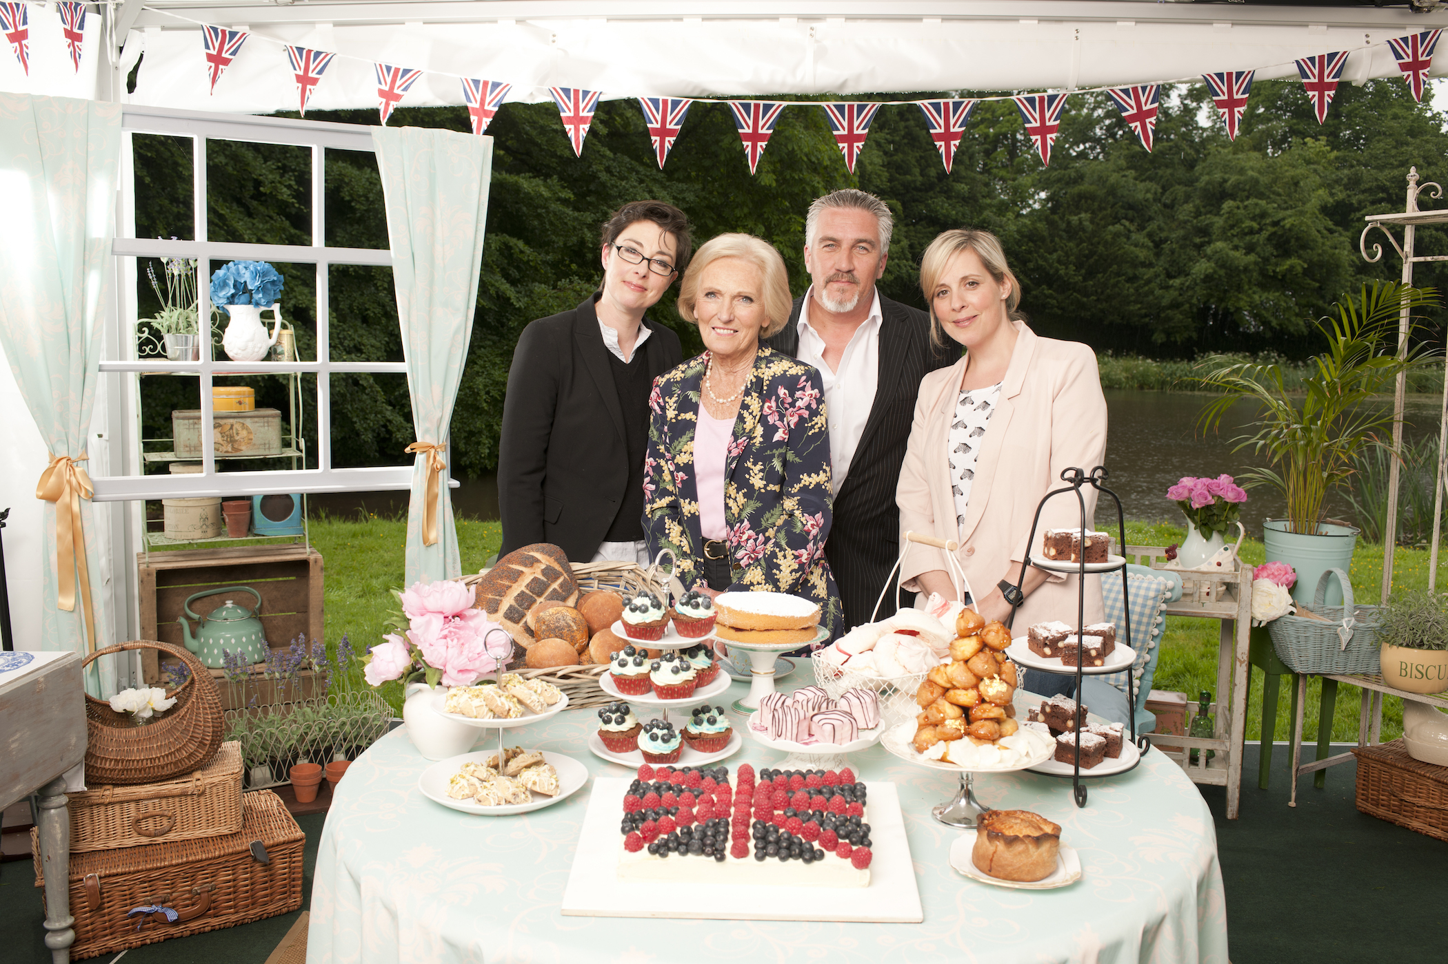
THE GREAT BRITISH BAKING SHOW: L to R, Sue Perkins, Mary Berry, Paul Hollywood and Mel Giedroyc. Courtesy of Love Productions.
ARLINGTON, VA -- THE GREAT BRITISH BAKING SHOW, the delectable baking competition that has grown into a beloved international phenomenon, returns for a fifth season this summer, premiering Fridays at 9pm beginning June 22 (check local listings) on PBS. Featuring the original cast of Mary Berry, Paul Hollywood, Sue Perkins and Mel Giedroyc, this season has never before been seen in the U.S.

Once again, viewers will meet twelve of Britain’s best amateur bakers who will don their aprons, enter the iconic tent and tackle culinary trials that increase in difficulty as the competition unfolds. Vying to be crowned star baker, challengers prepare three creations in each episode: a signature bake, which tests their creative flair and baking ability; the devilishly difficult technical challenge, in which contestants have to bake creations using only ingredient lists and minimal instruction; and finally the showstopper, designed to fully showcase each baker’s skill and creativity.

Contestants face the demanding but endearing judges Mary Berry and Paul Hollywood, two icons of British baking who are now household names in America. Comedy duo Sue Perkins and Mel Giedroyc are the series hosts, providing the bakers with much-needed emotional support and comic relief. Offering viewers the perfect sweet summer escape, Season 5 features unforgettable contestants attempting some of the series most difficult challenges, from bagels to strudel, treacle tarts to choux gateaus.

Season 5 will be available to stream the morning after broadcast on PBS.org. It will also be available on PBS station-branded digital platforms such as ROKU, Apple TV and Google Chromecast, as well as on PBS iPad and iPhone apps. All four previous seasons of THE GREAT BRITISH BAKING SHOW are available via Passport, a benefit for local PBS station donors, offering extended access to a rich library of public television programming (contact your local PBS station for details). All ten episodes will also be available for binge-viewing on Passport on premiere night, June 22. Throughout the season, fans can visit PBS Food to learn more about the contestants and get exclusive content from the program.

Known as “The Great British Bake Off” in the U.K., the show is produced by the award-winning Love Productions and was created by Anna Beattie and Richard McKerrow. Executive producers for Season 5 are Kieran Smith and Anna Beattie, the series director is Scott Tankard and the series producer is Amanda Westwood. For more information, screeners and images, visit the series’ PBS Pressroom page.
About PBS
PBS, with nearly 350 member stations, offers all Americans the opportunity to explore new ideas and new worlds through television and digital content. Each month, PBS reaches over 90 million people through television and 30 million people online, inviting them to experience the worlds of science, history, nature and public affairs; to hear diverse viewpoints; and to take front row seats to world-class drama and performances. PBS’ broad array of programs has been consistently honored by the industry’s most coveted award competitions. Teachers of children from pre-K through 12th grade turn to PBS for digital content and services that help bring classroom lessons to life. Decades of research confirms that PBS’ premier children’s media service, PBS KIDS, helps children build critical literacy, math and social-emotional skills, enabling them to find success in school and life. Delivered through member stations, PBS KIDS offers high-quality educational content on TV – including a 24/7 channel, online at pbskids.org, via an array of mobile apps and in communities across America. More information about PBS is available at www.pbs.org, one of the leading dot-org websites on the internet, or by following PBS on Twitter, Facebook or through our apps for mobile and connected devices. Specific program information and updates for press are available at pbs.org/pressroom or by following PBS Pressroom on Twitter.
About PBS Food
PBS is the original home of cooking and still offers the very best in food and cooking. From A Chef’s Life to Lidia Celebrates America to The Great British Baking Show, PBS programs and chefs have received more Peabody Awards, Daytime Emmy® Awards and James Beard Foundation Awards than any other network. Viewers can explore more deeply on the award-winning PBS Food site (pbs.org/food), which brings together the best food and cooking content from across public television with award-winning digital videos, recipes, articles and more.

– PBS –

Contacts:

Michae Godwin Mary Lugo / Cara White
PBS CaraMar, Inc.
703-739-8483 770-623-8190; 843-881-1480
mmgodwin@pbs.org lugo@negia.net; cara.white@mac.com

For images and additional up-to-date information on this and other PBS programs, visit PBS PressRoom at pbs.org/pressroom.

