GREAT YELLOWSTONE THAW Showcases Animal Survival
During the Region’s Toughest Spring

– Part of PBS’ “Summer of Adventure,” the BBC and PBS Co-Production Will Premiere June 21 –

ARLINGTON, VA; MAY 11, 2017 – Starting June 21, PBS viewers have the chance to witness one of the greatest seasonal changes on planet Earth in the stunning new three-part series GREAT YELLOWSTONE THAW, co-produced with BBC and airing Wednesdays, June 21-July 5, 9:00-10:00 p.m. ET (check local listings). Watch a clip here.
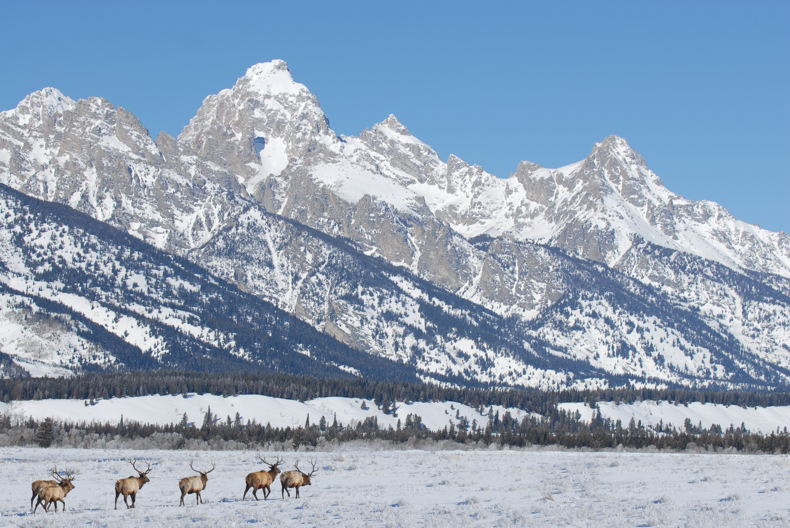

Bull elk migrating through the snow in Grand Teton National Park. Courtesy of Kirk Geisler/shutterstock.com

Bull elk migrating through the snow in Grand Teton National Park

Filmed over the course of several intense months, from deep winter to early summer, the series intercuts the stories of several different animal families—including wolves, bison, grizzlies, beavers and great gray owls. The series follows the animals in the Yellowstone ecosystem as they emerge from winter’s cold and adapt to an early spring thaw, before encountering the soaring summer temperatures. From winter to summer, Yellowstone’s temperature typically swings 140 degrees.

Dr. Kirk Johnson, Sant Director of the Smithsonian National Museum of Natural History and a renowned paleontologist and author, hosts the series. Johnson and a team of Yellowstone experts explore how these animals fend off floods, starvation, and fires, as well as the area’s extreme evolution from cold to heat during the spring season. GREAT YELLOWSTONE THAW showcases the extraordinary survival instincts the park’s natural species possess. Viewers will learn how the early thaw brings the bears of the Rocky Mountain region out of hibernation prematurely, creating concern over food supply. The wolves, which have recovered from their extinct status in the 1990s, are now beginning to thrive, but the fluctuating temperatures pose a threat to the species once again. While the beavers have to make their homes in freezing rivers, the great gray owls must migrate to find food in thawed areas in order to survive.

“We are thrilled to have Dr. Kirk Johnson return to PBS to share with viewers the amazing adaptability of these animals in an often brutal environment,” said Beth Hoppe, Chief Programming Executive and General Manager, General Audience Programming, PBS. “As part of our ‘Summer of Adventure’ line-up, this series highlights the dramatic and inspirational animal stories in a location that all Americans know, but very few know intimately.”

GREAT YELLOWSTONE THAW will be available for streaming the morning after broadcast on PBS station-branded digital platforms such as ROKU, Apple TV and Google Chromecast, as well as on PBS iPad and iPhone apps.

GREAT YELLOWSTONE THAW is part of a multi-title co-production deal among PBS, BBC and BBC Worldwide North America. This partnership ensures a pipeline of the high-quality, entertaining factual programs that PBS and BBC audiences have come to expect.

GREAT YELLOWSTONE THAW is part of “PBS Summer of Adventure,” taking viewers and their families on an adventure around the world this season. The line-up of history, science and natural history programming includes the six-part series THE STORY OF CHINA, an exploration of China’s 4,000-year history featuring Michael Wood, beginning June 20. The five-part program BIG PACIFIC, starting June 21, reveals the Pacific Ocean’s most guarded secrets. Following BIG PACIFIC on June 21, GREAT YELLOWSTONE THAW is a three-part series showcasing the stories of different animal families as they attempt to survive the toughest spring on Earth. On July 12, the three-part NATURE’S GREAT RACE explores the most astounding migrations on earth. RARE – CREATURES OF THE PHOTO ARK, beginning July 18, follows National Geographic photographer Joel Sartore in three episodes as he documents the world’s species at risk of extinction. WEEKEND IN HAVANA is a one-hour walking tour through Cuba on July 18. On August 2, IRELAND’S WILD COAST takes viewers on a one-hour journey along the island’s rugged Atlantic coast. PBS KIDS will also feature special “Summer of Adventure" children’s programming.
About Dr. Kirk Johnson
Dr. Kirk Johnson is the Sant Director of the Smithsonian National Museum of Natural History. He oversees more than 460 employees and a collection of more than 145 million objects—the largest collection at the Smithsonian.

Johnson is a paleontologist who has led expeditions in 11 countries and 19 states that resulted in the discovery of more than 1,400 fossil sites. His research focuses on fossil plants and the extinction of the dinosaurs. He is known for his scientific books and articles, popular books, museum exhibits, presentations, and collaborations with artists. In 2010-11, he led the Snowmastodon Project, the excavation of an amazing ice age site near Snowmass Village, Colorado. This dig recovered more than 5,400 bones of mammoths, mastodons and other ice age animals and was featured in the NOVA documentary, Ice Age Death Trap, and in Johnson’s book, Digging Snowmastodon, Discovering an Ice Age World in the Colorado Rockies. Johnson received a 2016 Kavli Science Journalism Award for his role as host of the three-part NOVA series Making North America, which aired on PBS networks in November 2015. His newest book, Ancient Wyoming, explores the prehistory and geology of the Bighorn Basin.

Johnson has a bachelor’s degree in geology and fine art from Amherst College, a master’s degree in geology and paleobotany from the University of Pennsylvania and a doctorate in geology and paleobotany from Yale University. He completed postdoctoral research at the University of South Australia and served as a Crosby lecturer at the Massachusetts Institute of Technology.

About BBC
The BBC has an unrivalled global reputation for the factual content it produces across arts, history, documentaries and natural history, and broadcasts some 7,000 hours of high-quality, distinctive factual programs a year on television. The BBC is recognized as an industry leader in terms of innovation, consistently pushing the boundaries of its productions, delivered to our audience by the most engaging and inspirational experts.

About PBS
PBS, with nearly 350 member stations, offers all Americans the opportunity to explore new ideas and new worlds through television and digital content. Each month, PBS reaches nearly 100 million people through television and nearly 28 million people online, inviting them to experience the worlds of science, history, nature and public affairs; to hear diverse viewpoints; and to take front row seats to world-class drama and performances. PBS’ broad array of programs has been consistently honored by the industry’s most coveted award competitions. Teachers of children from pre-K through 12th grade turn to PBS for digital content and services that help bring classroom lessons to life. Decades of research confirms that PBS’ premier children’s media service, PBS KIDS, helps children build critical literacy, math and social-emotional skills, enabling them to find success in school and life. Delivered through member stations, PBS KIDS offers high-quality educational content on TV – including a new 24/7 channel, online at pbskids.org, via an array of mobile apps and in communities across America. More information about PBS is available at www.pbs.org, one of the leading dot-org websites on the internet, or by following PBS on Twitter, Facebook or through our apps for mobile and connected devices. Specific program information and updates for press are available at pbs.org/pressroom or by following PBS Pressroom on Twitter.

– PBS –

For additional information, photos, interviews and more, contact:

Michae Godwin / Colleen Flanagan, PBS
mmgodwin@pbs.org / crflanagan@pbs.org
703-739-8483 / 703-739-8130

John Michael Kennedy / Chelsey Saatkamp, Goodman Media for PBS
PBSYellowstone@goodmanmedia.com; 212-576-2700

Deborah Schonfeld / BBC Worldwide North America
Deborah.schonfeld@bbc.com; 212-705-9498

For more information on this and other PBS programs, visit PBS PressRoom at pbs.org/pressroom.

