PBS and National Geographic Studios Join Forces in the New Series THE GREEKS, a Unique Exploration of What Made the Ancient Greeks Great

– Learn How the Ancient Greeks’ Remarkable Legacy Lives on to This Day –

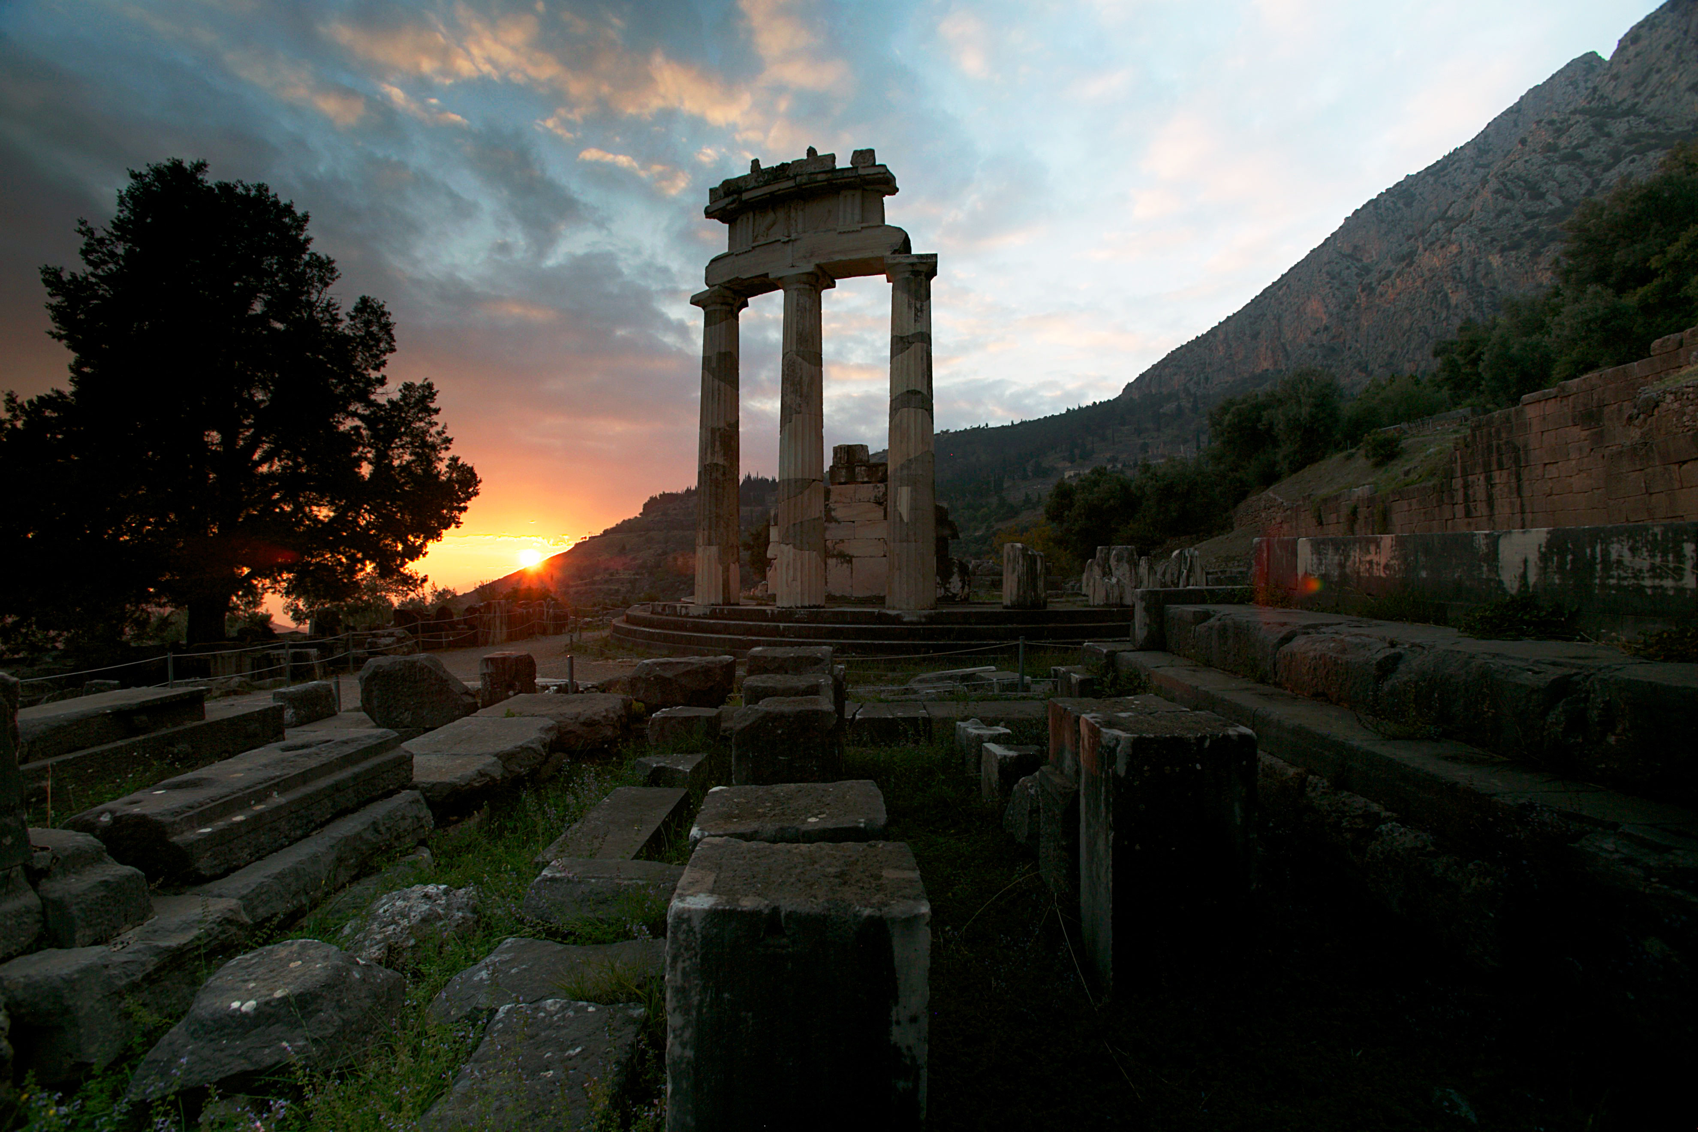
Sun sets behind the Temple of Athena at Delphi.
Credit: Jonathan Meyer
WASHINGTON, DC; May 1, 2106 – THE GREEKS, the highly anticipated new three-part miniseries tracing the innovations and legacy of an extraordinary people, airs nationally on PBS, starting June 21, 2016, at 9:00 p.m. ET (check local listings). In this landmark event from National Geographic Studios, historians and archaeologists, actors and athletes, scientists and artists launch a groundbreaking exploration of the ancient Greeks’ journey — not just to better understand their past, but to discover how their legacy illuminates our present, and will shape our future. From the origins of Western civilization to the first democracy to models of art, architecture and philosophy that are still mimicked today, the story of THE GREEKS is the story of us.

“This was a time and a place when there was a collision of ideas and inspiration and influence that resulted in a truly extraordinary culture,” says author and historian Bettany Hughes, a research fellow at King’s College London and one of more than a dozen scholars featured in the series. “They were working out the best way to be human, the best way to live in the world, and that’s an idea that is as strong now as it was when it was conceived 25 centuries ago.”

They were born of white rock and blue sea. They invented democracy, distilled logic and reason, wrote plays to plumb the deepest recesses of the soul and captured the perfection of the human form in athletics and art. “Any civilization that expresses curiosity among its citizenry — that is a civilization that will lead the world,” says astrophysicist Neal deGrasse Tyson, director of the Hayden Planetarium.

Quite simply, the Greeks created our world. Today, of course, Greece conjures very different images — civic unrest, financial meltdowns, long ATM lines. But as its ancient history attests, strife and discord are often incubators for greatness. Starting out as hunter-gatherers in harsh, unforgiving landscapes and rising to face off against the greatest empire the world had ever known, the Greeks would overcome incredible odds to pave the way for the modern West.

“This series has been over 3,000 years in the making,” says executive producer Jared Lipworth. “Seeing how the ancient Greeks evolved, how much they accomplished, and how their legacy has lasted, we start to realize what a spectacular civilization they created. Their Golden Age was fleeting by historical standards, but their influence is still massive all these centuries later.”

“We are still the intellectual children of Greek thought, of Greek ideas,” continues archaeologist and historian Patrick Hunt of Stanford University. “The idea that everyone has a voice and should be heard — this is something that we’re directly in debt to Greece for. Greece lives on in every person who casts a vote in a ballot box, anywhere in the world.”

Shot in 4K across multiple continents, each episode of THE GREEKS presents a crucial chapter in their epic journey:

Cavemen to Kings − Uncover the stunning origin story of the Greeks — from primordial hunter-gatherers struggling to survive on the rocky Greek mainland to savvy seafarers pioneering new trade networks across the Mediterranean Sea. Thousands of years before Greece’s Golden Age, inhabitants were already creating new forms of art and architecture; establishing the first writing system in Europe; building kingdoms of unprecedented wealth — the first draft of Western civilization. Though their society would meet a spectacular end — the greatest collapse in human history — the early Greeks ultimately laid the groundwork for the revolution in human thought that was to come.
Premieres Tuesday, June 21, 2016, 9:00-10:00 p.m. ET

The Good Strife − In the wake of the Bronze Age collapse, Greek civilization entered a crippling dark age. But with centralized monarchies out of the way, a new type of society was given the chance to rise from the ashes — built not by kings from the top down, but by individuals from the bottom up. Through centuries of strife, or perhaps because of them, this disparate group of people, bound by a common language, epic stories of heroic ancestors, a shared belief in the gods and an insatiably competitive spirit, delivered some of humanity’s greatest achievements — from the first Olympic Games to early theories of nature to an entirely new system of government: democracy.
Premieres Tuesday, June 28, 2016, 9:00-10:00 p.m. ET

Chasing Greatness− Democracy. Drama. Philosophy. It’s the ancient Greece we think we know — the bright shining moment that gave rise to Western civilization. But it almost didn’t happen at all. Follow in the footsteps of the Greeks who fought against the odds to deliver this Golden Age — from their extraordinary defeat of the Persian Empire to their construction of the Parthenon. And see how they let it all slip through their fingers.
Premieres Tuesday, July 5, 2016, 9:00-10:00 p.m. ET

From the streets of debt-stricken Athens to the steps of the U.S. Supreme Court, the epic story of ancient Greece’s rise and fall helps us understand the challenges we currently face and, perhaps, points the way toward a better future.

As a companion to the television series, NG Studios is also producing an innovative 10-part digital series titled The Greek Guide to Greatness, which explores the connections between ancient Greece and America today. The series will be available through PBS.org. The National Geographic Society Museum will also be featuring The Greeks: Agamemnon to Alexander The Great, an exhibition celebrating 5000 years of Hellenic history and culture and featuring more than 500 Greek artifacts, many of which have never left Greece before. The exhibit opens June 1, 2016.

The Greeks was made possible by a major grant from the National Endowment for the Humanities. Additional funding was provided by the Arthur Vining Davis Foundations; the National Hellenic Society; Peter and Adrienne Barris; The Behrakis Foundation; Peter L. Corsell; Dean and Monique Dakolias; Ted and Lynn Leonsis; The Marcus Family Foundation; The Metropoulos Family; Michael and Virginia Mortara Foundation; John Pappajohn; Peter and Diane Pappas; George and Georgia Stamas; Kathryn Kithas Stewart and Robert Stewart and the Agnes Varis Trust.

Premiere Dates: June 21, June 28, July 5 at 9:00 p.m. ET (check local listings)
Producer/Writer/Director: Chad Cohen
Co-Producers: Matt Hill and Chris Dye
Editors: Arthur Binkowski and Salvatore Vecchio
Director of Photography: James Ball and Stefan Wiesen
Narrator: Toby Leonard Moore
Executive Producer: Jared Lipworth
Producer: National Geographic Studios

About National Geographic Studios
National Geographic Studios (NG Studios) is known around the world for its remarkable visuals and compelling stories. For 50 years, NG Studios has been producing groundbreaking documentary films, starting with the 1963 program “Americans on Everest,” which presented the first moving pictures from the summit of Everest to ever be broadcast on American network television. Since then, NG Studios has continued to push filmmaking technology to its limits, bringing great stories to television audiences worldwide. NG Studios is the winner of 146 Emmy Awards and nearly 1,000 other industry accolades, including Peabody Awards, duPont-Columbia Awards and top honors from natural history film festivals around the world. Its programming appears on the National Geographic Channel, Nat Geo WILD and on PBS stations in the United States, and internationally on National Geographic Channels International, Nat Geo WILD, and Mundo as well as on terrestrial and other cable and satellite broadcasters. Its latest hit is the Emmy-nominated “Brain Games.” Founded in 1888 to “increase and diffuse geographic knowledge,” the National Geographic Society works to inspire people to care about the planet. To date, National Geographic has funded more than 10,000 scientific research, conservation and exploration projects, and supports education programs promoting geography literacy.
About PBS
PBS, with 350 member stations, offers all Americans the opportunity to explore new ideas and new worlds through television and online content. Each month, PBS reaches nearly 100 million people through television and nearly 33 million people online, inviting them to experience the worlds of science, history, nature and public affairs; to hear diverse viewpoints; and to take front row seats to world-class drama and performances. PBS’ broad array of programs has been consistently honored by the industry’s most coveted award competitions. Teachers of children from pre-K through 12th grade turn to PBS for digital content and services that help bring classroom lessons to life. PBS’ premier children’s TV programming and its website, pbskids.org, are parents’ and teachers’ most trusted partners in inspiring and nurturing curiosity and love of learning in children. More information about PBS is available at www.pbs.org, one of the leading dot-org websites on the Internet, or by following PBS on Twitter, Facebook or through our apps for mobile devices. Specific program information and updates for press are available at pbs.org/pressroom or by following PBS Pressroom on Twitter.

– PBS –

CONTACTS: Jared Lipworth, National Geographic, 202-775-6189, jared.lipworth@natgeo.com
Kayla Springer, PBS, 703-739-5351, kmspringer@pbs.org

For images and additional up-to-date information on this and other PBS programs, visit PBS PressRoom at pbs.org/pressroom.

