COINCIDING WITH EARTH DAY 50TH ANNIVERSARY, NEW DOCUMENTARY EXPLORES OUR RELATIONSHIP WITH OUR MOST FUNDAMENTAL RESOURCE
REVEALING A GLOBAL WATER CRISIS

Narrated by Kelly McEvers, H₂O, The Molecule That Made Us Premieres Wednesday, April 22 at 9pm ET/8pm Central on PBS

pbs.org/molecule
#MoleculePBS

BOSTON – As we usher in the 50th anniversary of Earth Day, a new documentary dives deep into one of the most critical issues affecting our planet: our supply of fresh water. At once indispensable and invisible in daily life, water is often taken for granted. Yet, competition for, and the cost of, water is rising to epic levels, as filmmakers show us in H₂O, The Molecule That Made Us, a special three-part broadcast and digital series from WGBH Boston for PBS, premiering on April 22, 2020 and airing for three consecutive Wednesdays. The series will also be available to stream at pbs.org/molecule and the PBS Video App.

A decade from now, the World Economic Forum projects we’ll need 40 percent more water than we do today. “Water is our most fundamental resource, yet we don’t really understand it,” observes narrator Kelly McEvers, the award-winning NPR journalist and host of the popular podcast, Embedded. “Over the course of three episodes, viewers learn to think completely differently about our water supply.”

In the emptiness of outer space, Earth is alive because of water. Humanity’s relationship with this simple molecule is everything. H₂O, The Molecule That Made Us dramatically reveals how water underpins every aspect of our existence. Segments from across the planet, intimate documentary and natural history cinematography combine to uncover dramatic discoveries and compelling characters and deliver important stories about this mysterious molecule.

H₂O, The Molecule That Made Us, narrated by NPR journalist Kelly McEvers, premieres Wednesday, April 22, Wednesday April 29 and Wednesday May 6, 2020 at 9pm ET/8C on PBS (check local listings); available for streaming at pbs.org/molecule and the PBS Video App. Viewers can join the conversation online, using #MoleculePBS and view a trailer here.

H₂O, The Molecule That Made Us documents the impact of a shrinking water supply in locations spanning South Africa, Gaza, the U.S. and other parts of the world. In California, extreme droughts have contributed to more frequent and devastating wildfires and the once popular resort community of Salton Sea is a ghost town as a result of its water supply running dry.

“Water is the elixir of life but, as we see in the series, we don’t value water in the way we need to in order to ensure we’ll have enough of it in the future,” comments WGBH’s VP, National Programming and Co-Executive Producer John Bredar. “A young man in Gaza, traversing the city streets to fill a plastic jug, his family’s water supply for the day, explains that no one in Gaza has a 24-hour supply of water. That’s how real the water crisis is.”

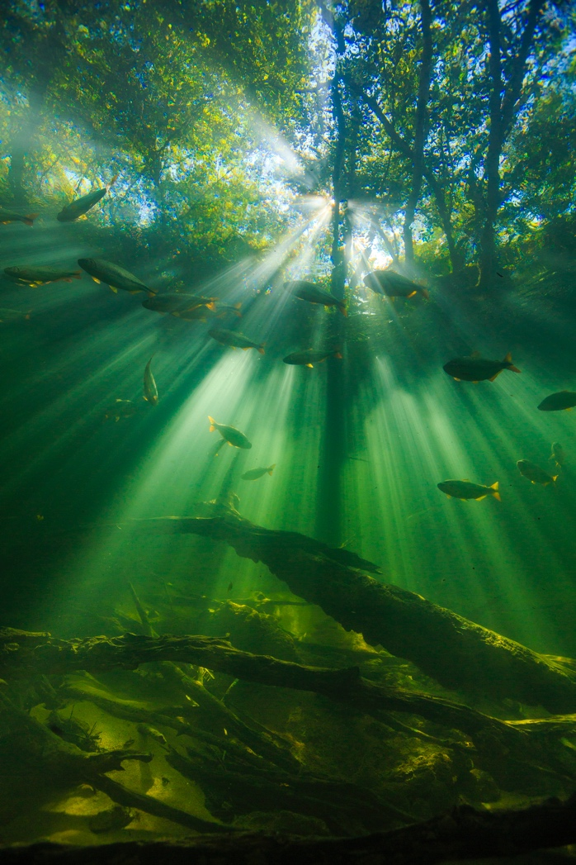
It turns out that the notion of running out of water is not as far-fetched as we may think. In fact, as we learn in H₂O, The Molecule That Made Us, water didn’t exist on Earth in the beginning. Moreover, only one percent of the world’s water today is fresh water and 92% of the world’s water consumption is utilized for growing crops. Water has become big business.

“What really struck me when working on the film was this idea that we can run out of water and that that is already happening in some places,” said WGBH Co-Executive Producer Laurie Donnelly. “Water shortages may feel like a far-away problem but, as we see in new, profound ways in the documentary, water connects all of us – every species across every country, continent and ocean.”

The Nature Conservancy (TNC) is the engagement and outreach partner for H₂O, The Molecule That Made Us. TNC will extend the reach and impact of the digital and broadcast initiative, and bring awareness to the science, perspectives, and solutions of TNC’s work.

“H₂0 from WGBH and Passion Pictures is a smart, engaging project that brings real world issues to PBS viewers,” said Bill Gardner, VP of Programming & Development at PBS. “As the industry leaders in natural history programming that informs and entertains while presenting positive solutions, impact and hope, we’re proud to feature this powerful miniseries as part of our Earth Day lineup.”

“It's been enlightening to chase these water stories around the world -- we now truly appreciate the extent of water's global interconnections with nature, and with the future of our civilization,” says Passion Picture series producer David Allen. “Nothing could be more important than to tell these essential stories. The future of our fresh water feels like something that can be solved.”

H₂O, The Molecule That Made Us Series Highlights:

- Episode 1: PULSE opens on the distant rock and ice of Greenland, where Geologist Stephen Mojzsis reveals a new theory on how water first arrived on Planet Earth. We see a dragonfly’s incredible journey from India to Africa – the world’s longest insect migration. We meet the Munoz family, ‘bloom chasers’, who use cutting edge time-lapse photo rigs to show the rare spectacle of deserts around the world exploding from barren wastelands into rich carpets of flowers. But the pulse of water is under threat.

- Episode 2: CIVILIZATIONS turns our ‘water lens’ on human history. In the jungle of the Congo in Africa, we see a hint of one provocative theory of evolution – Did we learn to walk in water? Starting in Ancient Egypt, it charts the critical role water plays in history, and around the world we see the birth of civilizations on the banks of the great rivers: Nile, Tigris and Euphrates, Indus and Yellow. The question is raised, can we guarantee water supplies that are needed for future existence?

- Episode 3: CRISIS examines how the planet’s changing water cycle is forcing us to change our relationship with water. An increasingly, globalized agricultural industry has become expert at turning precious water reserves into profit, “mining” water faster than it can be replaced. In its conclusion, the series visits locations such as New York City, a surprising model for sustainable water infrastructure, and hope emerges that the water crisis is solvable.

H2O The Molecule that Made Us is produced by WGBH Boston. Executive Producers: John Bredar and Laurie Donnelly. Series Producer: David Allen. Directors: Nicolas Brown and Alex Tate. Producer: Catherine Watling. Outreach and Engagement Partner: The Nature Conservancy. Funding for H2O The Molecule that Made Us is provided through the support of PBS viewers. Major funding for H2O The Molecule that Made Us is provided by: Anne Ray Foundation, Draper, The Arthur Vining Davis Foundations and Lynn Bay Dayton and Bruce C. Dayton.

Contacts:
Allison Salzberg Bara Levin
360PR+ WGBH Boston
617-585-5793 617-300-5391
asalzberg@360pr.plus bara_levin@wgbh.org

©2020 WGBH EDUCATIONAL FOUNDATION

About WGBH
WGBH Boston is America’s preeminent public broadcaster and the largest producer of PBS content for TV and the Web, including Masterpiece, Antiques Roadshow, Frontline, Nova, American Experience, Arthur and more than a dozen other primetime, lifestyle and children’s series. WGBH’s television channels include WGBH 2, WGBX 44, and the digital channels World and Create. WGBH TV productions focusing on the region’s diverse community include Greater Boston, Basic Black and High School Quiz Show. WGBH Radio serves listeners across New England with 89.7 WGBH, Boston’s Local NPR®; 99.5 WCRB Classical Radio Boston; and WCAI, the Cape and Islands NPR® Station. WGBH also is a major source of digital content and programs for public radio through PRX, including The World and Innovation Hub, a leader in educational multimedia with PBS LearningMedia™, providing the nation’s educators with free, curriculum-based digital content, and a pioneer in services that make media accessible to deaf, hard of hearing, blind and visually impaired audiences. WGBH has been recognized with hundreds of honors: Emmys, Peabodys, duPont-Columbia Awards and Oscars. Find more information at wgbh.org.

About PBS
PBS, with more than 330 member stations, offers all Americans the opportunity to explore new ideas and new worlds through television and digital content. Each month, PBS reaches over 120 million people through television and 26 million people online, inviting them to experience the worlds of science, history, nature and public affairs; to hear diverse viewpoints; and to take front row seats to world-class drama and performances. PBS’s broad array of programs has been consistently honored by the industry’s most coveted award competitions. Teachers of children from pre-K through 12th grade turn to PBS for digital content and services that help bring classroom lessons to life. Decades of research confirms that PBS’s premier children’s media service, PBS KIDS, helps children build critical literacy, math and social-emotional skills, enabling them to find success in school and life. Delivered through member stations, PBS KIDS offers high-quality educational content on TV— including a 24/7 channel, online at pbskids.org, via an array of mobile apps and in communities across America. More information about PBS is available at www.pbs.org, one of the leading dot-org websites on the internet, or by following PBS on Twitter, Facebook or through our apps for mobile and connected devices. Specific program information and updates for press are available at pbs.org/pressroom or by following PBS Pressroom on Twitter.

About The Nature Conservancy
The Nature Conservancy is a global conservation organization dedicated to conserving the lands and waters on which all life depends. Guided by science, we create innovative, on-the-ground solutions to our world's toughest challenges so that nature and people can thrive together. We are tackling climate change, conserving lands, waters and oceans at an unprecedented scale, providing food and water sustainably and helping make cities more sustainable. Working in 79 countries and territories, we use a collaborative approach that engages local communities, governments, the private sector, and other partners. To learn more, visit www.nature.org or follow @nature_press on Twitter.
About Passion Pictures
Passion Pictures has a thirty year history of exceptional story-telling with feature documentary productions that include: The Imposter, Listen to me Marlon, Eric Clapton, Andy Murray and the Academy-Award winning films: One Day in September and Searching for Sugar Man. Passion Planet, led by multi-Emmy Award winner David Allen, is known for authored narratives like My Life as a Turkey and The Octopus in My House, and landmark factual series like the PBS’s six-part series Earth: A New Wild.

