


28th ANNUAL HISPANIC HERITAGE AWARDS, PRESENTED BY TARGET, TO BE BROADCAST NATIONALLY OCTOBER 9TH ON PBS

Legendary Actress and Singer Rita Moreno to Host Ceremony on September 17th At Washington D.C.’s Historic Warner Theatre

- The 2015 Hispanic Heritage Award Honorees To Be Announced Shortly -

WASHINGTON, DC – The Hispanic Heritage Foundation announced today that the 28th Annual Hispanic Heritage Awards, presented by Target, will take place on September 17th at the Historic Warner Theatre and broadcast October 9th on PBS during Hispanic Heritage Month. Legendary actress, singer and previous Hispanic Heritage Award Honoree Rita Moreno will host the program and perform.

“The Hispanic Heritage Foundation is proud to partner with Target to honor yet another inspiring group of Latino leaders with our prestigious Hispanic Heritage Award and we are thrilled to be back on PBS to share our cultural pride, accomplishment and great promise with all of America,” said Jose Antonio Tijerino, President and CEO. “We are especially excited about this year’s celebration because it will be hosted by a past Hispanic Heritage Award recipient, Board Member and friend – the incomparable Rita Moreno. The evening will certainly be entertaining, meaningful and inspirational.”

The 2015 Hispanic Heritage Awards Honorees in categories such as Education, Arts, STEM (Science, Tech, Engineering, and Math), Sports, Innovation, Healthcare, Legend and Inspira for youth will be announced later this month with additional show details.

“PBS and our member stations are committed to offering programming that celebrates the diverse communities we serve, so we are thrilled to broadcast the Hispanic Heritage Awards for a second year,” said Paula Kerger, President and CEO of PBS. “The Hispanic Heritage Awards highlight the important contributions Latino Americans make to our nation, and we look forward to honoring this new group of 2015 award recipients.”

The Hispanic Heritage Awards were established in 1987 by President Ronald Reagan to commemorate the creation of Hispanic Heritage Month in America. Since that time, the Hispanic Heritage Awards are considered among the highest honors for Hispanics by Hispanics. Categories for the 2015 Awards include Arts, Vision, Legend, Sports, STEM (Science, Technology, Engineering, and Math), Leadership, Education, Inspira and more. Top Latino performers and personalities will pay tribute to the Honorees from the stage. The Awards are unique in that celebrities take the stage along with educators, innovators, community and business leaders, elected officials, and others. The Awards are supported by nearly 40 national Hispanic-serving institutions who co-host the program.

Past Honorees have included Juan Luis Guerra, Rita Moreno, Placido Domingo, Celia Cruz, Antonio Banderas, Tito Puente, Anthony Quinn, Carlos Gutierrez, Juan Marichal, Los Tigres Del Norte, Ricky Martin, Juanes, Ruben Blades, Jose Feliciano, Isabel Allende, Alejandro Sanz, Oscar de la Hoya, America Ferrera, Gloria Estefan, Martin Sheen, Andy Garcia, Carlos Vives, and Zoe Saldana, among many others.

The Awards serve as a launch of HHF’s year-round award-winning programs which inspire, identify, prepare and position Latino leaders in the classroom, community and workforce to meet America’s priorities in the STEM, finance, education, media, and innovation fields. HHF is a 501(c)(3) nonprofit organization. For more information on the year-round, high-impact programs and work of HHF, including the Hispanic Heritage Awards, visit www.hispanicheritage.org.

PBS, with over 350 member stations, offers all Americans the opportunity to explore new ideas and new worlds through television and online content. Each month, PBS reaches more than 103 million people through television and over 33 million people online, inviting them to experience the worlds of science, history, nature and public affairs; to hear diverse viewpoints; and to take front row seats to world-class drama and performances. PBS’ broad array of programs has been consistently honored by the industry’s most coveted award competitions. Teachers of children from pre-K through 12th grade turn to PBS for digital content and services that help bring classroom lessons to life. PBS’ premier children’s TV programming and its website, pbskids.org, are parents’ and teachers’ most trusted partners in inspiring and nurturing curiosity and love of learning in children. More information about PBS is available at www.pbs.org, one of the leading dot-org websites on the Internet, or by following PBS on Twitter, Facebook or through our apps for mobile devices. Specific program information and updates for press are available at pbs.org/pressroom or by following PBS Pressroom on Twitter.

Take A Look Back At The 2014 Hispanic Heritage Awards Here:

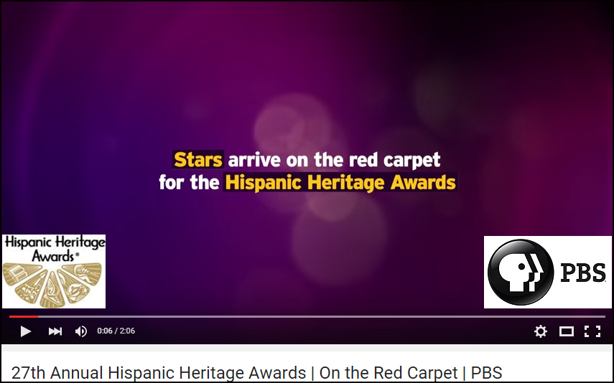

For more information on the 2015 Hispanic Heritage Awards or to request media credentials,
please contact John Reilly at 212.878.5076 / jreilly@rogersandcowan.com
or Nordhia Centeno at 310.854.8284/ ncenteno@rogersandcowan.com

###

