News Release – September 18th, 2017 -Photos & Sample Acceptance Remarks Included
(Many Additional High Res Photos/Full Remarks Available by Request. All Photos: Margarita Corporan Photography, unless noted)




THE 30TH HISPANIC HERITAGE AWARDS PRESENTED BY TARGET Took Place September 14th At The Warner Theatre In Washington DC
– Look For The National PBS Broadcast Special on October 6th –

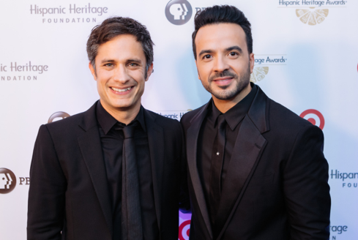
Honorees Gael García Bernal and Luis Fonsi on the Red Carpet (All Photos, Credit: Margarita Corporan Photography)

Honorees: Latin Music Superstar Luis Fonsi,
Gael García Bernal – Star Of Pixar’s Upcoming “COCO”
Members of the Nation’s “DREAMER” Community
NASCAR’s Groundbreaking Alba Colón, Coca-Cola’s Rudy Beserra
And The Latin Recording Academy

“It’s no secret that we are living one of the most difficult periods in this country… Unity, inclusion or acceptance no longer seem to be a priority in the agenda and yet, one song… in Spanish…, broke all the barriers, across all cultures, languages and ages… I want to dedicate this award to my biggest inspiration, mi orgullo and the most beautiful place in the world PUERTO RICO. Just like Texas, the Caribbean Islands and Florida, places in Puerto Rico like Culebra, Loiza and so many other areas have been deeply affected by the Hurricanes, and they desperately need our help. I take this opportunity to kindly ask you to donate and help those in need. It is our duty” – Luis Fonsi, Trailblazer Award (Sample Acceptance Remarks)

“Our undocumented community comes from across the world - we’re Latino, Asian, Arab and Black. We’re queer, we're trans, we're straight. And with or without DACA, we will continue to fight to survive and thrive in this country we call home. We will do so because we descend from a lineage of fighters and survivors - and we are here to stay… As we fight for our rights as immigrants, let’s remember the sacrifices our parents made so that we could become paramedics, lawyers, artists, scientists, and teachers. Let’s also remind others that we contribute greatly to the cultural and economic growth of the country. And finally, let us be activists by calling our elected officials and mobilizing the community.” – DREAMERS, Inspira Award

“I want to dedicate this award to these people [in] peril that take their future into their hands, and go forth and look for a right that is undeniable to any human being, which is just to be better. And to be better means better in a community. …to aim for the common good. This is a big shout out to all the Dreamers, all the people, all the young kids that… that are in this very critical situation because … it is unlike it’s ever been… There is an irrational mythology, an irrational fabricated idea that we are rapists, that we are criminals, drug traffickers… it’s very difficult to counteract that irrational ideology with rational thought. What we have to do is to manifest ourselves in every shape and form. Absolutely. Not be afraid. Be empowered. Be contestatarians. Those little guys who are fighting for the right to stay here in this country… Really! Speak out. …I want to talk on behalf of everyone in Mexico, to you guys is that no matter where you’re from, no matter from where your parents came to the United States, or your grandparents, or your great-grandparents came to the United States, or why you came to the United States. It doesn’t matter. We, as Mexicans, we have to offer you the possibility to feel that Mexico is your home, as well… The Ancients used to say, ‘wherever you feel good, that is your home.’ Well, I promise you that my intention is to make you feel good in Mexico ..and that you also consider that a home if you want to come visit, if you want to come live there. We need you. We need you more than ever.” - Gael García Bernal, Vision Award (Sample Acceptance Remarks)

Performances From: Luis Fonsi Singing “Despacito,”
Latin Grammy Winners Concha Buika and Gaby Moreno,
‘Miami’s Best Latin Band’ Locos por Juana,
And Acclaimed Pianist Llewellyn Sanchez-Werner

Hosts: Alicia Sanz & Frankie J. Alvarez. Presenters: Civil Rights Icon Dolores Huerta, iHeart Radio DJ Enrique Santos, Author Anand Giridharadas, Actor J.W.Cortés,
Actresses Veronica Falcón, Rosal Colon And Karina Ortiz, WWE Superstar Kalisto,
YouTube Influencer Jackie Hernandez And More

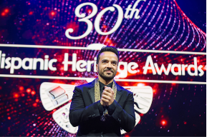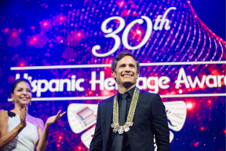
(L) Luis Fonsi honored with Trailblazer Award. (R) Gael García Bernal honored with Vision Award

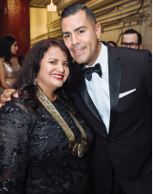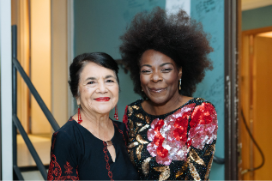
(L) STEM Award Honoree Alba Colon & J.W.Cortés. . (R) Dolores Huerta & Concha Buika

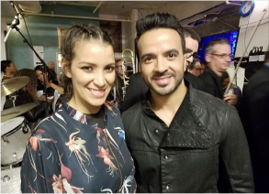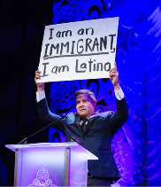
(L) Gaby Moreno & Luis Fonsi-Photo: J. Reilly. (R) HHF President & CEO José Antonio Tijerino.

“I developed my love for STEM related disciplines at a very young age. I was fortunate to have two loving parents who told me I could be whatever I wanted. My dreams were big and I knew nothing could stop me if I worked hard, lived with INTEGRITY, HONESTY and used patience to get where I wanted to be. And that is exactly what I did… It is my hope that through my work I can continue to serve as an example and leader for YOUNG WOMEN and HISPANICS to dream big and to challenge the stereotypes surrounding jobs in STEM career fields. In closing, I want to echo once again how special this honor is to me. I am VERY PROUD OF MY HERITAGE and I would not have wanted to journey through this life any other way. By working together and celebrating the beauty of our heritage and who we are…WE CANCHANGE THE WORLD”
- Alba Colón, STEM Award (Sample Acceptance Remarks)

“My gratitude goes out to the Hispanic Heritage Foundation. Thank you for presenting this important and significant award to an institution I love and represent. Eighteen years ago, The Latin Recording Academy launched the Latin GRAMMY Awards to showcase the extraordinary work of Latin musicmakers in the United States and around the world. Today they are the premier showcase for the diversity, relevance and excellence of Latin music. In addition to its worldwide cultural impact, Latin music is a source of enormous pride here in the U.S., especially now, as events threaten to affect the lives of all of us who believe in freedom, justice, equality and the pursuit of happiness…. Music is good for humanity; we want to be good for music. Today more than ever, Latin music is a cultural force virtually everywhere. Awards like the one we are receiving today help us enormously as we seek to support and advance it”- Gabriel Abaroa Jr.,
President/CEO of The Latin Recording Academy ARTS Award (Sample Acceptance Remarks)

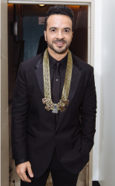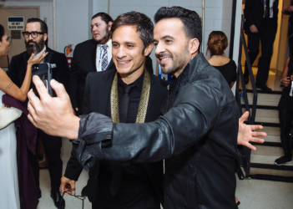
-Awardees Luis Fonsi & Gael García Bernal

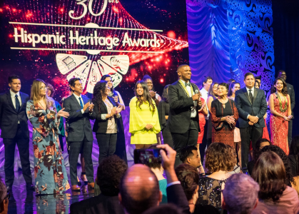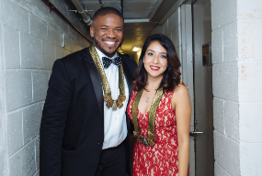
-DREAMER REPRESENTATIVES BEING HONORED

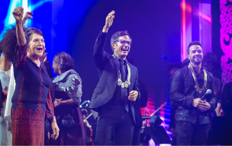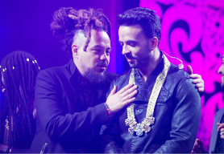
(L) Dolores Huerta, Gael Garcia Bernal & Luis Fonsi. (R) Itawe Correa of Locos por Juana congratulates Luis Fonsi

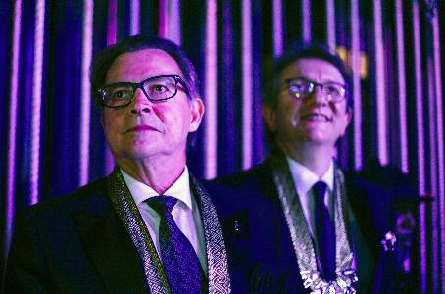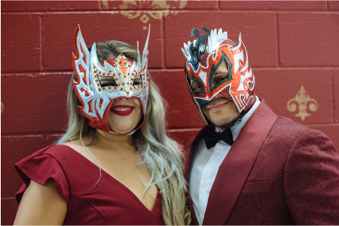
(L) Honorees Rudy Beserra & Gabriel Abaroa, Jr. (R) WWE Superstar Kalisto & his wife Abby

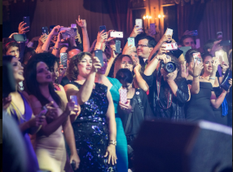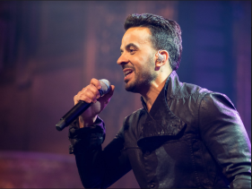
“Despacito” had the entire Warner Theater on its feet- Photos: Yunuen Bonaparte

WASHINGTON, DC – The Hispanic Heritage Foundation’s (HHF) 30th HISPANIC HERITAGE AWARDS PRESENTED BY TARGET took place on September 14th at the historic Warner Theatre in Washington, D.C. The Awards, which were created by the White House in 1987 to commemorate the establishment of Hispanic Heritage Month in America, are among the highest honors by Latinos for Latinos and supported by 40 national Hispanic-serving institutions that co-host the program.

The Hispanic Heritage Awards included top Latino performers and personalities paying tribute to the Honorees from the stage, and will be broadcast nationally on Friday, October 6, 2017, (10:00 p.m. ET) on PBS. The Awards recognize the contributions and accomplishments of leading Latino individuals and organizations in various fields while celebrating cultural pride and the great promise to America

The 2017 Hispanic Heritage Awardees and the Medallion Sponsors include:

The DREAMERS - Inspira Award, sponsored by American Federation of Teachers (AFT)
Luis Fonsi– Special Trailblazer Award, sponsored by TARGET
Gael García Bernal – Vision Award, sponsored by The Walt Disney Company
Rudy Beserra – Leadership Award, sponsored by The Coca Cola Company
The Latin Recording Academy – Arts Award, sponsored by Southwest Airlines, the Official Airlines
Alba Colón: STEM (Science, Technology, Engineering & Math) Award, sponsored by ExxonMobil

Other Medallion Level Sponsors include: Google, T-Mobile the Official Wireless Service Provider, and Friends of the National Museum of the American Latino.

Gold Sponsors include: CVS Health, NASCAR, Aetna Foundation; Silver Sponsors are Johnnie Walker; Crowell Moring; Adobe Foundation; The Libre Institute. Copper Sponsors are CBS, The Marquez Foundation, General Motors, and Compadre Sponsors include: CHCI, MGM Resorts International, Entravision, EsTiempo, Catholic Relief Services, and the U.S. Marines.

“We are extremely grateful to all our sponsors for their support of Hispanic accomplishment, vision and cultural pride,” said Jose Antonio Tijerino, President and CEO, Hispanic Heritage Foundation. “We are also very excited about the amazing line-up of talent that joined us in celebration of Hispanic Heritage Month and the value proposition Latinos offer America.”

The Hispanic Heritage Awards are unique in that educators, physicians, innovators, businesspersons, community leaders, and elected officials stand alongside celebrities and great artists in representing the great value Latinos provide the United States and the globe. Past Honorees have included Supreme Court Justice Sonia Sotomayor, Oscar Hijuelos, Juan Luis Guerra, Ana Gabriel, Rita Moreno, Plácido Domingo, Junot Díaz, Celia Cruz, Antonio Banderas, Tito Puente, Anthony Quinn, Juan Marichal, Los Tigres Del Norte, José Feliciano, Isabel Allende, Pedro Martinez, Alejandro Sanz, Oscar De La Hoya, Pepe Aguilar, Gloria Estefan, Martin Sheen, Andy Garcia, Juanes, Carlos Vives, Eva Longoria, and Zoe Saldana, among many others.

The Hispanic Heritage Awards serve as a launch of HHF’s year-round, award-winning programs which inspire, prepare and connect Latino leaders in the classroom, community and workforce to meet America’s needs in priority fields. HHF is a 501(c)(3) nonprofit organization. For more information on the mission of HHF visit www.hispanicheritage.org.

For more information on the 2017 Hispanic Heritage Awards or to request media credentials,
please contact John Reilly at 212.878.5076 / jreilly@rogersandcowan.com
or Sylvia Bedrosian: sbedrosian@rogersandcowan.com

###

