Celebrate Hispanic Heritage Month with
Special Programs in September and October on PBS

New Programs Include VOCES Documentaries “Building the American Dream” and “Latino Vote: Dispatches from the Battleground,” As Well As the 33rd Annual Hispanic Heritage Awards

ARLINGTON, VA; September 14, 2020 – In honor of Hispanic Heritage Month, PBS will offer a special lineup of new and encore programming celebrating Latinx heritage and culture this September and October, culminating in the broadcast of the 33RD ANNUAL HISPANIC HERITAGE AWARDS.
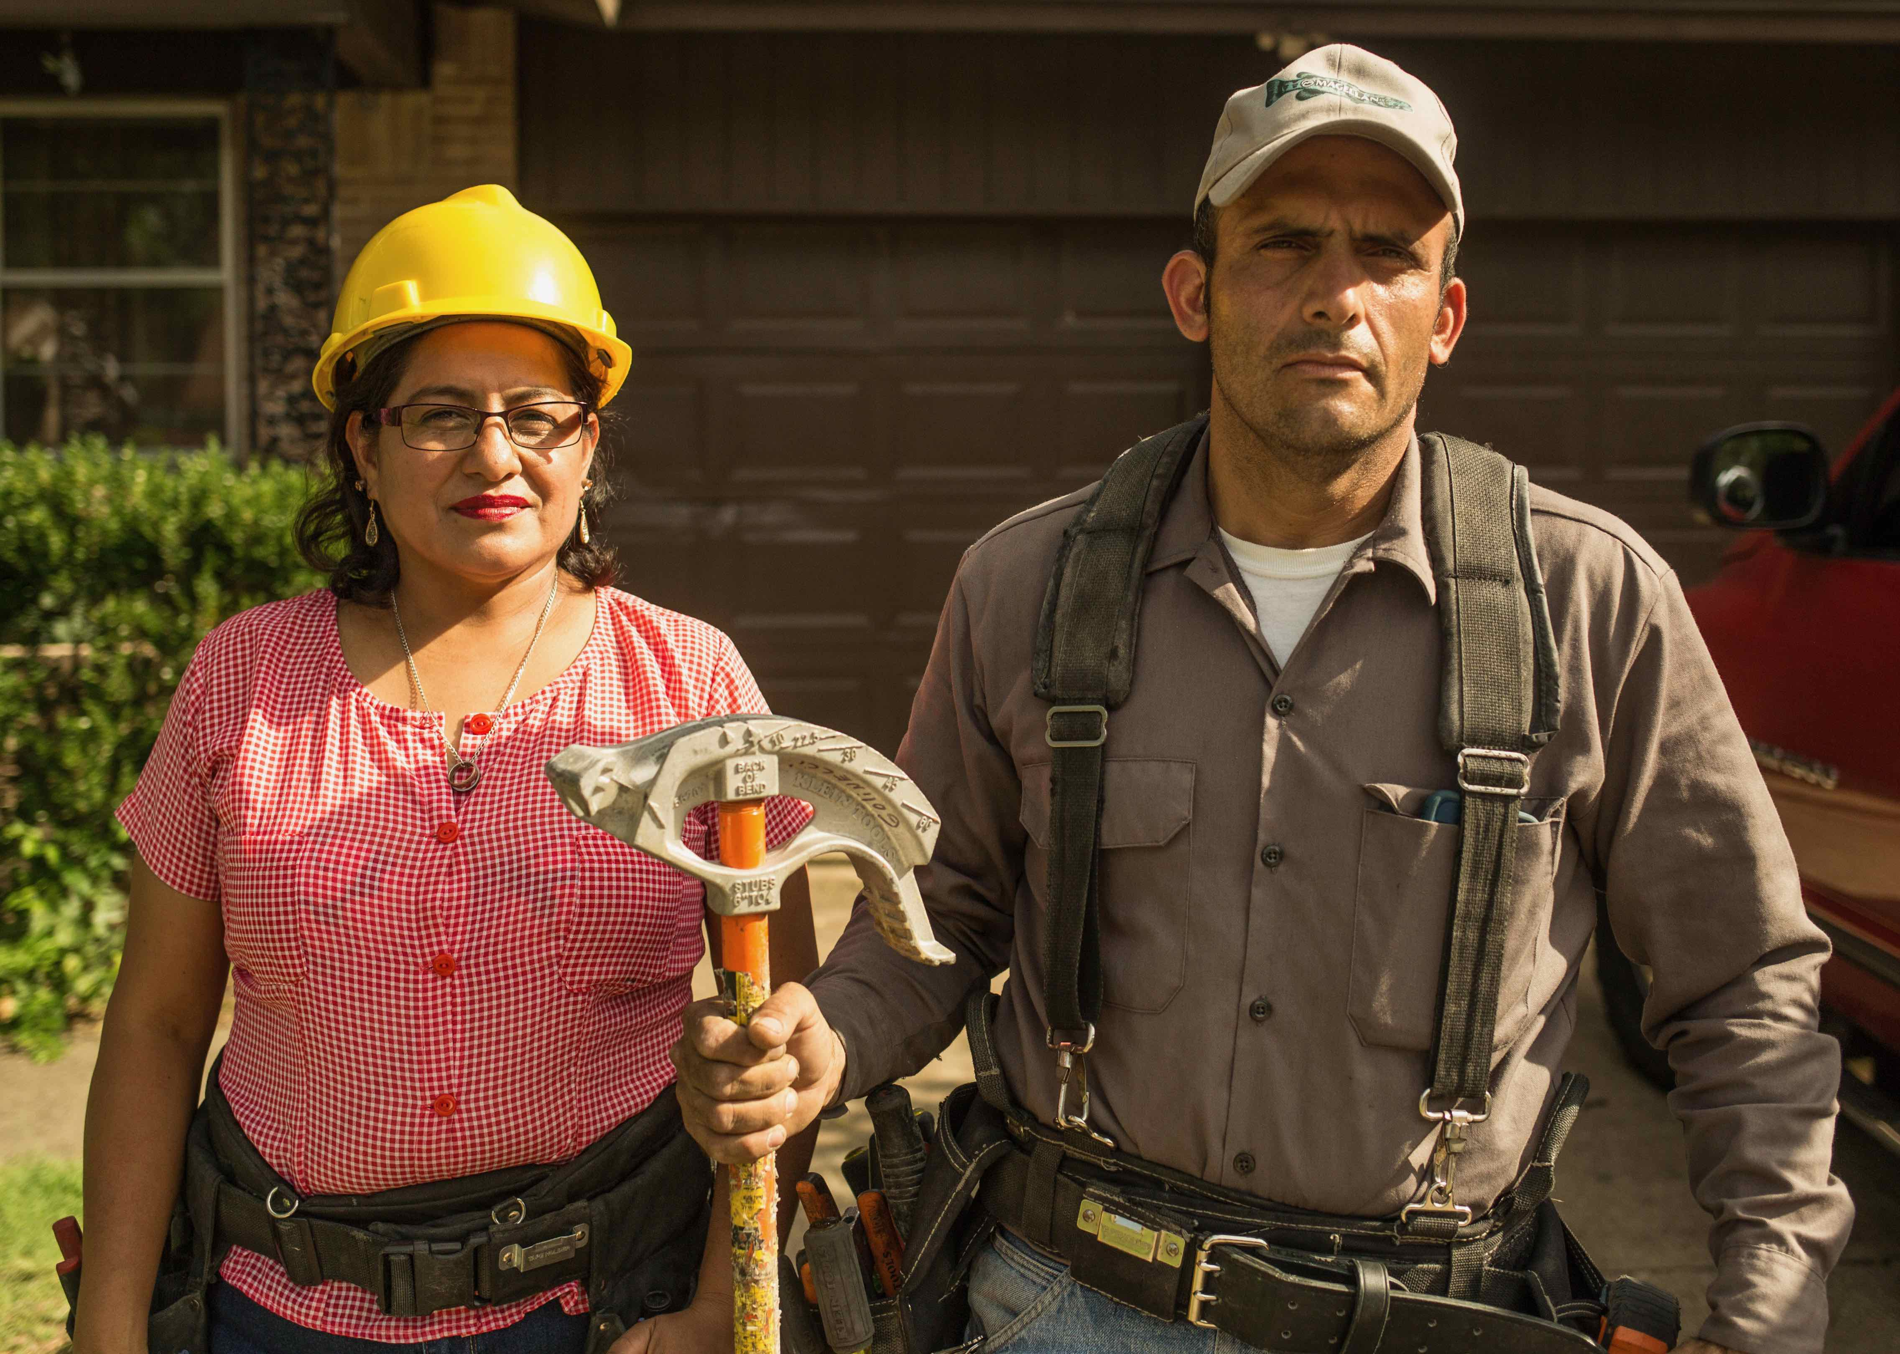
Claudia and Alex, electricians from El Salvador now living in Texas, in “Building the American Dream.” Credit: Moyo Oyelola

VOCES, the acclaimed series that offers the best of Latino arts, culture and history, presents “Building the American Dream,” which follows immigrant construction workers in Texas as they organize for safer working conditions, and “Latino Vote: Dispatches from the Battleground,” an inside look at the high-stakes effort to turn out the Latino vote in this year’s election. ART 21 “Borderlands” explores how contemporary artists are challenging notions of the U.S.-Mexico border, and POV’s “The Infiltrators” documents the lives of a pair of radical Dreamers trying to stop deportation — from the inside.

Additional streaming content and encore broadcasts explore the lives of groundbreaking women, Mexico City artists, educational programs aimed at helping Latino students succeed and much, much more.

PBS programs honoring Hispanic Heritage Month (check local listings):

VOCES "Building the American Dream" – Tuesday, September 15, 10:00-11:00 p.m. ET
Travel to Texas, where immigrant construction workers seek justice and equality in an industry rife with exploitation. Across the state, there’s an unprecedented building boom, fueled by Latino laborers with little or no rights.

ART 21: ART IN THE TWENTY-FIRST CENTURY “Borderlands”- Friday, October 2, 10:00-11:00 p.m. ET
Learn how contemporary art can challenge preconceived notions of the U.S.-Mexico border. Today's artists see the border as an open wound, theatrical stage, political podium, studio and contradictory landscape that features both ugliness and beauty.

POV "The Infiltrators" – Monday, October 5, 10:00-11:30 p.m. ET
Meet two young immigrants who get purposefully arrested by Border Patrol and put in a shadowy for-profit detention center. Marco and Viri, members of a radical Dreamers group, believe the best place to stop deportations is in detention.

THE HISPANIC HERITAGE AWARDS - Tuesday, October 6, 8:00-9:00 p.m. ET
Join the country’s highest tribute to Latinos by Latinos. The program includes performances and appearances by celebrated Hispanic artists. Selena Gomez will receive the ARTS Award, Jessica Alba will receive the Business Award, Puerto Rican superstar Bad Bunny will receive this year’s Vision Award, and our nation’s Farm Workers are being honored with the Heroes Award. Additional honorees will be announced throughout September.

VOCES “Latino Vote: Dispatches from the Battleground” – Tuesday, October 6, 9:00-10:00 p.m. ET
Visit the 2020 election battleground states of Nevada, Florida, Texas and Pennsylvania, where community organizers, local activists and political activists are targeting Latino voters, and learning that a “one size fits all” strategy will not win over this diverse electorate. Learn how Latino voters are poised to shape not only the upcoming election but also the future of the country.

Encore Broadcasts

AMERICAN MASTERS "Raul Julia: The World's a Stage" – Friday, September 4, 9:00-10:30 p.m. ET
Discover the life of charismatic Puerto Rican actor Raúl Juliá, known for his versatile roles on stage and screen.

VOCES “Children of Giant” – Sunday, September 6, 8:00-9:30 p.m. ET
Explore the making of the movie Giant and its powerful examination of Anglo/Mexican-American relations.

ANTIQUES ROADSHOW “Celebrating Latino Heritage” – Monday, September 21, 8:00-9:00 p.m. ET
Discover amazing items with connections to Latin American history and culture, including a treasure with an updated appraisal of as much as $2.2 million, now the highest-valued item in the entire "Roadshow" archive.

Streaming on PBS.org and The PBS Video App

AMERICAN MASTERS “Jovita Idár: Mexican American Activist and Journalist”
Meet the woman who helped organize the first Mexican American civil rights conference in 1911 to address racism, lynching and dismal educational opportunities for Mexican American children.

AMERICAN MASTERS “Ynés Mexía: Mexican-American Botanist and Adventurer”
Celebrate the life of the woman who became one of the most accomplished plant collectors of her time, discovering over 500 new plant species, 50 of which are named in her honor.

ART21 “Mexico City”
Artists use the growing megalopolis as their canvas, including Natalia Almada, Minerva Cuevas, Damián Ortega and Pedro Reyes.

BREAKING BIG “Carmen Yulín Cruz”
Track the route of San Juan’s Mayor, who became a heroic voice for the struggling island after a catastrophic hurricane slammed Puerto Rico.

INDEPENDENT LENS “Baby Mama High”
A high school senior with two small daughters and a boyfriend who wants to skip school is forced to stand up for herself and her daughters or give in to expectations.

INDEPENDENT LENS “Can’t Hold Me Back”
A Detroit teen overcomes a mountain of roadblocks to become the first in his family to earn a high school diploma — his ticket out of the struggles of inner-city poverty and violence.

INDEPENDENT LENS “Immigrant High”
Immigrant teens face discrimination, language barriers, unfamiliar cultural traditions and more, but Pan American International High School in Queens, New York, aims to give its Latino students a place to belong and excel.

INDEPENDENT LENS “Skipping Up”
Follows a group of San Antonio eighth graders as they finish their year in a successful dropout-prevention project that has generated national interest.

LATINO AMERICANS
Discover the rich and varied history and experiences of Latinos, who have helped shape North America over the last 500-plus years and become the largest minority group in the U.S.

PBS SHORT FILM FESTIVAL “Joyride”
Teenage Latina sisters break their grandmother out of her assisted living facility for one last joyride.

PBS SHORT FILM FESTIVAL “To Infinity”
A dying father helps his young daughter carry out an imaginary mission into space to reunite her with her mother, leading to an unimaginable revelation.
Hispanic Heritage Month programming will be available on all station-branded PBS platforms, including PBS.org and the PBS Video App, available on iOS, Android, Roku, Apple TV, Amazon Fire TV and Chromecast. PBS station members will be available to view all episodes via Passport (contact your local PBS station for details).

About PBS
PBS, with more than 330 member stations, offers all Americans the opportunity to explore new ideas and new worlds through television and digital content. Each month, PBS reaches over 120 million people through television and 26 million people online,
inviting them to experience the worlds of science, history, nature and public affairs; to hear diverse viewpoints; and to take front row seats to world-class drama and performances. PBS’s broad array of programs has been consistently honored by the industry’s most coveted award competitions. Teachers of children from pre-K through 12th grade turn to PBS for digital content and services that help bring classroom lessons to life. Decades of research confirms that PBS’s premier children’s media service, PBS KIDS, helps children build critical literacy, math and social-emotional skills, enabling them to find success in school and life. Delivered through member stations, PBS KIDS offers high-quality educational content on TV— including a 24/7 channel, online at pbskids.org, via an array of mobile apps and in communities across America. More information about PBS is available at www.pbs.org, one of the leading dot-org websites on the internet, or by following PBS on Twitter, Facebook or through our apps for mobile and connected devices. Specific program information and updates for press are available at pbs.org/pressroom or by following PBS Pressroom on Twitter.

– PBS –
CONTACTS:

Cara White / Mary Lugo
843-881-1480 / 770-623-8190
CaraMar, Inc.
cara.white@mac.com; lugo@negia.net

Michaé Godwin, PBS: 703-739-8483; mmgodwin@pbs.org

For images and additional up-to-date information on this and other PBS programs, visit PBS PressRoom at pbs.org/pressroom.

