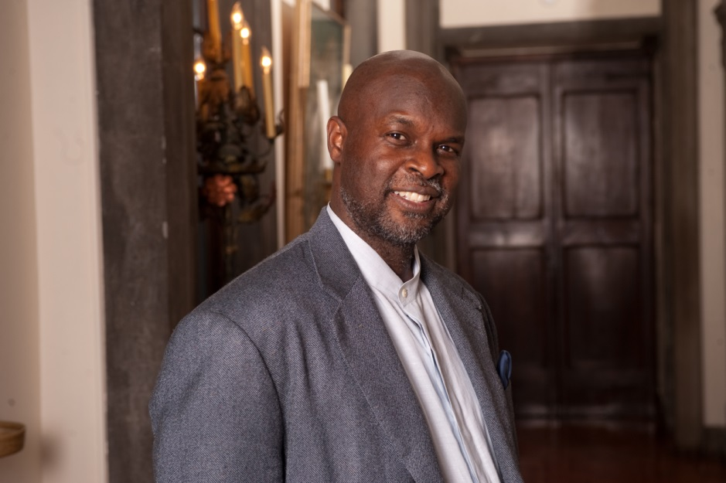

TUKUFU ZUBERI

Professor Tukufu Zuberi holds a doctorate in sociology from the University of Chicago, is the author or editor of several books, articles, essays, and reviews, and has received numerous awards for his academic work. He is dedicated to bringing a fresh view of culture and society to the public. He is a regular guest lecturer at colleges and universities across the country and internationally.

Born Antonio McDaniel to Willie and Annie McDaniel, and raised in the housing projects of Oakland, California in the 1970s, he embraced the name Tukufu Zuberi - Swahili for “beyond praise” and “strength.” He has said “I took the name because of a desire to make and have a connection with an important period where people were challenging what it means to be a human being.”

Dr. Zuberi is most recognized for his research of African and American society and for developing and expanding the Africana Studies program at the University of Pennsylvania. Dr. Zuberi is the Lasry Family Professor of Race Relations, a professor of sociology and the founder and past director of the Center for Africana Studies at the University of Pennsylvania. He has also been a visiting professor at Mekerere University in Kampala, Uganda and the University of Dar es Salaam in Tanzania.

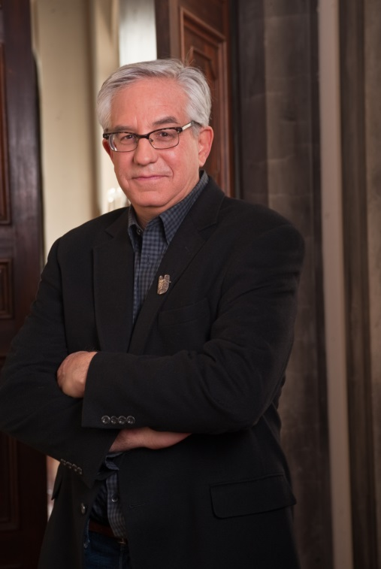
WES COWAN

Wes Cowan is President and Principal Auctioneer of Cowan’s Auctions, Inc., in Cincinnati, Ohio. He is an internationally recognized expert in historic Americana and, in addition to his hosting duties on HISTORY DETECTIVES, is a featured appraiser on ANTIQUES ROADSHOW. He writes a monthly antiques columns for the Cincinnati Enquirer, Antique Week, Collectors News and the SE Antiquing Journal and is a frequently requested speaker at antiques events around the country. Cowan holds a bachelor of arts and master of arts in anthropology from the University of Kentucky and a Ph.D. in anthropology from the University of Michigan.

A native of Louisville, Kentucky, Cowan grew up in a household filled with Victorian antiques, nurtured by a mother who liked all things “old.” Torn between the antiques business and American archaeology, Cowan first chose a course that set him on an academic road.

After receiving his doctorate degree, he taught in the anthropology department of Ohio State University. In 1984, he moved to Cincinnati, Ohio, to assume the post of Curator of Archaeology at the Cincinnati Museum of Natural History. He has published widely in the fields of American archaeology and paleoethnobotany and is co-editor of The Origins of Agriculture in International Perspective and Societies in Eclipse: Eastern North America at the Dawn of European Colonization.

In 1995, Cowan left academia and the museum world to return to his childhood love — antiques. Since then, Cowan’s Auctions has grown from a one-man shop to an internationally recognized business generating $15 million in annual sales.

