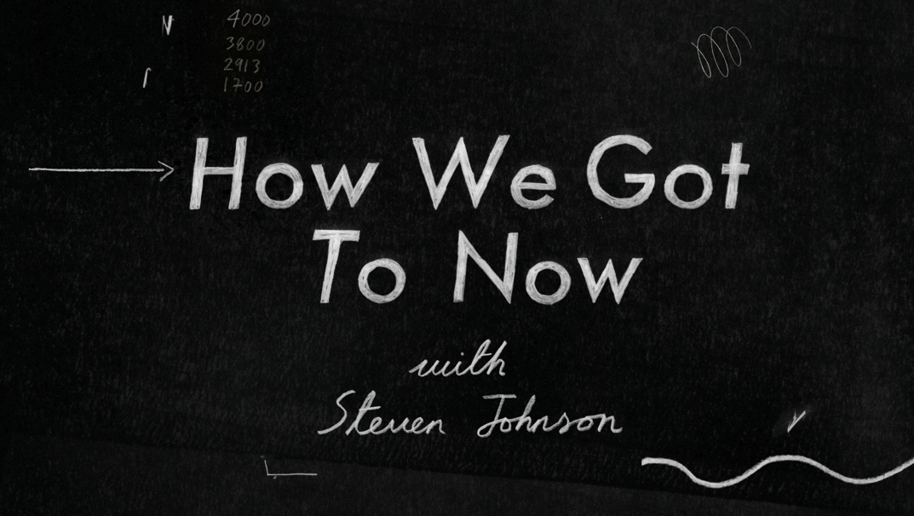
Summer 2014 TCA Panelist Bios

Steven Johnson, Host and Executive Producer
Steven Johnson is the author of the best-sellers Where Good Ideas Come From, The Invention of Air, The Ghost Map, Everything Bad Is Good for You, Mind Wide Open, Emergence and Interface Culture, and is the editor of the anthology The Inventor’s Cookbook. He is the founder of a variety of influential websites and writes for Time, Wired, The New York Times and The Wall Street Journal. He is widely regarded as one of the world’s most perceptive and thought-provoking thinkers on new media and the evolution of information technology. He lives in Marin County, California, and Brooklyn, New York, with his wife and three sons. You can find him, and his 1.4 million Twitter followers, @stevenbjohnson and www.stevenberlinjohnson.com.

Jane Root, Founder and Chief Executive, Nutopia
Jane Root has been channel controller on both sides of the Atlantic: from 2004-2007, she was president at Discovery Channel US, responsible for shows including Planet Earth, Man vs. Wild, Deadliest Catch, Dirty Jobs, Grizzly Man and Man on a Wire. At BBC2 in the UK (1998-2004), her hits included The Office, Top Gear, Great Britons, Restoration, The Apprentice and Coast. Prior to this, Root was a founding member of Wall to Wall Television, perhaps best known in the UK for Who Do You Think You Are and in the US for PBS’ TEXAS RANCH HOUSE series. She lives in Washington, DC, with her family, but enjoys collecting air miles.

