ICONIC AMERICA
PANELIST BIOS

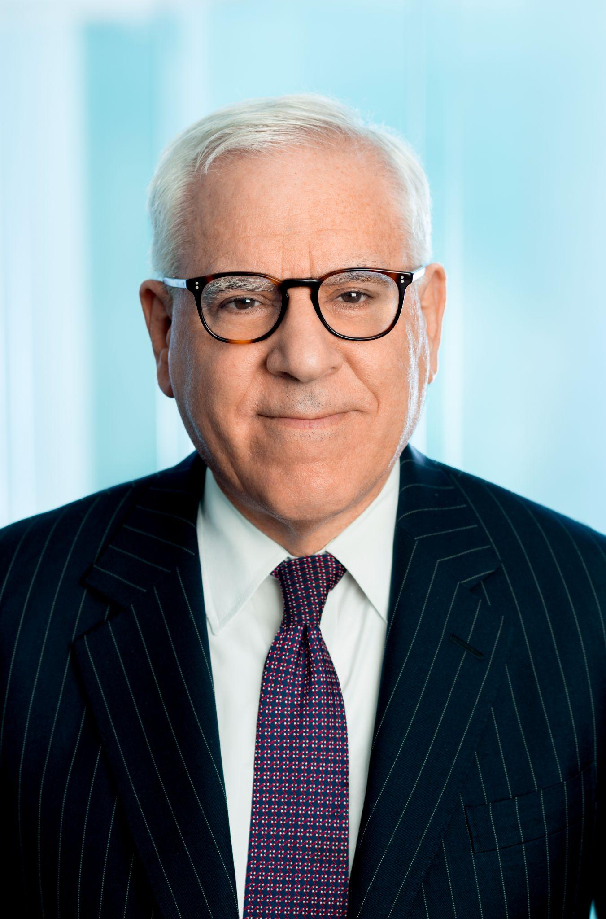
David M. Rubenstein is Co-Founder and Co-Chairman of The Carlyle Group, one of the world’s largest and most successful private investment firms. Established in 1987, Carlyle now manages $369 billion from 29 offices around the world.

Mr. Rubenstein is Chairman of the Boards of the John F. Kennedy Center for the Performing Arts, the Council on Foreign Relations, the National Gallery of Art, the Economic Club of Washington, and the University of Chicago; a Fellow of the Harvard Corporation; a Trustee of Memorial Sloan-Kettering Cancer Center, Johns Hopkins Medicine, the Institute for Advanced Study, the National Constitution Center, the Brookings Institution, and the World Economic Forum; and a Director of the Lincoln Center for the Performing Arts and the American Academy of Arts and Sciences.

Mr. Rubenstein is a member of the American Philosophical Society, Business Council, Harvard Global Advisory Council (Chairman), Madison Council of the Library of Congress (Chairman), Board of Dean’s Advisors of the Business School at Harvard, Advisory Board of the School of Economics and Management at Tsinghua University (former Chairman), and Board of the World Economic Forum Global Shapers Community.

Mr. Rubenstein has served as Chairman of the Boards of Duke University and the Smithsonian Institution, and Co-Chairman of the Board of the Brookings Institution.

Mr. Rubenstein is an original signer of The Giving Pledge, a significant donor to all of the above-mentioned non-profit organizations, and a recipient of the Carnegie Medal of Philanthropy, and the MoMA’s David Rockefeller Award, among other philanthropic awards.

Mr. Rubenstein is a leader in the area of Patriotic Philanthropy, having made transformative gifts for the restoration or repair of the Washington Monument, Lincoln Memorial, Jefferson Memorial, Monticello, Montpelier, Mount Vernon, Arlington House, Iwo Jima Memorial, the Kennedy Center, the Smithsonian, the National Archives, the National Zoo, the Library of Congress, and the National Museum of African American History and Culture. Mr. Rubenstein has also provided to the U.S. government long-term loans of his rare copies of the Magna Carta, the Declaration of Independence, the U.S. Constitution, the Bill of Rights, the Emancipation Proclamation, the 13th Amendment, the first map of the U.S. (Abel Buell map), and the first book printed in the U.S. (Bay Psalm Book).

Mr. Rubenstein is the host of The David Rubenstein Show: Peer-to-Peer Conversations on Bloomberg TV and PBS and Bloomberg Wealth with David Rubenstein on Bloomberg TV, and the author of The American Story: Conversations with Master Historians, a book published by Simon & Schuster in October 2019; How to Lead: Wisdom from the World's Greatest CEOs, Founders, and Game Changers, a book published by Simon & Schuster in September 2020; The American Experiment: Dialogues on a Dream, a book published by Simon & Schuster in September 2021; and How to Invest: Masters on the Craft, a book published by Simon & Schuster in September 2022.

Mr. Rubenstein, a native of Baltimore, is a 1970 magna cum laude graduate of Duke University, where he was elected Phi Beta Kappa. Mr. Rubenstein graduated in 1973 from the University of Chicago Law School, where he was an editor of the Law Review.

From 1973-1975, Mr. Rubenstein practiced law in New York with Paul, Weiss, Rifkind, Wharton & Garrison. From 1975-1976, he served as Chief Counsel to the U.S. Senate Judiciary Committee’s Subcommittee on Constitutional Amendments. From 1977-1981, during the Carter Administration, Mr. Rubenstein was Deputy Assistant to the President for Domestic Policy. After his White House service and before co-founding Carlyle, Mr. Rubenstein practiced law in Washington with Shaw, Pittman, Potts & Trowbridge (now Pillsbury Winthrop Shaw Pittman).


Sam Pollard is an accomplished feature film and television video editor, and documentary producer/director. Between 1990 and 2010, Mr. Pollard edited a number of Spike Lee's films: Mo' Better Blues, Jungle Fever, Girl 6, Clockers, and Bamboozled. Mr. Pollard and Mr. Lee co-produced a number of documentary productions for the small and big screen, including Four Little Girls, a feature-length documentary about the 1963 Birmingham church bombings which was nominated for an Academy Award, and When The Levees Broke, a four-part documentary that won numerous awards, including a Peabody and three Emmy Awards. Five years later in 2010 he co-produced and supervised the edit on the follow up to Levees, If God Is Willing And Da Creek Don’t Rise.

Since 2012, Mr. Pollard has completed as a producer/director Slavery By Another Name, a 90-minute documentary for PBS that was in competition at the Sundance Festival; August Wilson: The Ground On Which I Stand, a 90-minute documentary in 2015 for American Masters; and Two Trains Runnin’, a feature length documentary in 2016 that premiered at the Full Frame Film Festival. Sammy Davis Jr.: I’ve Gotta Be Me for American Masters premièred at the 2017 Toronto International Film Festival. In 2019, Mr. Pollard co-directed the six-part series Why We Hate which premiered on The Discovery Channel. In 2020, he was one of the directors on the 2020 HBO Series Atlanta’s Missing and Murdered: The Lost Children. He also completed in 2020 MLK/FBI, which premiered at the 2020 Toronto Film Festival and the New York Film Festival.


Melissa Rivers is the go-to, award-winning host for all things fashion and pop culture, as well as a reality TV star, an actress, and an executive producer. She’s the New York Times bestselling author of numerous books, including her latest, Lies My Mother Told Me: Tall Tales From A Short Woman. Her weekly podcast, Melissa Rivers Group Text, tackles celebrity interviews, current events, lifestyle, relationships, parenting, health and wellness, and so much more. It was simply inspired by the same daily group chats among Melissa and her friends, but delves a bit deeper.

“My podcast is the perfect vehicle for talk in the 21st century – allowing for numerous points of view, intelligent conversations, a lot of laughter, and a timely and compelling approach to issues we are all confronting,” Melissa shares. “I know listeners enjoy it as much as my guests and I enjoy making it.” Melissa is perhaps best known as an architect and creator of the modern Red Carpet Event Brand through her countless interviews and appearances as a co-host on E! Television, including the globally recognized and iconic hit series, Fashion Police. A philanthropist and an advocate, Melissa ardently supports a number of charitable causes including Didi Hirsch Mental Health Services, Our House Grief Support Center, and Center For The Art of Performance UCLA, among others. In her spare time, Melissa enjoys tennis, skiing, surfing, and occasionally sleeping.


Nancy Wang Yuen is a sociologist and pop culture expert. She is the author of Reel Inequality: Hollywood Actors and Racism and co-author of The Prevalence and Portrayal of Asian and Pacific Islanders Across 1,300 Popular Films. She is the host of The Disrupters Podcast and has appeared on PBS, NPR, MSNBC, BBC World, and Dr. Phil. She has spoken and consulted on diversity issues at Amazon, Disney, Dreamworks, Lionsgate and Netflix. She is a guest writer at CNN, Elle, LA Times, NBC, Newsweek, Today, and Vanity Fair. Nancy is currently writing a book about her life through the films and TV shows she grew up watching.

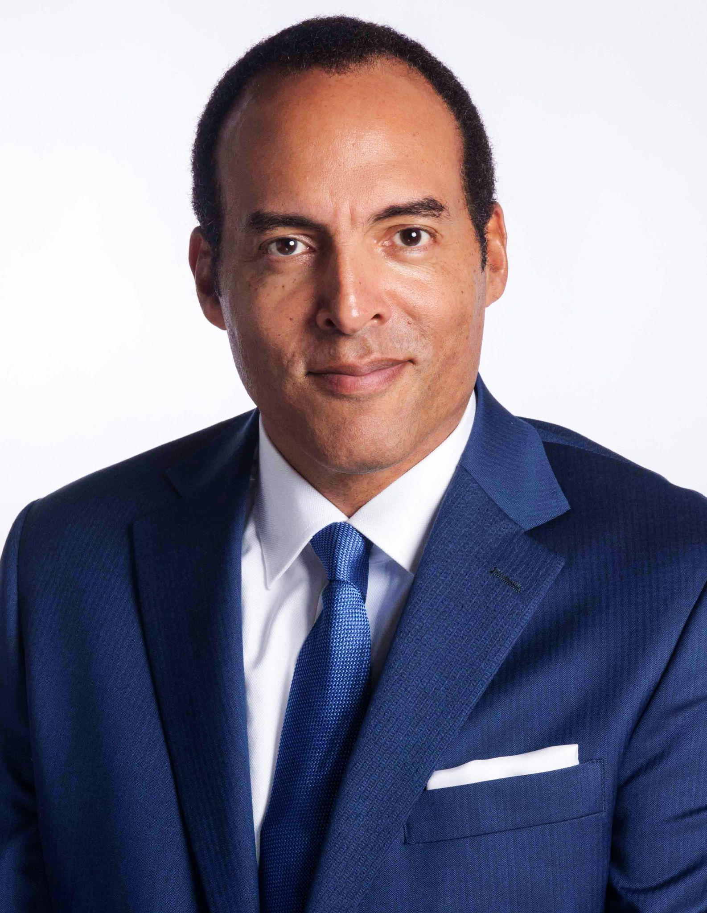
Michael Boulware Moore is a high-impact business leader, keynote speaker, board member, and author. He is an innovative thought leader on diversity, equity, and inclusion; African American history, social justice, and brand strategy. He earned a BA from Syracuse University and an MBA from Duke University.

Michael is currently the Diversity, Equity, and Inclusion Officer at Blackbaud - the world’s leading software company powering the social good community - where he leads the function globally. Previously, Michael was the Founding President/CEO of the International African American Museum. IAAM is a leading institution elevating the history and contributions of those who were brought enslaved to America. Michael was also CEO of Glory Foods and was the long-time principal of a boutique brand strategy
consulting firm. He has classical consumer packaged goods experience early in his
career at Kraft and Coca-Cola.

Michael was named to Charleston Business Magazine’s 50 Most Influential list. He received an honorary Doctorate in Public History degree from Dickinson College. In July of 2019, the City of Charleston honored him with “Michael Boulware Moore Day.”

Michael chairs the Board of Trustees at St. Mark’s School in Southborough, MA where he received a Distinguished Alumni Award. He has served on a number of nonprofit boards including the National Park Foundation, the International African American Museum, Penn Center, and the Charleston Metro Chamber of Commerce. Michael is a frequent keynote speaker. Over the years, he has brought his vibrant and thought provoking message to groups of up to 20,000 people at conferences, universities, schools, museums, and other organizations. Michael powerfully presents the story of his great great grandfather, Civil War hero and Reconstruction Congressman Robert Smalls. He also speaks about the connectivity between the past and the present; on the role that history plays in framing and guiding the present.

Michael is a valued media contributor, having been featured on CNN, MSNBC, NBC, ESPN, PBS, CBS, C-SPAN, BBC, The New York Times, The Washington Post, The Economist, USA Today, Forbes, HuffPost, etc. Michael is the author of Bridging the Gaps: The Love of Marketing and the forthcoming illustrated children’s book Freedom on the Sea about Robert Smalls. Michael is married and has four sons. He currently lives in a suburb of Charleston, SC.

