IHEARTRADIO LIVE WITH NEW KIDS ON THE BLOCK
Premieres Friday, September 6 on PBS

Relive the Magic of the Iconic Boy Band’s Greatest Hits Along With New Songs from Their Latest Album

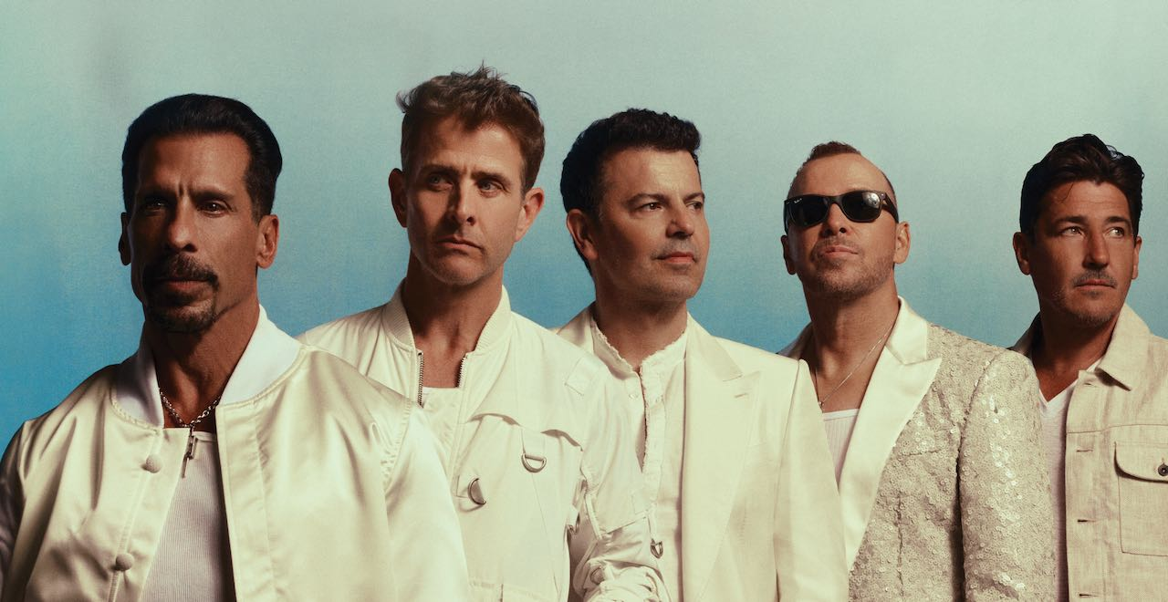Credit: Austin Hargrave.

Celebrate the enduring legacy of the multiplatinum selling pop icons that continue to capture the hearts of millions in this unforgettable musical experience. New Kids on the Block — aka NKOTB — are back with their recently released album Still Kids, the group’s eighth full-length studio album and first album in over a decade. Taped at the iHeartRadio Theater in Los Angeles in
May 2024, IHEARTRADIO LIVE WITH NEW KIDS ON THE BLOCK premieres Friday, September 6, 2024, at 9:00 p.m. ET (check local listings) on PBS.

IHEARTRADIO LIVE WITH NEW KIDS ON THE BLOCK features band members Jonathan Knight, Jordan Knight, Joey McIntyre, Donnie Wahlberg and Danny Wood performing the pop anthems, dance tracks and love songs that are fan favorites of the Blockheads. Relive the magic of their biggest hits with newly recorded performances of “Step By Step,” “Please Don’t Go Girl,” “Hangin Tough,” “Cover Girl,” and “Tonight,” as well as fresh hits from the new album, including their instant smash, new single “Kids.” In addition to an intimate performance, the special features an in-depth interview with band members and a nostalgic reflection on their incredible careers.

About PBS
PBS, with more than 330 member stations, offers all Americans the opportunity to explore new ideas and new worlds through television and digital content. Each month, PBS reaches over 36 million adults on linear primetime television, more than 16 million users on PBS-owned streaming platforms, 53 million viewers on YouTube, and 60 million people view PBS content on social media, inviting them to experience the worlds of science, history, nature, and public affairs and to take front-row seats to world-class drama and performances. PBS’s broad array of programs has been consistently honored by the industry’s most coveted award competitions. Teachers of children from pre-K through 12th grade turn to PBS LearningMedia for digital content and services that help bring classroom lessons to life. As the number one educational media brand, PBS KIDS helps children 2-8 build critical skills, enabling them to find success in school and life. Delivered through member stations, PBS KIDS offers high-quality content on TV — including a PBS KIDS channel — and streaming free on pbskids.org and the PBS KIDS Video app, games on the PBS KIDS Games app, and in communities across America. More information about PBS is available at PBS.org, one of the leading dot-org websites on the internet, Facebook, Instagram, or through our apps for mobile and connected devices. Specific program information and updates for press are available at pbs.org/pressroom or by following PBS Communications on X.

About iHeartMedia
iHeartMedia, Inc. [Nasdaq: IHRT] is the leading audio media company in America, reaching over 90% of Americans every month. iHeart’s broadcast radio assets alone have more consumer reach in the U.S. than any other media outlet; twice the reach of the next largest broadcast radio company; and over four times the ad-enabled reach of the largest digital only audio service. iHeart is the largest podcast publisher according to Podtrac, with more downloads than the next two podcast publishers combined and has the number one social footprint among audio players, with seven times more followers than the next audio media brand, and the only fully integrated audio ad tech solution across broadcast, streaming and podcasts. The company continues to leverage its strong audience connection and unparalleled consumer reach to build new platforms, products and services. Visit iHeartMedia.com for more company information.

- PBS –

CONTACT: Cara White, CaraMar, Inc., cara.white@mac.com

For images and additional up-to-date information on this and other PBS programs, visit PBS PressRoom at pbs.org/pressroom.

