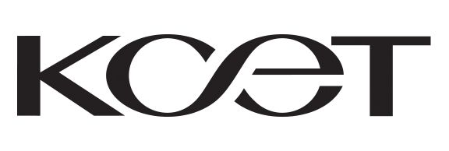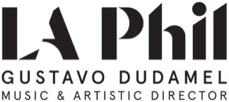

CONTACT FOR KCET: CONTACT FOR LA PHIL:

Allison Gray Lisa White
agray@kcet.org lwhite@laphil.org
747-201-5298 213-216-1174

New PBS Television Series IN CONCERT AT THE HOLLYWOOD BOWL
Hosted by LA Philharmonic’s Gustavo Dudamel
Premieres January 22, 2021 on PBS Stations Nationwide

Produced by KCET and the LA Phil, Highlights from Past Seasons of the Hollywood Bowl Summer Concert Series Provide Unprecedented Access to Unforgettable Performances Featuring Gustavo Dudamel and the Los Angeles Philharmonic, Kristin Chenoweth, Audra McDonald, Bramwell Tovey, Sutton Foster, Brian Stokes Mitchell, Rodrigo y Gabriela, Natalia Lafourcade, Los Angeles Azules, La Santa Cecilia, Dianne Reeves, Christian McBride, Chucho Valdes, Cecile McLorin Salvant, Kamasi Washington, Herbie Hancock, Carlos Santana, Cindy Blackman Santana, Wayne Shorter,

Misty Copeland, Pablo Ferrández, Vin Scully, Carlos Vives, Café Tacvba, Katy Perry, Pink Martini, Thomas Wilkins, Nile Rodgers & CHIC, Diego El Cigala,

John Williams and More!

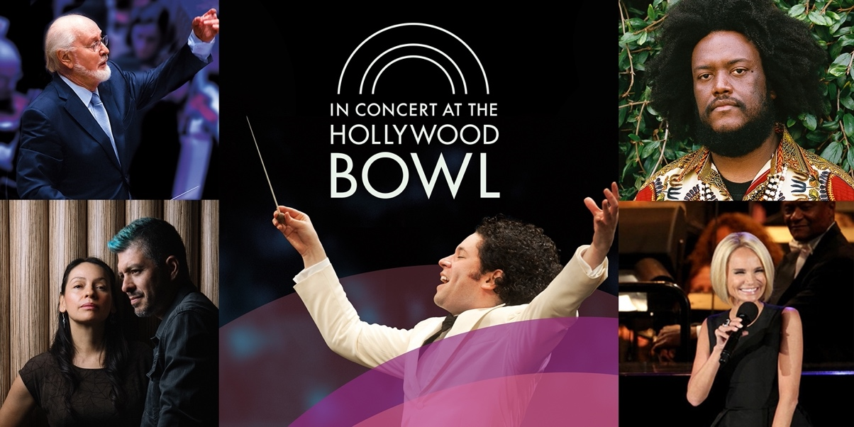

Pictured above clockwise from left to right: Kamasi Washington (Image courtesy of LA Phil), John Wiliams (Image courtesy of LA Phil), Gustavo Dudamel (Image courtesy of Adam Latham), Rodrigo y Gabriela (Image courtesy of Ebru Yildiz) and Kristin Chenoweth (Image courtesy of Krista Schlueter) – all part of the lineup of the new PBS series IN CONCERT AT THE HOLLYWOOD BOWL.

https://www.pbs.org/show/concert-hollywood-bowl/

For downloadable artwork, please visit: http://pressroom.pbs.org/Programs/i/In-Concert-at-the-Hollywood-Bowl

Burbank, Calif. – Dec., 1, 2020 – KCET, Southern California PBS station and home for award-winning, original public media programming, today announced the new weekly PBS television program IN CONCERT AT THE HOLLYWOOD BOWL, a weekly music series produced in partnership between KCET and the Los Angeles Philharmonic Association. On May 13, the 2020 season of the Hollywood Bowl was officially cancelled for the first time in its 98-year history in an effort to protect artists, audiences and staff from the spread of COVID-19. The series, which aired in Southern California earlier this summer, will allow viewers nationwide to experience iconic moments from the LA Phil archives at the Hollywood Bowl. Six episodes featuring the “best of” live performances from the past 10 years at the Bowl’s Summer Concert Series will be hosted by LA Phil’s Music and Artistic Director Gustavo Dudamel. IN CONCERT AT THE HOLLYWOOD BOWL premieres on Friday, January 22, at 9:00 p.m. on PBS and on the free PBS app.

LA Phil’s Music and Artistic Director Gustavo Dudamel said, "While it was heartbreaking not to be able to share music together at the Hollywood Bowl this past Summer, having the opportunity to look back on these extraordinary concerts reminded us of everything that makes it so special and unique. These beautifully-crafted programs take us across genres and generations, from celebrations of Mexico and Hispanic Heritage Month to some of the most legendary Jazz, Pop, Broadway, and Classical artists, giving once-in-a-lifetime performances. We will return to the Bowl stronger than ever, but until then we can enjoy these magical moments."

“The LA Phil is an iconic institution and experiencing the summer concert series at the Hollywood Bowl is an unforgettable moment for so many Angelenos. We are excited that this collaboration will help bring arts and culture to millions of viewers at home during a time when it’s needed most by our community,” said Chief Creative Officer of KCET Juan Devis. “Southern California is home to one of the most important cultural communities in the world, and we have an undeniably important responsibility to share these iconic performances from past years with the community and with audiences nationwide.”

Each week, viewers will be transported to a front-row seat with unprecedented access to musical performances and appearances from a star-studded lineup that includes Gustavo Dudamel and the Los Angeles Philharmonic, and performances by well-known musicians/artists/celebrities that include Kristin Chenoweth, Audra McDonald, Bramwell Tovey, Sutton Foster, Brian Stokes Mitchell, Rodrigo y Gabriela, Natalia Lafourcade, Los Angeles Azules, La Santa Cecilia, Dianne Reeves, Christian McBride, Chucho Valdes, Cecile McLorin Salvant, Kamasi Washington, Herbie Hancock, Carlos Santana, Cindy Blackman Santana, Wayne Shorter, Misty Copeland, Pablo Ferrández, Vin Scully, Carlos Vives, Café Tacvba, Katy Perry, Pink Martini, Thomas Wilkins, Nile Rodgers & CHIC, Diego El Cigala, John Williams and many more.

The Hollywood Bowl roster always features a broad variety of artists and genres, showcasing world-class artists ranging from classical and pop to jazz, rock and world music. The series features the return of legendary Hollywood Bowl favorites, as well as acclaimed artists making their Hollywood Bowl debuts, while celebrating the music from a diverse array of cultures and communities around the world.

Upcoming episodes of IN CONCERT AT THE HOLLYWOOD BOWL will air as follows (subject to change):

Friday, January 22 at 9:00 p.m.: “Hecho en Mexico” (“Made in Mexico”)
Featuring Gustavo Dudamel and the LA Phil performing Marquez’s El Nereidas de Dimas, Rodrigo y Gabriela with Gustavo Dudamel and the LA Phil, Natalia Lafourcade with Gustavo Dudamel and the LA Phil, Los Angeles Azules with YOLA (Youth Orchestra Los Angeles), and La Santa Cecilia.

Friday, January 29 at 9:00 p.m.: “Jazz at the Hollywood Bowl”
Featuring Dianne Reeves with Ivan Lins, Christian McBride, Chucho Valdes, Cecile McLorin Salvant, Kamasi Washington and Mega Nova (Herbie Hancock, Carlos Santana and Wayne Shorter).

Friday, January 29 at 10:00 p.m.: “Musicals and the Movies”
Featuring Kristin Chenoweth with Kevin Stites and the LA Phil, Audra McDonald with Bramwell Tovey and the LA Phil, Sutton Foster with Brian Stokes Mitchell, Gustavo Dudamel and the LA Phil.

Friday, February 5 at 9:00 p.m.: “Gustavo and Friends”
Featuring Gustavo Dudamel and the LA Phil performing excerpts from Swan Lake with Misty Copeland, Pablo Ferrández, Gustavo Dudamel and the LA Phil performing a selection from Dvorak’s Cello Concerto, Gustavo Dudamel and the LA Phil performing Copland’s Fanfare for the Common Man, as well as Gustavo Dudamel, the LA Phil, Amanda Majeski, J’Nai Bridges, Issachah Savage, Ryan Speedo Green and the Los Angeles Master Chorale (LAMC) performing the finale to Beethoven’s Symphony No. 9.

Friday, February 5 at 10:00 p.m.: “Fireworks!”
Featuring Katy Perry, Pink Martini, Thomas Wilkins, Nile Rodgers & CHIC, Diego El Cigala, Gustavo Dudamel and the LA Phil performing a selection from Stravinsky’s Firebird Suite, plus John Williams and the LA Phil performing music from Star Wars.

Friday, February 12 at 9:00 p.m.: “Música Sin Fronteras” (“Music Without Borders”)
Featuring Vin Scully, Gustavo Dudamel and the LA Phil, Carlos Vives, Café Tacvba, and Siudy Garrido Flamenco Dance Theater with the LA Phil and conducted by Paolo Bortolameolli

One of the largest natural amphitheaters in the world, with a seating capacity of nearly 18,000, the Hollywood Bowl has been the summer home of the Los Angeles Philharmonic since its official opening in 1922 and plays host to the finest artists from all genres of music, offering something for everyone. In February 2018, the Hollywood Bowl was named Best Major Outdoor Concert Venue for the 14th year in a row at the 29th Annual Pollstar Awards, and in November 2018 was awarded the Top Amphitheater prize at the 2018 Billboard Live Music Awards for the second consecutive year. For millions of music lovers across Southern California, the Hollywood Bowl is synonymous with summer.

IN CONCERT AT THE HOLLYWOOD BOWL will stream simultaneously with the broadcast on PBS and the FREE PBS App, available on iOS, Android, Roku streaming devices, Apple TV, Amazon Fire TV, Android TV, Samsung Smart TV and Chromecast.

For updates, follow @KCET @LAPhil and #InConcertAtTheHollywoodBowl on social media.

ABOUT KCET
On-air, online and in the community, KCET plays a vital role in the cultural and educational enrichment of Southern and Central California. KCET offers a wide range of award-winning local programming as well as the finest public television programs from around the world. Throughout its 54-year history, KCET has won hundreds of major awards for its local and regional news and public affairs programming, its national drama and documentary productions, its quality educational family and children's programs, its outreach and community services and its website, kcet.org. KCET is a donor-supported community institution. For additional information about KCET productions, web-exclusive content, programming schedules and community events, please visit kcet.org. Select original programming from KCET is also available for streaming on Apple TV, YouTube, Amazon and Roku platforms. For more information please visit kcet.org/apps. KCET is a content channel of the Public Media Group of Southern California. KCET Original content and PBS programming are available to stream the FREE PBS App on streaming devices.

ABOUT The Los Angeles Philharmonic
The Los Angeles Philharmonic Association, under the vibrant leadership of Music & Artistic Director Gustavo Dudamel, presents an inspiring array of live performances – orchestral, pop, rock, country, jazz, blues, Latin, world music, opera, chamber, Baroque, organ and celebrity recitals, theatrical performances, explorations of film music, dance, comedy, groundbreaking multimedia productions and an unmatched commitment to commissioning and performing music from the composers of today – at three of L.A.’s iconic venues, Walt Disney Concert Hall (laphil.com), the Hollywood Bowl (hollywoodbowl.com) and The Ford (theford.com). The LA Phil’s season at Walt Disney Concert Hall extends from September to June and at the Hollywood Bowl and the Ford Theatre throughout the summer. With the preeminent Los Angeles Philharmonic at the foundation of its offerings, the LA Phil aims to enrich and transform lives through music, with a robust mix of artistic, education and community programs.

