IN DEFENSE OF FOOD
Premieres Wednesday, December 30 on PBS

− Author Michael Pollan’s Global Journey to Rediscover the
Pleasures of Healthy Food −

Join New York Times best-selling author Michael Pollan on a fascinating journey to answer the question: What should I eat to be healthy? Busting myths and misconceptions, IN DEFENSE OF FOOD reveals how common sense and old-fashioned wisdom can help us rediscover the pleasures of eating and at the same time reduce our risks of falling victim to diet-related diseases. IN DEFENSE OF FOOD, a Kikim Media production, premieres Wednesday, December 30, 2015, 9:00-11:00 p.m. ET (check local listings) on PBS.
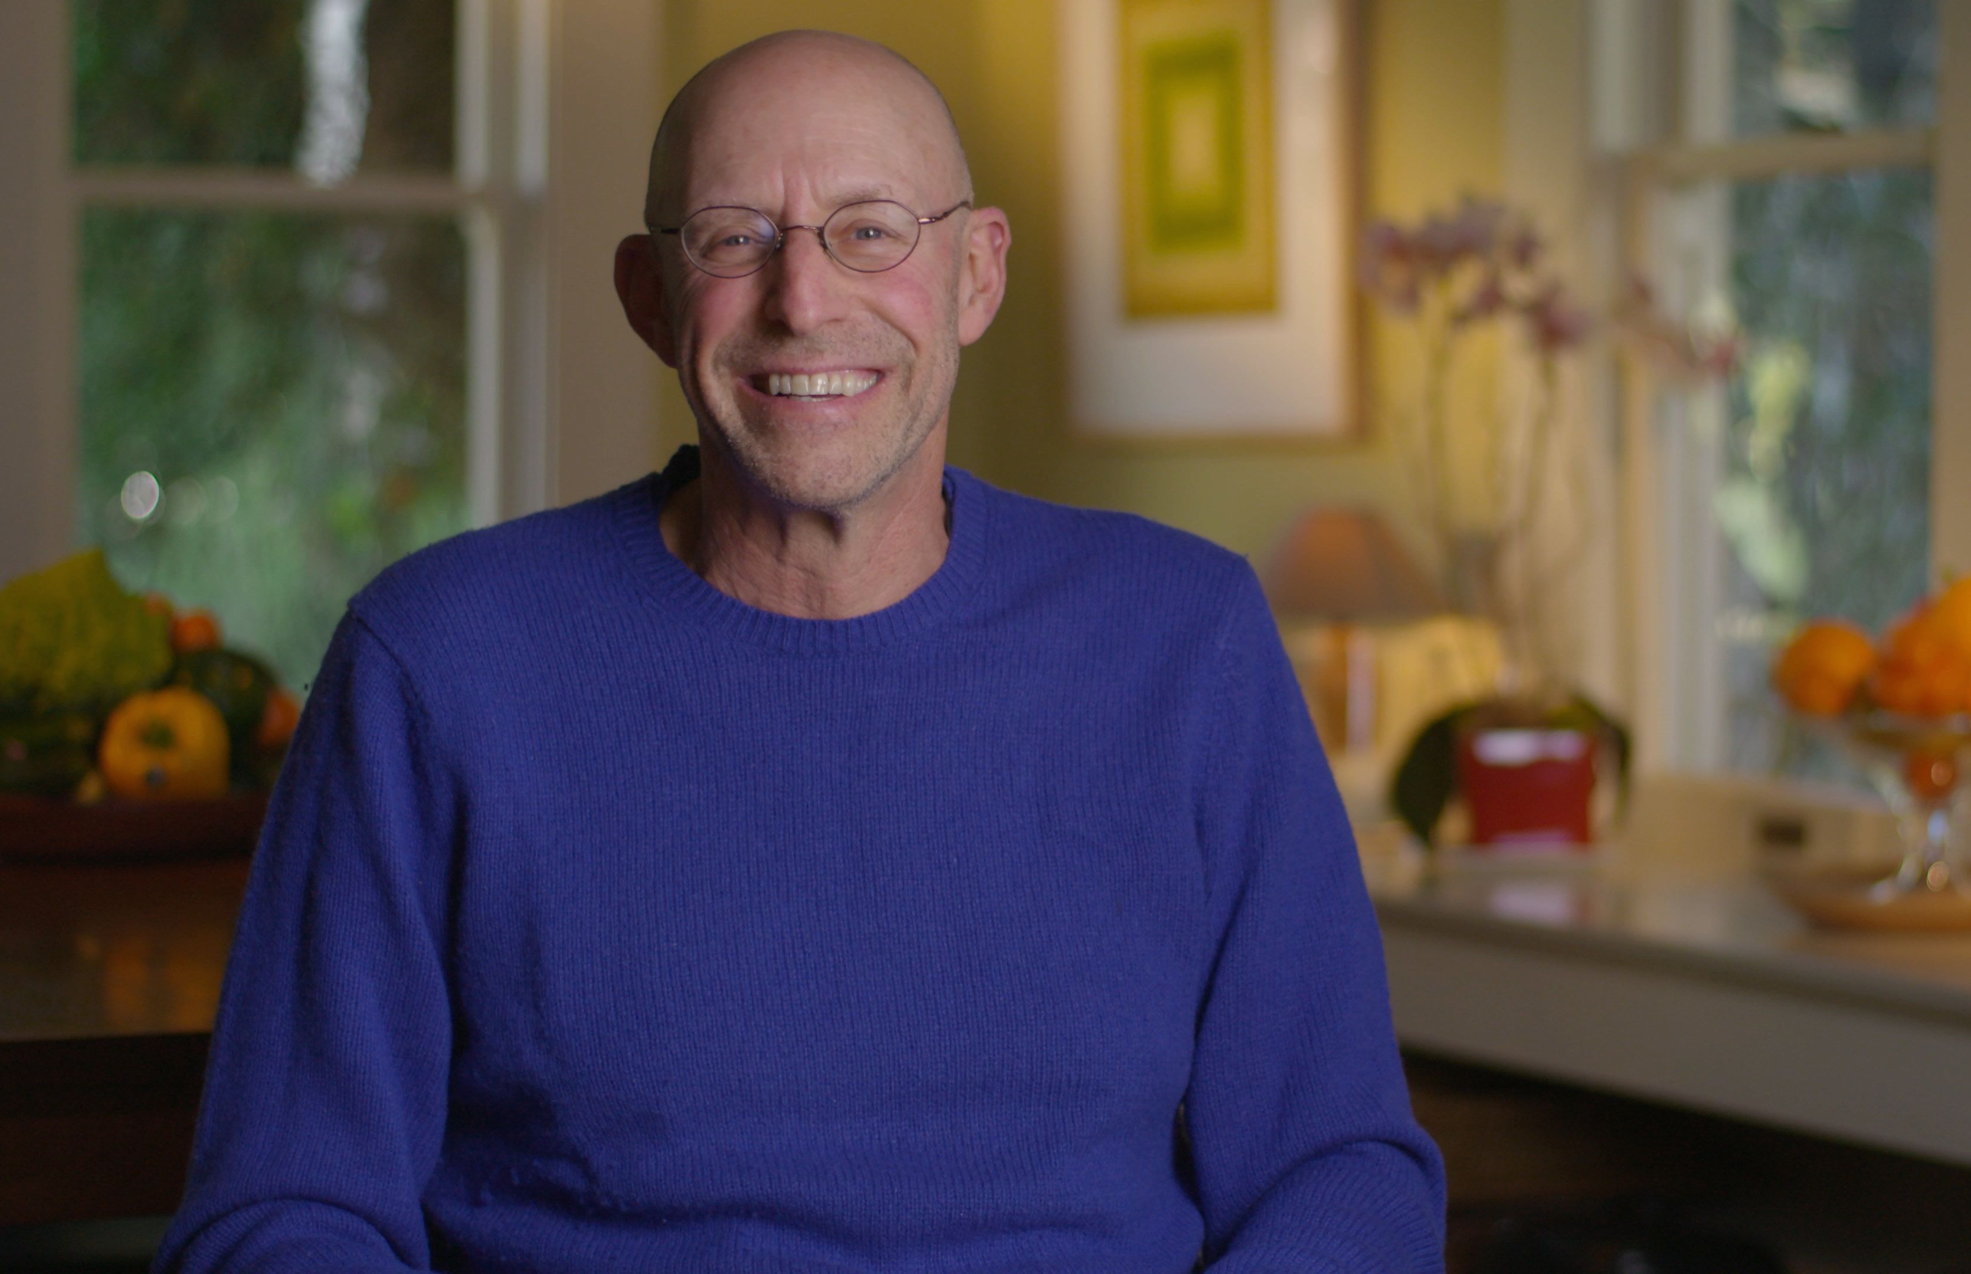Michael Pollan.

Pollan’s journey of discovery takes him from the plains of Tanzania, where one of the world’s last remaining tribes of hunter-gatherers still eats the way our ancestors did, to Loma Linda, California, where vegetarian Seventh Day Adventists enjoy remarkable longevity, and eventually to Paris, where the French diet, rooted in culture and tradition, proves surprisingly healthy. Along the way, he shows how a combination of faulty nutrition science and deceptive marketing practices have encouraged us to replace real food with scientifically engineered “food-like substances.” And he explains why the solution to our dietary woes is in fact remarkably simple: Eat Food. Not Too Much. Mostly Plants.

Featuring interviews with scientists, nutrition experts, physicians, food activists and more, and including the stories of real families, IN DEFENSE OF FOOD is directed by Michael Schwarz. The film is produced by Schwarz and Edward Gray with a telescript by Gray. Kiki Kapany is the executive producer. The film is edited by Rhonda Collins and Gail Huddleson. Major funding for IN DEFENSE OF FOOD was provided by the National Science Foundation and PBS. The film is presented by KQED and distributed by PBS.

* * *

Almost every day there’s a new headline about food. Eat more fiber. Drink less milk. Eggs are bad. Eggs are good. No wonder people are confused. IN DEFENSE OF FOOD begins with an exploration of the kind of food most Americans eat today — known as the Western diet. It includes lots of meat, white flour, sugar and vegetable oils. It’s cheap, convenient and has been processed to taste really good. But the effects of the Western diet on health are not so tasty, including alarming increases in obesity and Type 2 diabetes.

So if the Western diet makes us sick, what kind of diet will make us healthy? Pollan’s search for the answer leads him to explore the kinds of food that come from nature.

And what nature provides is remarkably diverse. In the Andes, the Quechua people harvest potatoes and grains and eat only a small amount of meat. In East Africa, the Masai thrive on a diet consisting mostly of cattle blood milk, and meat. In the Arctic, the Inuit have long eaten tremendous amounts of fat from whales, seals and fish. And in Tanzania, members of the Hadza tribe are some of the last people on earth who still get their food the way our ancestors did: by hunting and gathering. Scientists who study the Hadza have found that they very rarely develop the diseases found in those who eat the Western diet, like obesity, Type 2 diabetes and heart disease.

What Pollan means by telling us to “eat food” is to eat what people ate for the thousands of years before we became dependent on processed foods. He believes that many of our troubles today stem from thinking about foods solely in terms of the nutrients that are in them — a tendency fueled by the food industry’s practice of making health claims on products based on the nutrients they’ve added (vitamins, fiber or Omega 3s) or taken away (most famously fat). But science shows that a wide variety of diets can be healthy, provided they consist of the kind of whole foods our species has evolved to eat, which include all of the nutrients we need.

The film examines everything from rising concerns about Omega 3s and 6s to what we’re learning about the biochemical roots of our craving for sugar — and how too much sugar can overwhelm our ability to process it. It looks at why nutritional guidelines that advised reducing fat in our diet had the unintended consequence of increasing obesity — as well as what the latest studies show about the benefits of a plant-based diet, and the role of the trillions of intestinal bacteria that inhabit all of us — an emerging new field of nutrition science that is changing the way scientists think about food and health. And it reveals how hidden environmental cues influence not only how much we eat but also what we eat.
Drawing conclusions from these findings, IN DEFENSE OF FOOD offers viewers simple, practical advice on healthier eating. It’s indispensable viewing for anyone interested in the relationship between food and health.
“There are many aspects of our lives where we feel like we have very little power. But when it comes to food, we do have power,” says Pollan. “The rise of farmers markets, the rise of organic agriculture, the rise of the food movement — none of this was the result of government action. All of this was the result of consumers voting with their forks, signaling to farmers and the food industry they wanted something different. And this has created a multi-billion dollar alternative food economy. So we may be at a turning point.”

“Eat food, not too much, mostly plants, is what our species has done for hundreds of thousands of years,” he adds. “So that advice is about as universal as any advice you could offer. It’s very rare in our lives where the answer to a complicated question is so simple, but when it comes to eating, it is.”

IN DEFENSE OF FOOD will be accompanied by a comprehensive education program for middle school students created by the Laurie M. Tisch Center for Food, Education and Policy at the Teachers College, Columbia University. In addition, an extensive outreach program has been designed to help food and health organizations and community groups use the film to spark deeper engagement and action in support of healthier homes, schools and communities.

A selection of Michael Pollan’s Food Rules
Eat only foods that will eventually rot.
Eat only foods that have been cooked by humans.
Avoid foods you see advertised on television.
Eat mostly plants.
Treat meat as a flavoring or special occasion food.
If it came from a plant, eat it. If it was made in a plant, don’t.
Eat your colors – that is, eat as many different kinds of plants as possible.
Use smaller plates and glasses.
Serve the vegetables first.
Make water your beverage of choice.
Stop eating before you’re full.
Eat more like the French do.
Try to spend as much time enjoying the meal as it took to prepare it.
Don’t eat anything your great-grandmother wouldn’t recognize as food.
Break the rules once in a while.

About Michael Pollan

Michael Pollan is the author of Cooked: A Natural History of Transformation (2013) and four New York Times best-sellers: Food Rules: An Eater’s Manual (2010); In Defense of Food: An Eater’s Manifesto (2008); The Omnivore’s Dilemma: A Natural History of Four Meals (2006); and The Botany of Desire: A Plant’s-Eye View of the World (2001). The Omnivore’s Dilemma was named one of the 10 best books of 2006 by both The New York Times and The Washington Post. A young readers edition called The Omnivore’s Dilemma: The Secrets Behind What You Eat was published in 2009. In 2011, Pollan published an illustrated version of Food Rules with new paintings by Maira Kalman.

The Botany of Desire received the Borders Original Voices Award for the best non-fiction work of 2001, and was recognized as a best book of the year by the American Booksellers Association and Amazon.com. A two-hour documentary based on the book and produced and directed by Michael Schwarz premiered on PBS in fall 2009. Pollan is also the author of A Place of My Own (1997) and Second Nature (1991).

Pollan was named to the 2010 TIME 100, the magazine’s annual list of the world’s 100 most influential people, and was named by Newsweek as one of the top 10 “New Thought Leaders” in 2009. A contributing writer to The New York Times Magazine since 1987, his writing has received numerous awards. His essays have appeared in many anthologies, and his articles have appeared in major publications including Harper’s Magazine (where he served as executive editor from 1984 to 1994), National Geographic, Mother Jones, The Nation, The New York Review of Books, Vogue, Travel + Leisure, Gourmet, House & Garden, and Gardens Illustrated, among others. In 2009 he appeared in the documentary Food, Inc., which received an Academy Award nomination.

In 2003, Pollan was appointed the John S. and James L. Knight Professor of Journalism at the University of California at Berkeley’s Graduate School of Journalism, and the director of the Knight Program in Science and Environmental Journalism. In addition to teaching, he lectures widely on food, agriculture, health, and the environment.

Pollan, who was born in 1955, grew up on Long Island, and was educated at Bennington College, Oxford University and Columbia University, from which he received a Masters in English. He lives in the Bay Area with his wife, the painter Judith Belzer, and their son Isaac.

About the Filmmakers
Michael Schwarz (Producer and Director) founded Kikim Media with his wife Kiki Kapany in 1996. His work has been honored with the most prestigious awards in broadcasting — including three national Emmy Awards, two George Foster Peabody Awards, the Alfred I. duPont-Columbia University Journalism Award and the Grand Prize in the Robert F. Kennedy Journalism Awards for Coverage of the Disadvantaged.
In addition to IN DEFENSE OF FOOD, Schwarz is also currently directing The Valley, a three-hour cultural, intellectual, and technological history of Silicon Valley; and The Ornament of the World, a two-hour history of medieval Spain.
Other recent projects include: The Botany of Desire, based on Michael Pollan’s book about the relationship between plants and people; Capturing Grace (executive producer), the unlikely story of what happens when the world-renowned Mark Morris Dance Group and people with Parkinson’s disease join forces to create a unique performance; Extreme by Design, a film about students building a better world, one product at a time; My Father, My Brother and Me (FRONTLINE), a chronicle of Parkinson’s disease; and Hunting the Hidden Dimension (NOVA), the story of fractal geometry.
As a Fulbright Fellow in the 1980s, Schwarz conducted documentary production workshops in Malaysia, India, Sri Lanka, Indonesia and Papua New Guinea.
Edward Gray (Producer and Telescript) is a three-time Emmy Award winner, a two-time winner of the Writers Guild of America Award, and a recipient of both the Edward R. Murrow Award and the Robert F. Kennedy Journalism Award.

The documentaries Gray has made for national broadcast on public television include: Alaska, The World and Wally Hickel, the story of the iconoclastic Interior Secretary who was fired by Richard Nixon; Security vs. Liberty, a look at counterterrorism policies for the PBS series America at a Crossroads; Through Many Lives: The Aging Brain, for the series The Secret Life of the Brain; and The Orphan Trains, for the American Experience series. Gray worked with Michael Schwarz and Kikim Media as a co-producer on The Botany of Desire and Hunting the Hidden Dimension.

For ABC News, Gray was senior producer and co-writer of Peter Jennings Reporting: The Kennedy Assassination – Beyond Conspiracy. He spent three years as a staff producer and writer in the TV production unit of The New York Times, where he produced Searching for the Roots of 9/11, with Times columnist Thomas Friedman. Gray lives in New York City.

Kiki Kapany (Executive Producer) combines a background in media and law (J.D. ’86). Her experienced legal sense, paired with a sound creative approach to production on a worldwide scale, adds a key dimension to Kikim’s resources. Kapany manages all of the entertainment law and day-to-day business required in Kikim’s operations, including overseeing business development, strategic planning, finance and administration. Her expertise extends to the creation and management of major production budgets, extensive image research, grant reporting, organizing project deliverables and managing all production and post-production logistics for a wide variety of projects.

About PBS
PBS, with over 350 member stations, offers all Americans the opportunity to explore new ideas and new worlds through television and online content. Each month, PBS reaches more than 103 million people through television and over 33 million people online, inviting them to experience the worlds of science, history, nature and public affairs; to hear diverse viewpoints; and to take front row seats to world-class drama and performances. PBS’ broad array of programs has been consistently honored by the industry’s most coveted award competitions. Teachers of children from pre-K through 12th grade turn to PBS for digital content and services that help bring classroom lessons to life. PBS’ premier children’s TV programming and its website, pbskids.org, are parents’ and teachers’ most trusted partners in inspiring and nurturing curiosity and love of learning in children. More information about PBS is available at www.pbs.org, one of the leading dot-org websites on the Internet, or by following PBS on Twitter, Facebook or through our apps for mobile devices. Specific program information and updates for press are available at pbs.org/pressroom or by following PBS Pressroom on Twitter.

– PBS –

Contacts:
CaraMar, Inc.
Mary Lugo 770-623-8190 lugo@negia.net
Cara White 843-881-1480 cara.white@mac.com
Abbe Harris 908-244-5516 abbe@caramar.net

For further information and photos visit http://www.pbs.org/pressroom

