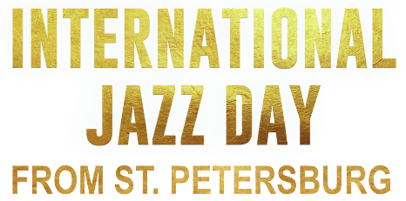

A one-hour music special available to public television stations
beginning April 26, 2019 (check local listings)

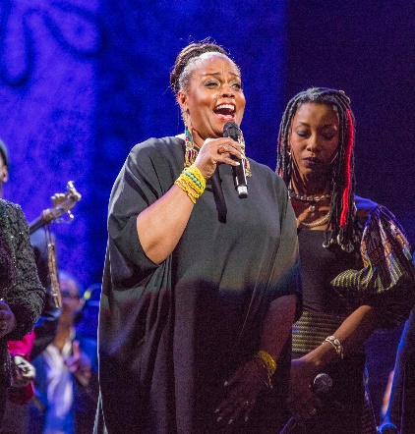
On April 30, 2018, a diverse group of world-renowned artists came together from all over the world for an extraordinary global concert, recorded at St. Petersburg’s famed Mariinsky Theatre, home to the internationally acclaimed Mariinsky Ballet and one of the crown jewels of a city renowned for its UNESCO World Heritage sites. The event took place on International Jazz Day, the one day each year that jazz is celebrated worldwide, bringing together people of all ages, backgrounds, and nationalities in more than 190 countries on all seven continents. The resulting new one-hour music special, INTERNATIONAL JAZZ DAY FROM ST. PETERSBURG, will air on public television stations beginning April 26, 2019 (check local listings).
Dianne Reeves

Long considered Russia’s cultural capital, St. Petersburg has played an important role in the popularization and development of jazz in Russia. The country’s jazz scene was born in 1927 in St. Petersburg with the appearance of the “First Concert Jazz Band” at the St. Petersburg State Capella, followed by the creation of the first jazz collective in 1929. Moreover, St. Petersburg is the only city in the country to have a Jazz Philharmonic Hall, founded in 1989.

The 2018 All-Star Global Concert featured nearly three dozen acclaimed artists representing 14 countries and spanning a variety of styles, cultures, and languages. Herbie Hancock (USA) and Igor Butman (Russia) served as co-artistic directors, and John Beasley (USA) served as musical director. Additional artists included: Oleg Akkuratov (Russia), Till Brönner (Germany), Oleg Butman (Russia), Terri Lyne Carrington (USA), Joey DeFrancesco (USA), Fatoumata Diawara (Mali), Vadim Eilenkrig (Russia), Kurt Elling (USA), Antonio Faraò (Italy), James Genus (USA), Robert Glasper (USA), David Goloschyokin (Russia), Hassan Hakmoun (Morocco), Gilad Hekselman (Israel), Horacio Hernandez (Cuba), Taku Hirano (Japan), Anatoly Kroll (Russia), Gaoyang Li (China), Rudresh Mahanthappa (USA), The Manhattan Transfer (USA), Branford Marsalis (USA), James Morrison (Australia), Moscow Jazz Orchestra (Russia), Makoto Ozone (Japan), Danilo Pérez (Panama), Dianne Reeves (USA), Lee Ritenour (USA), Luciana Souza (Brazil), and Ben Williams (USA), among others.

The concert’s many historic moments include an unforgettable performance by The Manhattan Transfer, along with Jazz Day debuts by Malian phenom Fatoumata Diawara and Moroccan sintir master Hassan Hakmoun. The ensemble cast of performers channels the soul and spirit of jazz through swinging renditions of such tunes as “Too Close for Comfort,” featuring vocalists Dianne Reeves and Kurt Elling with organist Joey DeFrancesco; “Actual Proof” with pianist Herbie Hancock and saxophonist Rudresh Mahanthappa; and Victor Young’s classic “Stella By Starlight” interpreted by pianist Robert Glasper, bassist Ben Williams, and drummer Terri Lyne Carrington.

International Jazz Day from ST. PETERSBURG is a co-production of WTTW Chicago and the Thelonious Monk Institute of Jazz.

About International Jazz Day
For more than a century, the truly American music of jazz has promoted peace, diversity, individual expression, dialogue among cultures, and respect for human dignity. International Jazz Day highlights the unifying attributes of this music through live performances, education programs, and special events worldwide. International Jazz Day was first celebrated in 2012, and is recognized on the official calendars of both the United Nations and the United Nations Educational, Scientific, and Cultural Organization (UNESCO). Each year on April 30, universities, libraries, schools, arts centers, organizations of all disciplines, artists, and jazz enthusiasts all over the world honor this revered musical art form that for more than a century has brought together people of different cultures, religions, and nationalities.

About WTTW CHICAGO
WTTW Chicago presents a wide array of groundbreaking content for the national public media system, with series and specials on education, politics, public affairs, science, business, arts and entertainment, health, and religion. WTTW Chicago’s landmark series include MEXICO — One Plate at a Time with Rick Bayless and the animated series Nature Cat, a co-production with Chicago’s Spiffy Pictures which premiered nationwide in November 2015. WTTW Chicago has also served as the national presenting station for such programs as 1916 - The Irish Rebellion, inCommon with Mike Leonard, Curious Traveler, Dream of Italy, Islands Without Cars, Speakeasy, Vintage, the educational children’s properties Mission to Planet 429 and UMIGO, the award-winning children’s series WordWorld, and many others. For more information, please visit wttw.com/national.

###

More information and photos are available at http://www.pbs.org/pressroom.

