IWO JIMA: FROM COMBAT TO COMRADES
PREMIERES TUESDAY, NOVEMBER 10, 2015 on PBS

Join Host Ryan Phillippe to Follow Survivors to the Island Battlefield
Where Former Enemies Now Reunite as Friends

ARLINGTON, VA; September 29, 2015 – An unforgettable journey back to the iconic site of one of the fiercest battles of World War II, IWO JIMA: FROM COMBAT TO COMRADES is the powerful and moving story of the American and Japanese servicemen who came together 70 years later for a historic reunion in March 2015. This island battlefield is the only former combat zone in the world that sees men who once were enemies return as friends in a ceremony of peace and remembrance. Hosted by Flags of Our Fathers actor Ryan Phillippe,
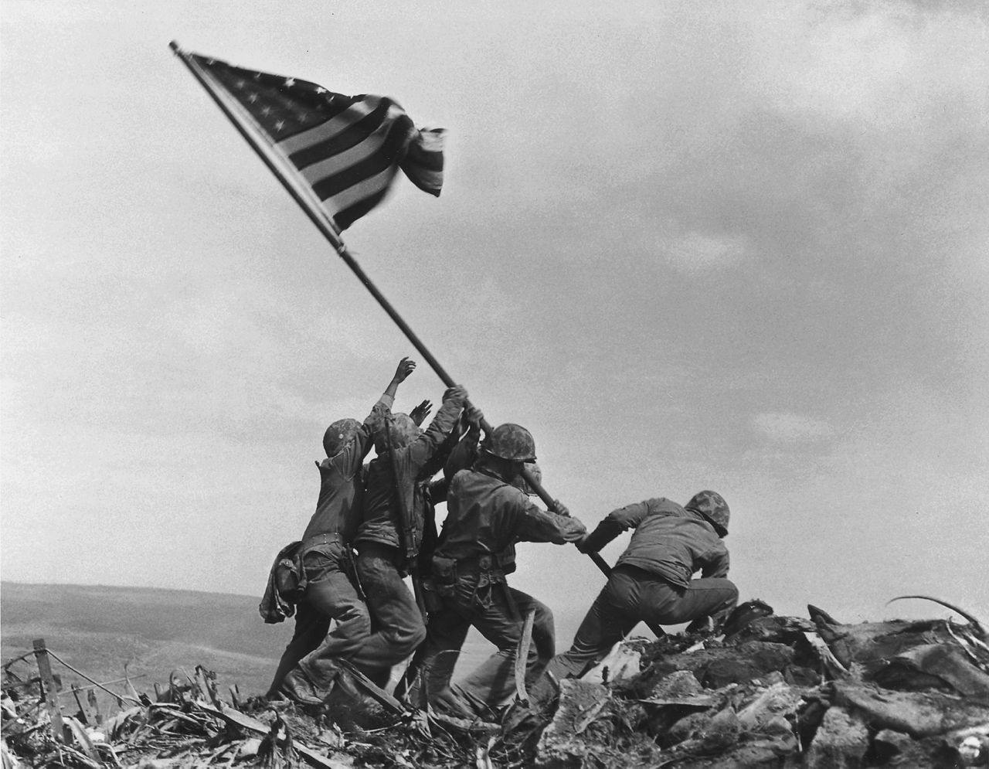
U.S. Marines of the 28th Regiment, 5th Division, raise the American flag atop Mt. Suribachi, Iwo Jima, on February 23, 1945.
Credit: © 2015 Associated Press
IWO JIMA: FROM COMBAT TO COMRADES premieres on Tuesday, November 10, 2015, 8:00-9:00 p.m. ET (check local listings) as part of Veterans Day programming on PBS.

Two film crews were used to capture the historic reunion for IWO JIMA: FROM COMBAT TO COMRADES. An American unit followed three U.S. veterans — Lt. General Larry Snowden, USMC (Ret.), US Marine Hershel “Woody” Williams and Army Air Corps fighter pilot Jerry Yellin — while a Japanese crew filmed Tsuriji Akikusa, the only Japanese survivor able to make the arduous trip to Iwo Jima. Through their firsthand accounts, the film takes viewers back to 1945 when these men first encountered each other as four of the 90,000 combatants on an eight square mile island, a dot in the Pacific Ocean just 650 miles from Tokyo. Twenty-eight thousand soldiers died either defending or taking Iwo Jima. Seventy years later, men who lost so much make the emotional pilgrimage back to face the defining moment of their lives.

“This film is an odyssey from the hell and hatred that was the battle of Iwo Jima in 1945, to the forgiveness, friendship, and healing which happened this year on the very island that saw perhaps the fiercest fighting of WWII,” said Executive Producer Arnold Shapiro. “The 70th anniversary commemoration ceremony on Iwo Jima embodied the phrase, ‘once enemies, now friends,’ and we watched as men’s lives were transformed before our eyes. It was an honor to work with an outstanding team of American and Japanese filmmakers to preserve the story of these men and their inspiring journey.”

“PBS is honored to present this inspiring documentary about reconciliation and healing,” said Bill Gardner, Vice President for Programming and Development at PBS. “The veterans who share their personal experiences are remarkably candid about the events of the war, and their journey from hatred to reconciliation is powerful and encouraging.”

Host Ryan Phillippe portrayed John “Doc” Bradley, one of the young men in the famous photograph who helped raise the flag over Iwo Jima, in Clint Eastwood’s Flags of our Fathers. Both of Phillippe’s grandfathers fought in World War II and his father served in Vietnam.

IWO JIMA: FROM COMBAT TO COMRADES is part of PBS Stories of Service, which highlights national programming content on PBS that features compelling stories of those who have served, and provides a deeper understanding of our nation’s military history. Additional PBS programs airing around Veterans Day include: DEBT OF HONOR: DISABLED VETERANS IN AMERICAN HISTORY, which takes an unflinching look at the reality of warfare and disability through moving interviews with some of the country’s most prominent disabled veterans, on Tuesday, November 10 from 9:00-10:00 p.m.; and INDEPENDENT LENS “Stray Dog,” where viewers will meet Vietnam veteran Ronnie Hall, who is coming to terms with his combat experience and shattering misconceptions about veterans, on Monday, November 9 from 10:00-11:30 p.m.

IWO JIMA: FROM COMBAT TO COMRADES will be available on DVD in December 2015 from PBS Distribution.

About the Major Participants

Lt. General Larry Snowden (USMC, Ret.) is the highest-ranking US officer alive who fought on Iwo Jima, where he was twice wounded. He founded the Reunion of Honor twenty years ago so that his fellow veterans, as well as Japanese survivors, could return to Iwo Jima – this time in peace and friendship. He retired from the Marine Corps after 37 years of service and has attended every Reunion of Honor for the last 20 years. Now 94 years old, he says this was his last trip to Iwo Jima.

Hershel “Woody” Williams, born in Fairmont, West Virginia, is the last surviving Medal of Honor recipient (of 27) for valor “above and beyond the call of duty” on Iwo Jima. It took 70 years for him to return to the site of his heroism. Williams founded Gold Star Families to acknowledge all those who lost loved ones to war.

Jerry Yellin, who served as a US Army Air Corps P-51 fighter pilot, hated the Japanese. He blamed them for killing 16 close friends during the war, for attacking Pearl Harbor, and for the decades of post-traumatic stress (PTSD) he suffered after the war. But then his son married a Japanese woman and gave him three half-Japanese grandchildren. In the film, he tells about his personal transformation and redemption. The author of four books, today Yellin travels the world sharing his story and helping to bring healing and hope to a new generation of veterans who are battling PTSD.

Tsuriji Akikusa is one of just a handful of surviving Japanese soldiers and he owes his life to an unknown American soldier who rescued him when he was wounded during the fighting. His generous nature won over a number of American veterans who never thought they would shake the hand of their former enemy. Today, at 89, Akikusa still works as an electrician running a successful business.

Dan King is a historian who often works as a historical consultant on films and provided the English translation for the Japanese interviews in the film. King, who has a degree in Japanese from California State University, Los Angeles, has traveled to Iwo Jima nine times, and interviewed 100 Japanese veterans who served in World War II. He is the author of The Last Zero Fighter and A Tomb Called Iwo Jima.

IWO JIMA: FROM COMBAT TO COMRADES

Hosted by |  | RYAN PHILLIPPE
Executive Producer |  | ARNOLD SHAPIRO
Produced and Directed by |  | CAROL L. FLEISHER
Producer |  | LORI MASON FRYE
Editor |  | ROB GOUBEAUX, ACE
Post Producer |  | JOHN GENGL

An ARNOLD SHAPIRO PRODUCTION
in association with
CENTE SERVICES CORPORATION

About Arnold Shapiro Productions
Arnold Shapiro Productions has been producing documentary and reality series and specials for 34 years, producing programs for every broadcast network including PBS and 14 cable channels. ASP’s 29 series and over 90 specials include “Rescue 911,” hosted by William Shatner, which aired on CBS for seven years; six summer-seasons of CBS’s “Big Brother”; A&E's “Beyond Scared Straight,” which ran for five years; and “Scared Silent: Exposing & Ending Child Abuse,” hosted by Oprah Winfrey and simulcast on CBS, NBC, ABC, and PBS, which holds the record for being the most watched non-news documentary special ever aired on American television. Arnold Shapiro's 100+ awards include an Academy Award, 16 Emmys, a Peabody Award, the People’s Choice Award, and the Career Achievement Award presented by the International Documentary Association.

About PBS Stories of Service
As America’s storyteller, PBS is bringing together multi-platform content and powerful conversations around U.S. military veterans under the banner of Stories of Service. The national programming content features compelling stories of those who have served and provides a deeper understanding of our nation’s military history. Through public television on air and on PBS.org, PBS member stations will create their own local content and provide community resources for returning veterans and their families. The initiative will educate the civilian population about our military history and highlight the contributions from the veteran community. The Stories of Service initiative was announced in May 2014 along with a community engagement campaign for select PBS member stations and their local veterans and funded by the Corporation for Public Broadcasting (CPB), called Veterans Coming Home. The PBS programming under Stories of Service, many with funding support from CPB, includes a comprehensive list of titles, many of which can be found here. The initiative runs through 2017 with the premiere of Ken Burns’s and Lynn Novick’s THE VIETNAM WAR.

About PBS
PBS, with over 350 member stations, offers all Americans the opportunity to explore new ideas and new worlds through television and online content. Each month, PBS reaches more than 103 million people through television and over 33 million people online, inviting them to experience the worlds of science, history, nature and public affairs; to hear diverse viewpoints; and to take front row seats to world-class drama and performances. PBS’ broad array of programs has been consistently honored by the industry’s most coveted award competitions. Teachers of children from pre-K through 12th grade turn to PBS for digital content and services that help bring classroom lessons to life. PBS’ premier children’s TV programming and its website, pbskids.org, are parents’ and teachers’ most trusted partners in inspiring and nurturing curiosity and love of learning in children. More information about PBS is available at www.pbs.org, one of the leading dot-org websites on the Internet, or by following PBS on Twitter, Facebook or through our apps for mobile devices. Specific program information and updates for press are available at pbs.org/pressroom or by following PBS Pressroom on Twitter.

– PBS –

CONTACT:
CaraMar, Inc.
Mary Lugo 770-623-8190 lugo@negia.net
Cara White 843-881-1480 cara.white@mac.com
Abbe Harris 908-244-5516 abbe@caramar.net

For images and additional information visit http://www.pbs.org/pressroom

