Independent Lens Presents The Kill Team
Monday, January 19, 2015 on PBS

About the Filmmaker

Dan Krauss (Director/Producer/Cinematographer) was nominated for an Academy Award and two Emmy Awards for his first film, The Death of Kevin Carter. The film also won prizes from the Tribeca Film Festival, the International Documentary Association, and the San Francisco International Film Festival, among others.
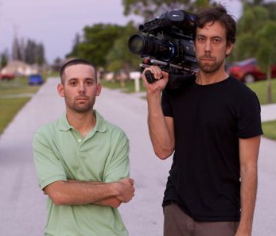

Adam Winfield (left) and director Dan Krauss (right).
Credit: Lincoln Else

Working as a Director of Photography, Krauss has photographed numerous feature documentaries, including Inequality for All (Sundance Film Festival, 2013 – Grand Jury Prize); Broadway Idiot (SXSW, 2013); We Are Legion (SXSW 2012); The Most Dangerous Man in America (Academy Award nomination, 2010); and Life 2.0 (Sundance Film Festival, 2010).

In 2012, Krauss received a grant from the National Endowment for the Arts and a fellowship from the Sundance Documentary Institute.

Krauss earned his Masters Degree from UC Berkeley’s Graduate School of Journalism, where he is presently a lecturer in film and television production.

###

