About the Film-Makers
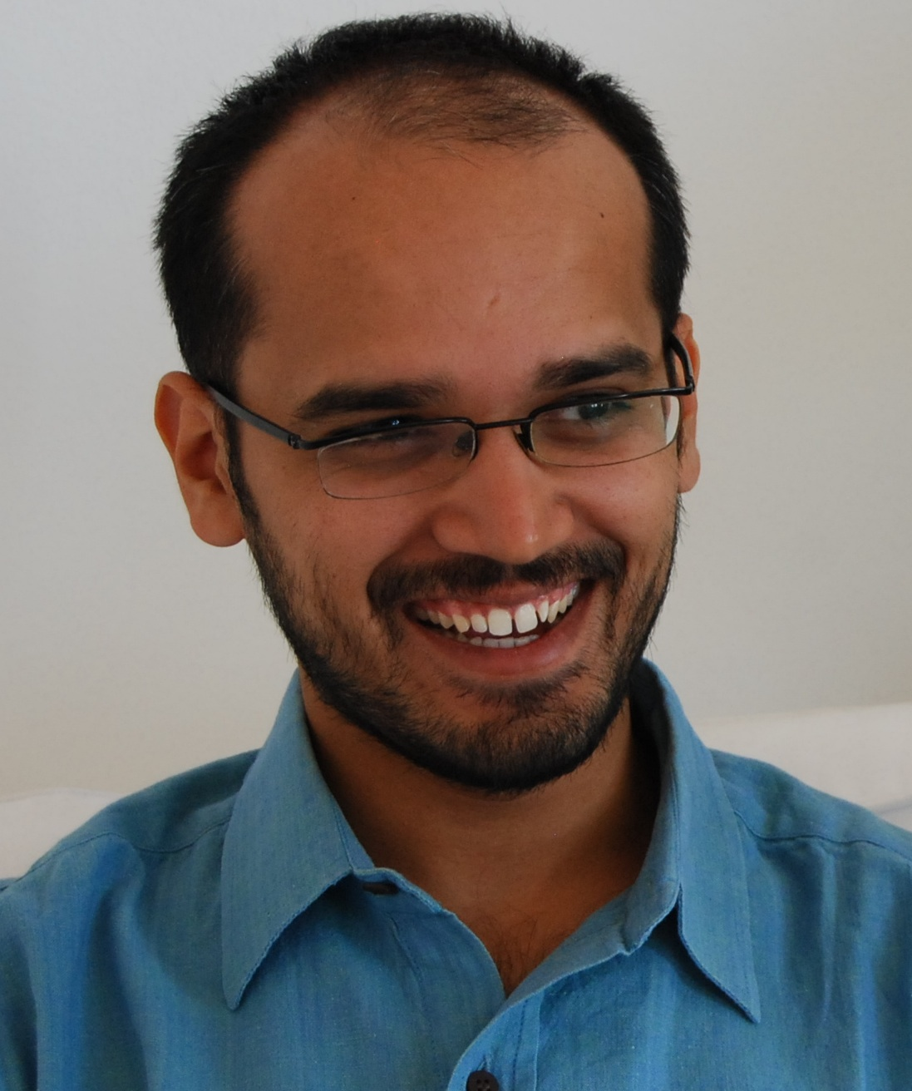
Fahad Mustafa (Director/Producer):
Born in Kanpur on 10th November 1984, Fahad has since lived in Dammam, New Delhi, Vienna and Edmonton. He was an Erasmus Mundus Global Studies scholar. His previous film, as director, was FC Chechnya (Austria, 2010)


Deepti Kakkar (Director/Producer):
Born in Delhi on 21st February 1986, Deepti has been engaged in issues of social development sustainable livelihood for the last 10 years. She has previously directed a film on microfinance in India, and worked on story-development and as production manager on FC Chechnya. Deepti lives in Ghaziabad, India.

