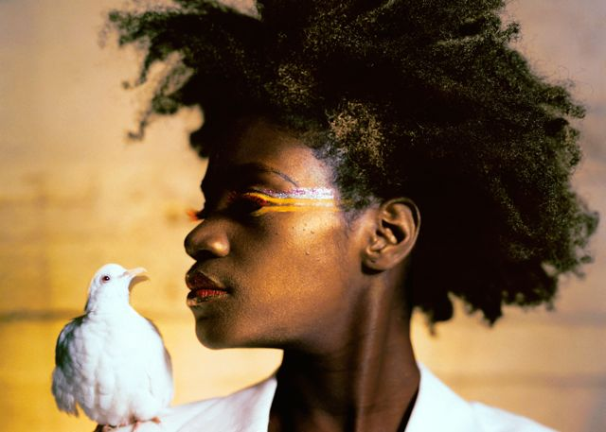
Credit: Lyle Ashton Harris in collaboration with Thomas Allen Harris.

Through a Lens Darkly: Black Photographers and the Emergence of a People Premieres on Independent Lens
Monday, February 16, 2015 on PBS

“A family memoir, a tribute to unsung artists, and a lyrical, at times heartbroken, meditation on imagery and identity. The film is always absorbing to watch, but only once it’s over do you begin to grasp the extent of its ambitions, and just how much it has done within a packed, compact hour and a half. Overall, he is a wise and passionate guide to an inexhaustibly fascinating subject.”
- A. O. Scott, The New York Times

(San Francisco, CA) — The first documentary to explore the role of photography in shaping the identity, aspirations and social emergence of African Americans from slavery to the present, Through a Lens Darkly: Black Photographers and the Emergence of a People probes the recesses of American history through images that have been suppressed, forgotten and lost. Bringing to light the hidden and unknown photos shot by both professional and vernacular African American photographers, the film opens a window into the lives of black families, whose experiences and perspectives are often missing from the traditional historical canon. These images show a much more complex and nuanced view of American culture and society and its founding ideals. Inspired by Reflections in Black by author Deborah Willis, the film features the works of Carrie Mae Weems, Lorna Simpson, Anthony Barboza, Lyle Ashton Harris, Hank Willis Thomas, Coco Fusco, Clarissa Sligh, and many others. Through a Lens Darkly, directed by Thomas Allen Harris, premieres on Independent Lens on Monday, February 16, 2015, 10:00-11:30 PM ET (check local listings), as part of Black History Month programming on PBS.

The work of pioneering black photographers over the past 170 years — both men and women — is highlighted throughout the film. Their images help reclaim a sense of collective self-worth and humanity, and provide a rich history of African American contributions to the development of photography, both as an art form and a force to be reckoned with. Capturing the spirit of transformation that led African Americans from the deprivations of slavery to the self-sufficiency of economic mobility and social stability, the film also focuses on the ways in which black photographers learned to use the medium to construct strategically useful political, aesthetic, and cultural representations of themselves and their world.

Filmmaker Thomas Allen Harris, who carries at least one camera with him at all times, has been mining material from his extended family archives for over 20 years. But making Through a Lens Darkly provided him with new insights. “This project would take me on a personal journey to understand why it was so important for black photographers, both professional and vernacular, to make photographs,” he said. “Through this journey I was to learn that it was a form of activism and a strategy for survival in America.”

Visit the Through a Lens Darkly companion website (http://www.pbs.org/independentlens/through-a-lens-darkly/) which features information about the film, including an interview with the filmmaker, preview clips and more.

About the Filmmaker

Thomas Allen Harris (Director, Producer, Writer) is the founder and president of Chimpanzee Productions, a company dedicated to producing unique audiovisual experiences that illuminate the human condition and the search for identity, family, and spirituality. Chimpanzee’s innovative and award-winning performance-based documentary films —VINTAGE - Families of Value, E Minha Cara/That’s My Face, and Twelve Disciples of Nelson Mandela — have received critical acclaim at international film festivals such as Sundance, Berlin, Toronto, FESPACO, Outfest, Flaherty, and Cape Town, and have been broadcast on PBS, the Sundance Channel, ARTE, as well as CBC, Swedish Broadcasting Network, and New Zealand Television. His video and installations have been featured at prestigious museums and galleries including the Museum of Modern Art, the Whitney Biennial, the Corcoran Gallery, Reina Sophia, and the London Institute of the Arts. Harris has received numerous fellowships and awards including a United States Artist Fellowship, Guggenheim Fellowship, Rockefeller Fellowship, as well as CPB/PBS and Sundance Directors Fellowships. A graduate of Harvard College, Harris lectures widely on the use of media as a tool for social change.
CREDITS
Director, Producer, Writer |  | Thomas Allen Harris

Inspired by the book Reflections in Black: A History of Black Photographers
1840 to the Present by Deborah Willis

Producers  Executive Producers  Consulting Producer  Writers  Editors  Composer  Additional Music and Opening Theme Composed and Performed by |  | Deborah Willis  Ann Bennett  Don Perry  Kimberly Steward  John Singleton  Gregory Warren  Don Perry  Paul Carter Harrison  K.A. Miille  Matthew Cohn  Vernon Reid  Miles Jay

About Independent Lens

Independent Lens is an Emmy® Award-winning weekly series airing on PBS Monday nights at 10:00 p.m. The acclaimed series features documentaries united by the creative freedom, artistic achievement, and unflinching visions of independent filmmakers. Presented by Independent Television Service, the series is funded by the Corporation for Public Broadcasting, a private corporation funded by the American people, with additional funding from PBS and the John D. and Catherine T. MacArthur Foundation. For more visit pbs.org/independentlens. Join the conversation: facebook.com/independentlens and on Twitter @IndependentLens.
###
FOR IMMEDIATE RELEASE

CONTACT
Lisa Tawil, ITVS 415-356-8383 lisa_tawil@itvs.org
Mary Lugo 770-623-8190 lugo@negia.net
Cara White 843-881-1480 cara.white@mac.com
For downloadable images, visit pbs.org/pressroom/

