American Denial Premieres on Independent Lens
Monday, February 23, 2015 on PBS

About the Filmmakers

Christine Herbes-Sommers (Producer) is President of Vital Pictures, Inc. and has produced over 100 hours of documentary, dramatic, and educational programming for PBS since 1976. Her film Joan Robinson: One Woman’s Story won the duPont-Columbia Award in 1981, and her work over the years has garnered many other awards. At Vital Pictures she partnered with Llewellyn Smith and California Newsreel to develop and produce the award-winning, four-part series Unnatural Causes: Is Inequality Making Us Sick? and was executive producer for the award-winning documentary Herskovits at the Heart of Blackness. She is currently producer for Raising of America and is spearheading the Coming of Age in an Aging America project. She and Smith were also producers for the groundbreaking series Race: The Power of an Illusion in 2001. Prior to Vital Pictures, Christine was a staff producer at WGBH/Boston and at The Big Picture Company in Rhode Island where she created innovative programming for schools nationwide. She has a BA in Political Science from Knox College and a MA from the Fletcher School of Law & Diplomacy.
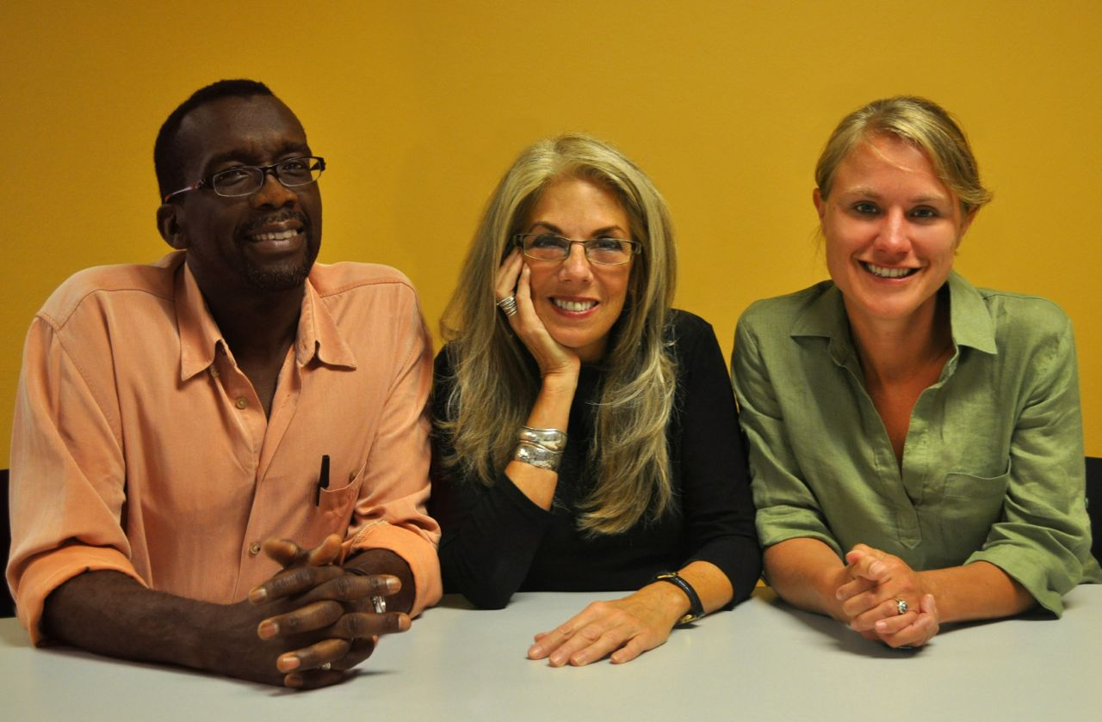
Llewellyn Smith, Christine Herbes-Sommers and Kelly Thomson.
Courtesy of ITVS.

Llewellyn Smith (Producer/Director) is co-founder and project director at Blue Spark Collaborative. Until 2012, with his producing partner Christine Herbes-Sommers at Vital Pictures, they created a number of award-winning films. Smith was co-executive producer for the PBS series Unnatural Causes: Is Inequality Making Us Sick?, a look at the surprising impact social and economic conditions have in determining health and longevity. He also served as director-producer for the Vital Pictures documentary Herskovits at the Heart of Blackness, a look at the consequences of race identity politics, which aired on Independent Lens. In 2012, Smith directed and produced Vital Pictures’ Gaining Ground: Building Community on Dudley Street. The film followed community organizing and community building effort over a two-year period in the remarkable low-income Boston neighborhood where he grew up. Other films or series contributions include Africans in America: America’s Journey through Slavery (1997), Race: The Power of an Illusion (2003), and Forgotten Genius (2007)

Kelly Thomson (Producer) served as producer and editor on Vital Pictures’ award-winning films, including Gaining Ground: Building Community on Dudley Street, The Raising of America, Herskovits at the Heart of Darkness, and Unnatural Causes: Is Inequality Making Us Sick? She is currently in production on an independent documentary that profiles female leaders in Islamic

mysticism (w.t. Shaykha.) Her first feature independent documentary, Savage Memory, has screened at festivals, museums, and universities across the globe. She recently served as Artist-in-Residence at the Dudley Street Neighborhood Initiative where she worked with teens to create short films. Thomson began working in film at the age of 19 and has worked on a number of independent films over the past fifteen years, including Wild Art, Hotels 4, All Falls Down, A Vote for Choice, and Funeral of the Last Gypsy King. She received her BA from New York University in Religious Studies.

###

