Lacey Schwartz’s Little White Lie Premieres on Independent Lens
Monday, March 23, 2015 on PBS

About the Filmmaker

Lacey Schwartz (Writer/Producer/Director) is the CEO of the production and outreach organization Truth Aid. She has over a decade of experience in the nonprofit and media sector working with a variety of production companies, networks, and organizations including MTV, BET, @radical.media, Be’chol Lashon/Institute for Jewish Community and Research, and NASCAR.
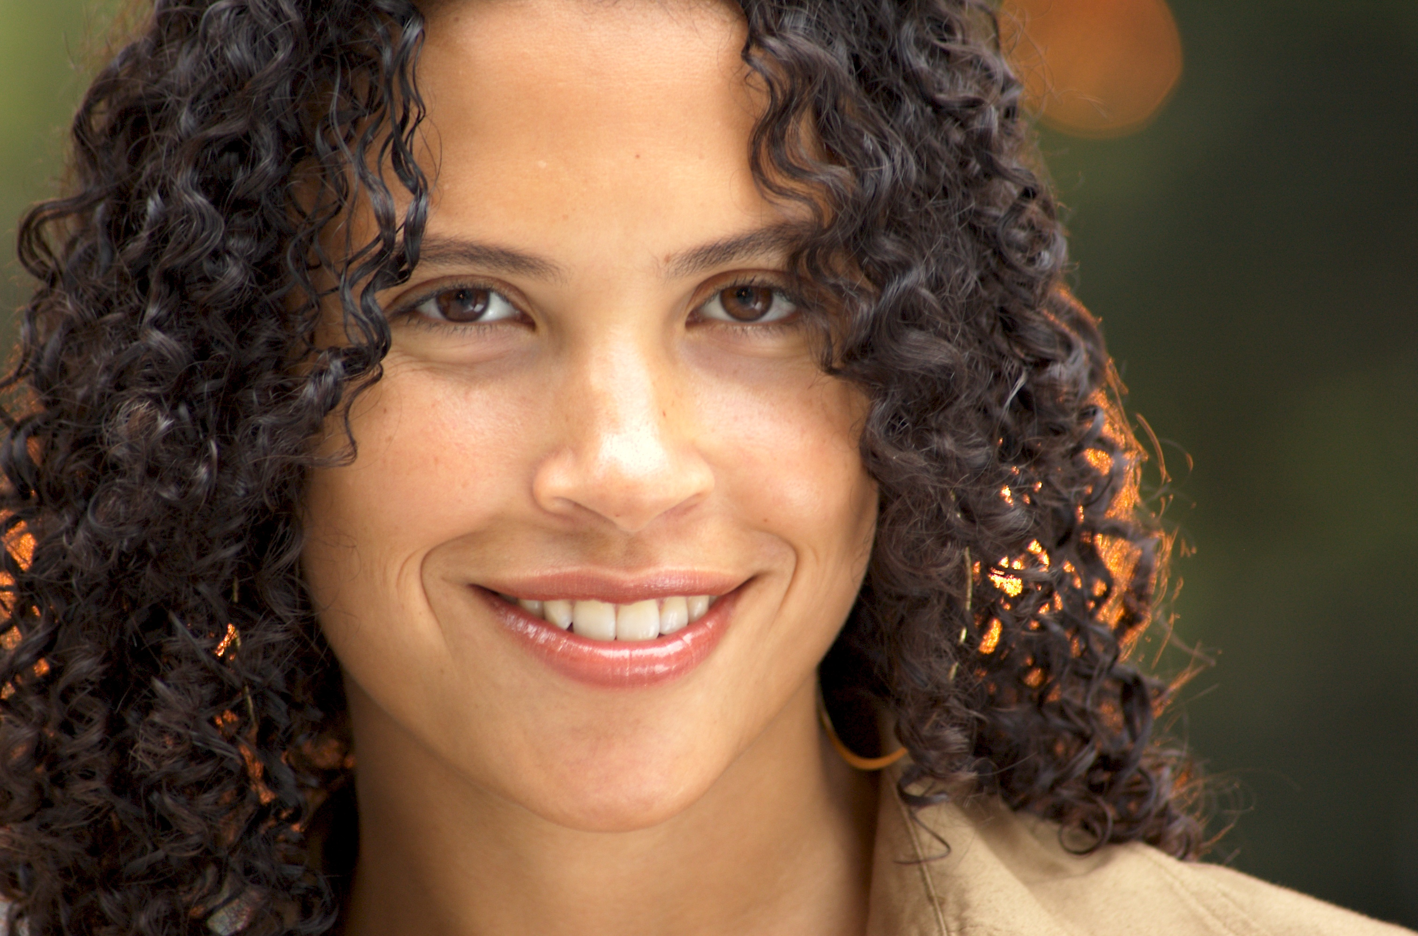
Credit: Michael Hill

Little White Lie is her first film as a director. She also Executive Produced the narrative film Difret, which won audience awards at the 2014 Sundance and Berlin Film Festivals. Prior to her media career, Schwartz was a professional DJ and public high school math and theater teacher. She has a BA from Georgetown University, a JD from Harvard Law School, and is a member of the New York State Bar.

She speaks widely on issues of diversity and the use of media to spark dialogue around important social issues, giving people tools that lead to personal evolution and social change.

###

