Little Hope Was Arson Premieres on
Independent Lens Monday, April 6, 2015 on PBS

About the Filmmakers

Theo Love (Director, Producer, Editor) is an international storyteller. Growing up as an American in Southeast Asia gave him a curiosity for culture and characters that don’t quite fit in. After traveling the globe documenting everything from villages in Tanzania to urban areas of London, Love landed in Los Angeles and launched his career as a director. In addition to his work in the documentary field, Theo is an award-winning short filmmaker and is planning his next jump into narrative features. Little Hope Was Arson is his first feature documentary.
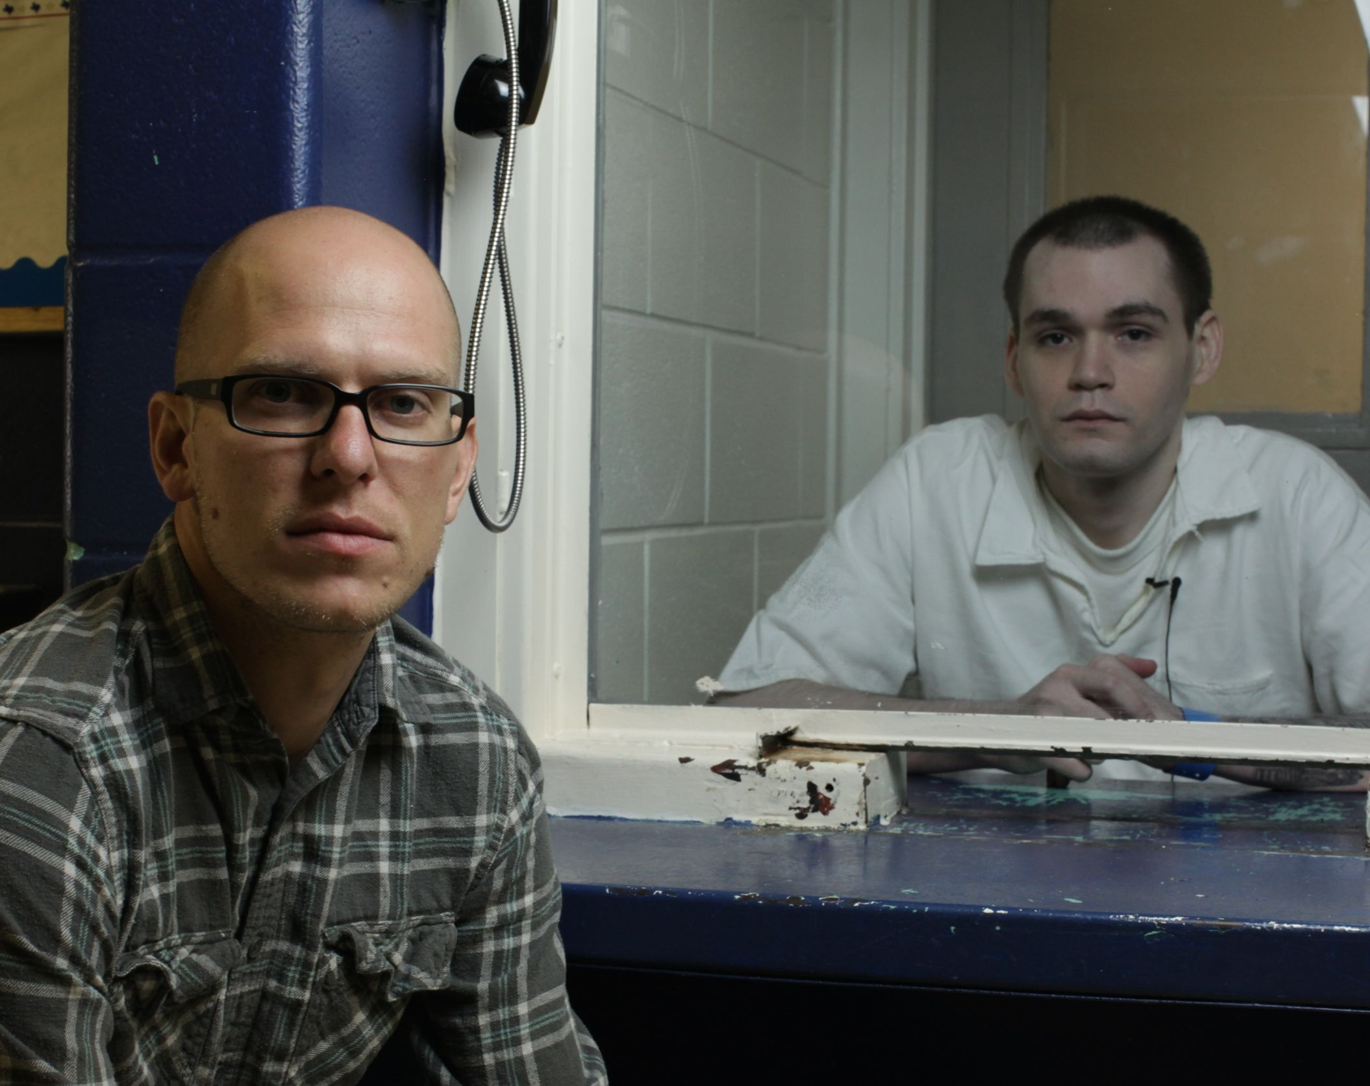
Theo Love interviews Daniel McAllister (right) in a Texas prison.
Credit: Nate Larson

Trenton Waterson (Producer ) is an award-winning independent film producer and a Creative Executive for Marvel Studios. Raised on a farm in Northern California, Trenton has spent the past eight years in Los Angeles with one foot in the franchise filmmaking world and the other in his more intimate, independent productions. Trenton’s credits include work on productions for Jerry Bruckheimer Films, Walt Disney Productions, Spyglass Entertainment, New Line Cinema as well as Marvel Studios, where he learned production management as mentor and assistant to Patty Whitcher, the Line Producer of Marvel’s Thor (2011) and Avengers (2012). His most recent studio credit was with Marvel Studios as Creative Executive of the Iron Man 3 (2013) film and franchise.

During his time spent studio side, Trenton has also creatively produced multiple award-winning short film projects under his company, theCollaborate. In addition to Little Hope Was Arson, his first feature film as a producer, Trenton will soon release two more feature films: We All Might Make It (2014) and Just Because He Breathes (2015).
Bryan Storkel (Executive Producer) is an award-winning documentary filmmaker who loves quirky characters and is fascinated by religious topics. His first documentary, Strictly Background (a film he shot and edited), is a character driven film following professional "extras" in Hollywood. Storkel's follow-up film, HOLY ROLLERS: The True Story of Card Counting Christians, focuses on a group of pastors who run the largest organized gambling team in the country, taking millions from casinos. The film played at over 40 festivals and won ten Best Documentary Awards.

His most recent film, Fight Church, released in 2014, is a feature documentary about the confluence of Christianity and Mixed Martial Arts. The film follows several cage-fighting pastors in a quest to reconcile their faith with a sport that some consider violent and barbaric.
###

