FOR IMMEDIATE RELEASE

CONTACT
Lisa Tawil, ITVS 415-356-8383 lisa_tawil@itvs.org
Mary Lugo 770-623-8190 lugo@negia.net
Cara White 843-881-1480 cara.white@mac.com
For downloadable images, visit pbs.org/pressroom/

Little Hope Was Arson Premieres on Independent Lens
Monday, April 6, 2015 on PBS

Series of Church Burnings Sparks Fear and Soul-Searching
in East Texas
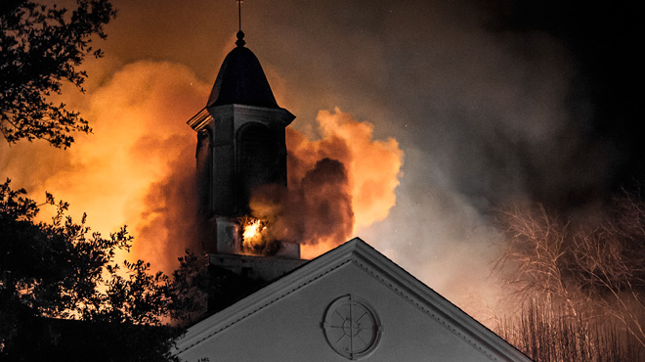
Credit: Jamie Maldonado
(San Francisco, CA) — On January 1, 2010, Little Hope Baptist Church burned to the ground in Canton, Texas, the buckle of the Bible Belt. Officials concluded the fire was caused by a problem in the century-old church’s wiring. But when nine more churches went up in flames in one month, the largest manhunt in East Texas history was ignited. In this riveting investigation of a community terrorized from the inside out, families are torn apart and even Satan himself is considered a suspect. Directed by Theo Love, Little Hope Was Arson is an incredible true story of two boys with dark secrets and the community that raised them wrestling with forgiveness and justice. The film premieres on Independent Lens Monday, April 6, 2015, 10:00-11:30 PM ET (check local listings) on PBS.

One of the highest-profile cases in East Texas history, the criminal investigation into the multiple church burnings took incredible twists and turns. Moments after Texas Rangers followed a young man named Jason Bourque into a local hardware store, a janitor found the words “Little Hope was arson” scratched in the store’s bathroom stall. Bourque, 19, and his best friend, Daniel McAllister, 21, who had met as children in the Sunday school of a local Baptist church, were now the primary suspects. Once they were arrested and charged with the crime, the entire community — from parents to pastors — struggled to understand what happened and why.

The son of Christian missionaries, filmmaker Theo Love grew up in Southeast Asia, worshipping most often in private homes or outdoors. “From the moment I read about these fires, I knew that I wanted to make this into a movie,” said Love. “Not only was it a chilling mystery — it challenged the very core of my faith. But I knew there was a redemptive story that could rise from these violent and tragic acts.”

Visit the Little Hope Was Arson companion website (http://www.pbs.org/independentlens/little-hope-was-arson/) which features information about the film, including an interview with the filmmaker, preview clips, and more.

Participants (in order of appearance):

Reverend Bill Parr, pastor of Little Hope Baptist Church
Benny Woods, Clear Springs Missionary Baptist Church
Lee Richards, Tyland Baptist Church
Reverend David and Peggy Mahfood, Tyland Baptist Church
Special Agent Larry Smith, ATF lead investigator in the church burnings
Sergeant Brent Davis, Texas Ranger and lead investigator in the church burnings
Christy McAllister, Communications Operator, Department of Public Safety, and sister of
Daniel McAllister
Brian Hoback, ATF, National Response Team Leader
Rev. Roy Devisscher, Community Christian Fellowship
Kim Bourque, Jason’s mother
Bob and Brenda Steel, Jason’s grandparents, who raised him from childhood
David McAllister, Daniel’s father
Rev. Carlton Young, former pastor, First Baptist Church of Ben Wheeler, where Jason and Daniel met as children
James Ellis, Sunday school teacher to both Daniel and Jason
Dan Harrison, former Texas judge
Greg Waldron, Jason’s lawyer
Brent Ratekin, Daniel’s court-appointed lawyer
Pastor David Martin, Pinebrook Baptist Church
Daniel McAllister, convicted of the church burnings and currently serving multiple life sentences
Jason Bourque, convicted of starting the church fires, Jason was an Eagle Scout and the 2008 Texas State Debate Champion

About the Filmmaker

Theo Love (Director, Producer, Editor) is an international storyteller. Growing up as an American in Southeast Asia gave him a curiosity for culture and characters that don’t quite fit in. After traveling the globe documenting everything from villages in Tanzania to urban areas of London, Love landed in Los Angeles and launched his career as a director. In addition to his work in the documentary field, Theo is an award-winning short filmmaker and is planning his next jump into narrative features. Little Hope Was Arson is his first feature documentary.

CREDITS

Directed by  Produced by |  | Theo Love  Trenton Waterson  Theo Love
Executive Produced by |  | Bryan Storkel
Cinematography  Edited by  Music by  Additional Photography by  Associate Producer  Executive Producers |  | Nate Larson  Theo Love  Michael Lee  Austin Tirado  Luke Boney  Andrew Peters  Mark Blitch  Andrew Peters  Tom and Cindy Waterson  Tom and Kathy Love  Will Garroutte  Joshua Fine

About Independent Lens

Independent Lens is an Emmy® Award-winning weekly series airing on PBS Monday nights at 10:00 PM. The acclaimed series features documentaries united by the creative freedom, artistic achievement, and unflinching visions of independent filmmakers. Presented by Independent Television Service, the series is funded by the Corporation for Public Broadcasting, a private corporation funded by the American people, with additional funding from PBS and the John D. and Catherine T. MacArthur Foundation. For more visit pbs.org/independentlens. Join the conversation: facebook.com/independentlens and on Twitter @IndependentLens.

###

