Born to Fly: Elizabeth Streb vs. Gravity
on Independent Lens
Monday, May 11, 2015 on PBS

About the Filmmaker

Catherine Gund (Producer/Director) is an Emmy-nominated producer, director, writer, and organizer, and the founder of Aubin Pictures. Her media work focuses on arts and culture, HIV/AIDS and reproductive health, the environment, and other social justice issues. Her films — which include Born to Fly, What's on Your Plate?, A Touch of Greatness, Motherland Afghanistan, Making Grace, On Hostile Ground, and Hallelujah! Ron Athey: A Story of Deliverance — have screened around the world in festivals, theaters, museums, and schools; on PBS, Discovery's Planet Green, and the Sundance Channel. Gund's most recent project, Born to Fly pushes the boundaries between action and art, daring us to join choreographer Elizabeth Streb and her dancers in pursuit of human flight. Her multimedia project What's On Your Plate? is a fun and provocative documentary about kids and food politics, accompanied by a curriculum, website, and workbook for families.
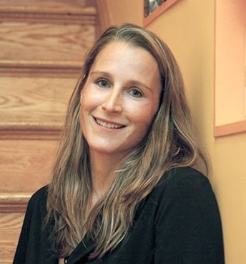
Credit: Lena Vassiliou

Gund currently serves on several boards including Art Matters, Bard Early Colleges, Osa Conservation ​and The George Gund Foundation. She co-founded the Third Wave Foundation, which supports young women and transgender youth, and DIVA TV, an affinity group of ACT UP/NY. She was the founding director of BENT TV, the video workshop for gay, lesbian, bisexual, and transgender youth. She was on the founding boards of Iris House, Working Films, Reality Dance Company, and The Sister Fund and has also served for MediaRights.org, The Robeson Fund of the Funding Exchange, The Vera List Center for Art and Politics at the New School, and the Astraea Foundation. She lives in NYC with her four children.

###

