Stray Dog Premieres on Independent Lens
Monday, November 9, 2015 on PBS

About the Filmmakers
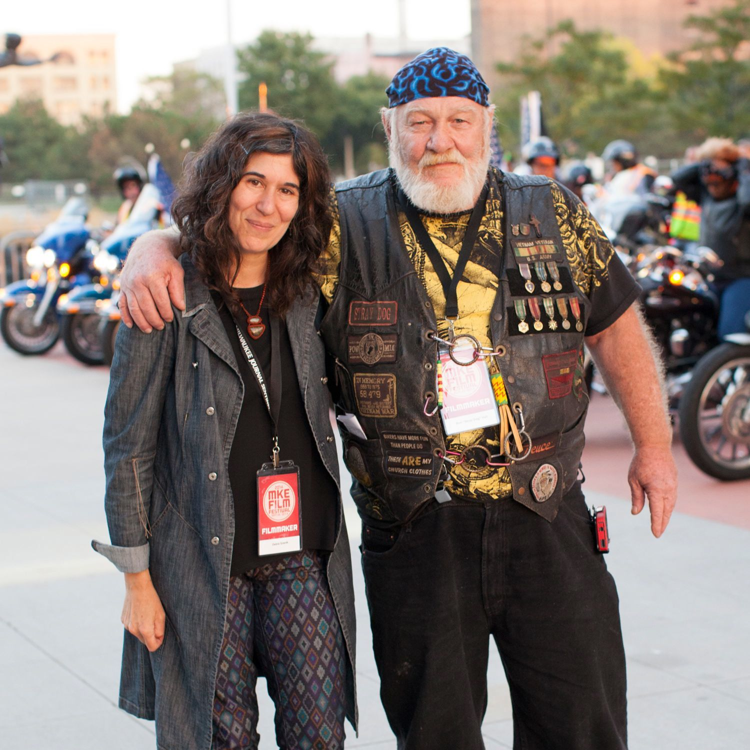
Debra Granik and Ron “Stray Dog” Hall. Credit: Jennifer Johnson for Milwaukee Film.
Debra Granik (Director) started working in film and video in the Boston grassroots media movement in the late 1980s. She studied politics at Brandeis University and her first forays into operating a camera and collaborating on political documentation were with Boston-based media groups such as the Women’s Video Collective. While in Boston she had the good fortune to be able to take classes at Massachusetts College of Art, Studio for Interrelated Media, which exposed her to a great variety of film work and traditions. Granik shot and produced educational programs related to workplace health and safety issues and then worked on several long form documentaries by Boston-based filmmakers. From there, she moved to New York to attend New York University’s graduate film program.

At NYU, she made several short films, one of which, Snake Feed, garnered an award at Sundance, which led to involvement in the Sundance Screenwriting and Directing Labs. She expanded the story from Snake Feed into a longer script which formed the basis for the feature Down to the Bone, created with her producing partner, Anne Rosellini. Down to the Bone was awarded the Best Director prize at the 2004 Sundance Film Festival. Her next film, Winter's Bone, won the Grand Jury Prize at the 2010 Sundance Film Festival and was nominated for four Oscars including Best Picture and Best Adapted Screenplay. Going forward, she hopes to be proceeding on both the narrative fiction and documentary tracks, including forays onto the third rail when the two tracks seem to converge.

Anne Rosellini (Producer) is an independent film producer who runs a production and development company in New York with director Debra Granik. Together they made the 2010 Oscar-nominated film Winter’s Bone, starring Jennifer Lawrence, and 2004 Sundance winner Down to the Bone, starring Vera Farmiga. Rosellini comes from a background in programming and acquisitions. She founded the 1 Reel Film Festival in Seattle in 1996, which became one of the largest showcases of independent short film in the US. She was also a programmer for the Seattle International Film Festival, the Women in Film Festival, and the Arab Film Festival, before becoming an Acquisitions Manager for AtomFilms, an online platform for short films. She holds a BFA from The School of the Art Institute of Chicago.

Victoria Stewart (Producer/Editor) is a New York-based film editor and producer who works in both narrative and documentary. Stewart was an assistant editor on Winter's Bone and the editor of Hillbilly Up, a documentary about Ozarks culture that accompanied the film's release. Prior to her career in post-production, she worked as an art department assistant for film and television. She is currently co-producing and editing a documentary about life after incarceration. Victoria hails from San Francisco and received a BA in Film and Performance Studies from Stanford University. She is an active member of the Brooklyn Filmmakers Collective.

