FOR IMMEDIATE RELEASE

CONTACT
Lisa Tawil, ITVS 415-356-8383 lisa_tawil@itvs.org
Mary Lugo 770-623-8190 lugo@negia.net
Cara White 843-881-1480 cara.white@mac.com
For downloadable images, visit pbs.org/pressroom/
Stray Dog Premieres on Independent Lens
Monday, November 9, 2015 on PBS

Portrait of Vietnam Veteran Ron “Stray Dog” Hall, who filmmaker
Debra Granik met when she cast him in her
Academy Award-nominated feature, Winter’s Bone

(San Francisco, CA) – A burly and bearded biker, Ron “Stray Dog” Hall lives in southern Missouri where he owns and operates the At Ease RV Park. A Vietnam veteran, Stray Dog is forever wrestling with the brutal legacy of the war on his soul, a constant struggle of conscience, remorse, and forgiveness. The film follows Stray Dog as he caravans on his Harley with his fellow vets to pay tribute to their fallen brothers at the Vietnam Memorial. Back home, he forges a new life of domesticity with his Mexican wife Alicia and her two sons, who are also struggling to find their place in the ever-changing hardscrabble heartland of America. A film by Debra Granik (Winter’s Bone), Stray Dog premieres on Independent Lens on November 9, 2015, 10:00-11:30PM ET (check local listings) on PBS.
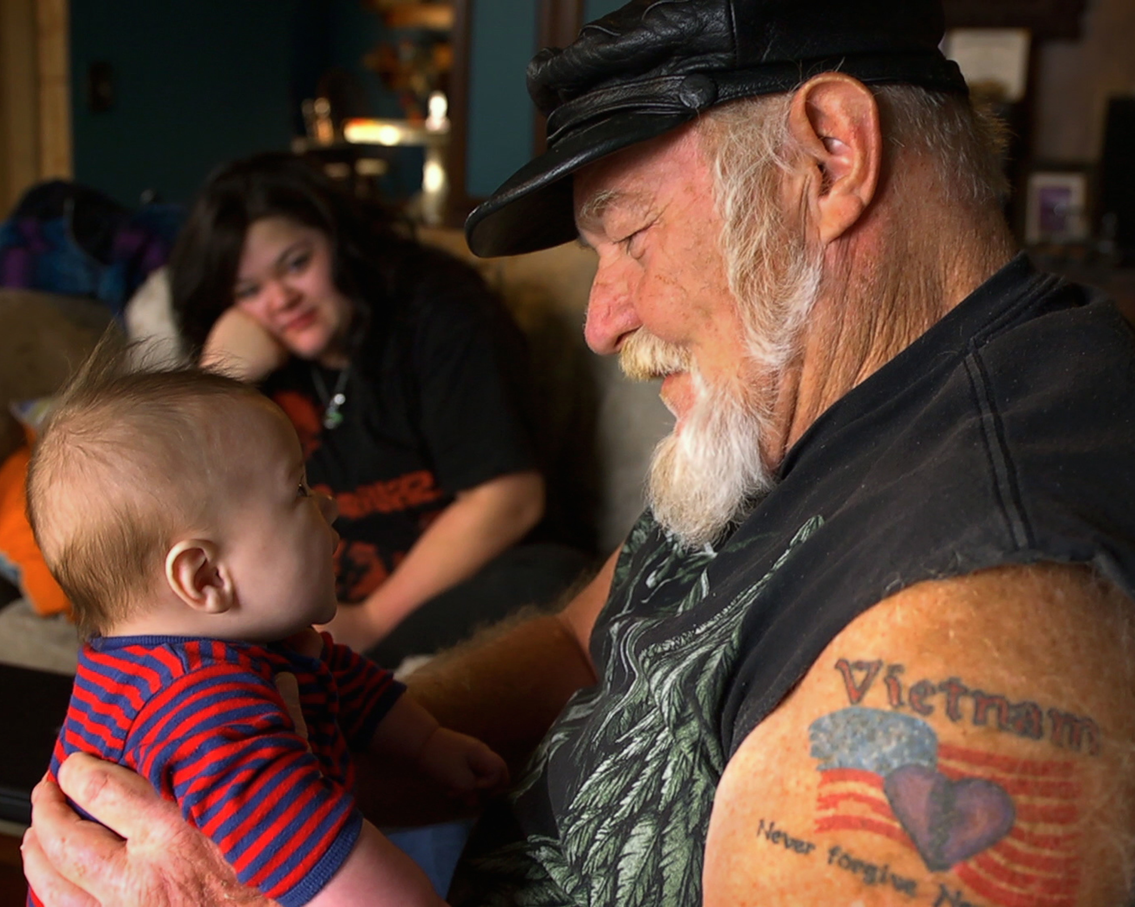
Ron “Stray Dog” Hall with family members.
Credit: Eric Phillips-Horst

“Too many times we want to reduce people to fit into the categories of either red Americans or blue Americans. Ron Hall challenges those lazy stereotypes,” said Lois Vossen, Executive Producer of Independent Lens. “With humor and grace, director Debra Granik captures American life on the margins through the life of one extraordinary ordinary man. Stray Dog is a remarkable portrait that captures the fellowship among veterans and the lingering trauma of war.”

Every year, Stray Dog joins thousands of bikers on a cross-country ride, hurtling down America’s highways, staving off specters of post-traumatic stress and haunting memories while forging deep bonds along the way. And from the back of his bike, Alicia tries to decipher a totally unfamiliar world. Back at home, Stray Dog navigates the pressures of everyday life, including the economic
survival of his extended family and the financial woes of his tenants. The arrival of Alicia’s
twin sons from Mexico illustrates the huge divide between the America of an immigrant’s dreams and the grim reality of rural communities that offer little hope of opportunity. As he strives daily to be the man he wants to be for his family and community, Stray Dog continues to tally the cost of war, bearing witness to the soldiers coming home from Iraq and Afghanistan — both the dead and the living.

Filmmaker Debra Granik met Stray Dog while making her Academy Award-nominated feature film, Winter’s Bone. “I sat next to him in the Biker Church of Branson and he agreed to play the part of Thump Milton in the film,” Granik says. “Stray Dog brought his life experiences to the role, and he brought some of his friends and neighbors to help populate one of the scenes with locals. When shooting wrapped, we reconnected and I got a glimpse of his broad web of family, friends, and affiliations. His vivid descriptions and his questions piqued our interest, and we decided to come back and record some conversations with him and moments of his daily life.”

“Early on, Stray Dog would refer to his Harley as his shrink,” recalls Granik. “Over his lifetime, Ron has sought ways to channel his post-combat need for high adrenaline levels and his natural restlessness into benign channels that are compatible with civilian survival. He searches for missions, for ways to be helpful, which often involve trying to solve a problem for a family member, a neighbor or a friend, or just understanding when someone can’t pay their rent because of a non-livable wage.”

Visit the Stray Dog companion website (http://www.pbs.org/independentlens/stray-dog), which features information about the film.

About the Filmmaker

Debra Granik (Director) started working in film and video in the Boston grassroots media movement in the late 1980s. She studied politics at Brandeis University and her first forays into operating a camera and collaborating on political documentation were with Boston-based media groups such as the Women’s Video Collective. While in Boston she had the good fortune to be able to take classes at Massachusetts College of Art, Studio for Interrelated Media, which exposed her to a great variety of film work and traditions. Granik shot and produced educational programs related to workplace health and safety issues and then worked on several long form documentaries by Boston-based filmmakers. From there, she moved to New York to attend New York University’s graduate film program.

At NYU, she made several short films, one of which, Snake Feed, garnered an award at Sundance, which led to involvement in the Sundance Screenwriting and Directing Labs. She expanded the story from Snake Feed into a longer script which formed the basis for the feature Down to the Bone, created with her producing partner, Anne Rosellini. Down to the Bone was awarded the Best Director prize at the 2004 Sundance Film Festival. Her next film, Winter's Bone, won the Grand Jury Prize at the 2010 Sundance Film Festival and was nominated for four Oscars including Best Picture and Best Adapted Screenplay. Going forward, she hopes to be proceeding on both the narrative fiction and documentary tracks, including forays onto the third rail when the two tracks seem to converge.

Anne Rosellini (Producer) is an independent film producer who runs a production and development company in New York with director Debra Granik. Together they made the 2010 Oscar-nominated film Winter’s Bone, starring Jennifer Lawrence, and 2004 Sundance winner Down to the Bone, starring Vera Farmiga. Rosellini comes from a background in programming and acquisitions. She founded the 1 Reel Film Festival in Seattle in 1996, which became one of the largest showcases of independent short film in the US. She was also a programmer for the Seattle International Film Festival, the Women in Film Festival, and the Arab Film Festival, before becoming an Acquisitions Manager for AtomFilms, an online platform for short films. She holds a BFA from The School of the Art Institute of Chicago.

Victoria Stewart (Producer/Editor) is a New York-based film editor and producer who works in both narrative and documentary. Stewart was an assistant editor on Winter's Bone and the editor of Hillbilly Up, a documentary about Ozarks culture that accompanied the film's release. Prior to her career in post-production, she worked as an art department assistant for film and television. She is currently co-producing and editing a documentary about life after incarceration. Victoria hails from San Francisco and received a BA in Film and Performance Studies from Stanford University. She is an active member of the Brooklyn Filmmakers Collective.

CREDITS

Director Debra Granik
Producers Anne Rosellini
Victoria Stewart
Executive Producer Jonathan Scheuer
Cinematographer Eric Phillips-Horst
Editor Victoria Stewart

Stray Dog is a co-production of Life at Ease, LLC and Still Rolling Productions.

About Independent Lens

Independent Lens is an Emmy® Award-winning weekly series airing on PBS Monday nights at 10:00 PM. The acclaimed series features documentaries united by the creative freedom, artistic achievement, and unflinching visions of independent filmmakers. Presented by Independent Television Service, the series is funded by the Corporation for Public Broadcasting, a private corporation funded by the American people, with additional funding from PBS and the John D. and Catherine T. MacArthur Foundation. For more visit pbs.org/independentlens. Join the conversation: facebook.com/independentlens and on Twitter @IndependentLens.

###

