Chuck Norris vs. Communism Premieres on Independent Lens
Monday, January 4, 2016 on PBS

About the Filmmakers
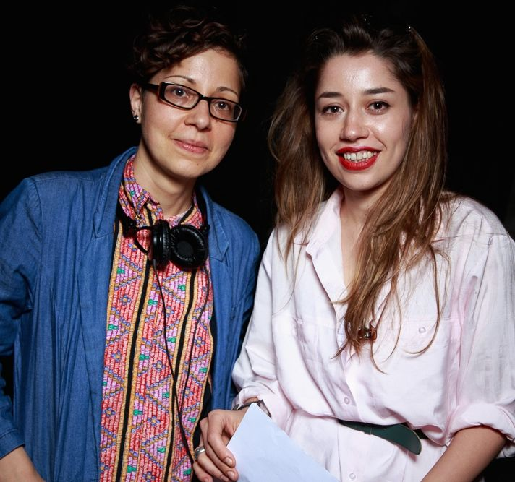
Ilinca Calugareanu and Mara Adina.
Credit: Kevin Williams
Ilinca Calugareanu (Director), a London-based Romanian filmmaker, studied documentary filmmaking at Manchester’s Granada Centre for Visual Anthropology. Her short films have been screened in festivals around the world. Calugareanu’s credits include The Writing on the Wall (2006, Romania) and Endgames (2008, UK). She has also worked as an editor on fiction and documentary shorts and features for the past five years. She has a background in anthropology with a focus on communist and post-communist Romania, which gives her a unique perspective on the story of the VHS phenomenon.

Mara Adina (Producer, Vernon Films) started her career as a production manager and then line producer at Kuwait National Television (KTV), while also producing with several Middle Eastern production companies during her stay there. On her return to London, she established Vernon Films, an independent production company. In 2014 she released Counterpart, the first English-language film directed by two-time BAFTA-winning director Adrian Sitaru.

Brett Ratner (Producer, RatPac Documentary Films): RatPac Documentary Films is a division of RatPac Entertainment, the film finance and production partnership of filmmaker Brett Ratner and Australian mogul James Packer. RatPac Documentary Films most recently premiered Electric Boogaloo to great acclaim at the Toronto Film Festival, as well as Roman Polanski's Weekend of a Champion, and the award-winning Night Will Fall on HBO. Brett Ratner previously produced the controversial Sundance documentary Catfish; the acclaimed HBO documentaries Helmut by June, about the legendary photographer Helmut Newton, and I Knew It Was You: Rediscovering John Cazale; and, for PBS, the Emmy-nominated American Masters: Woody Allen – A Documentary.

