Autism in Love Premieres on Independent Lens
Monday, January 11, 2016 on PBS
About the Filmmakers
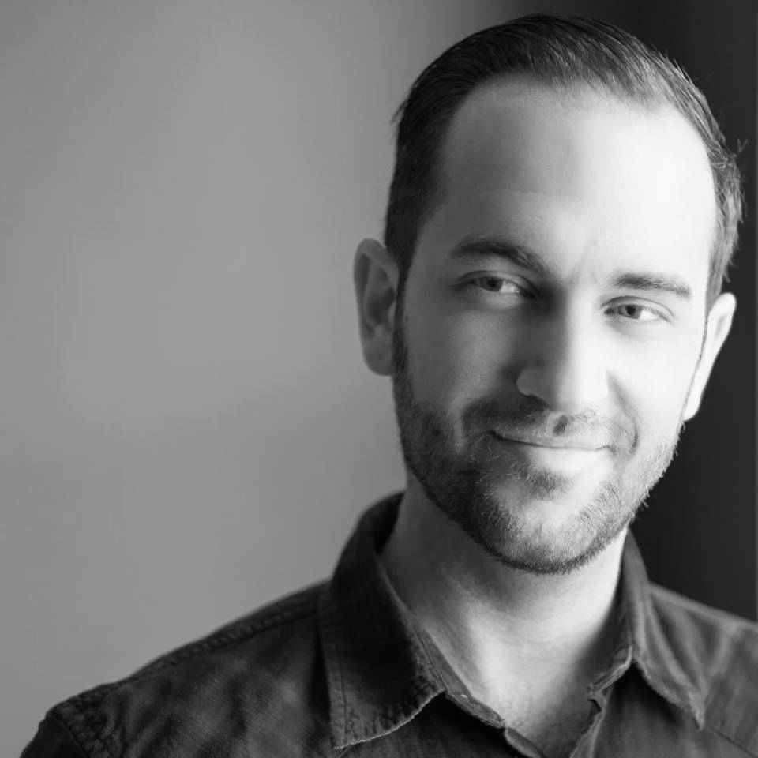
Matt Fuller (Director) discovered his passion and talent for storytelling early in life. While a junior in high school, he began directing documentaries and public service announcements for the Boys & Girls Clubs of America, local government agencies, and national corporate clients. After graduating from the University of Central Florida, Fuller began working for Sony Pictures Entertainment on the thriller Vacancy. While on the Sony backlot, Fuller went on to work for director Nelson McCormick as he directed two Sony feature films, Prom Night and The Stepfather. Fuller then transitioned to MBST Entertainment, working under seasoned producers Scott Kroopf and Larry Brezner as a creative executive. He soon became director of film and television development, where he supervised the development and production of Warner Bros.’s Arthur and Relativity’s Limitless. Autism in Love is his directorial debut; he recently launched The InSight Picture Company.

Carolina Groppa (Producer) was born and raised in São Paulo, Brazil, and moved to the U.S. with her family at the age of nine. After studying theater and film at the University of Central Florida, Groppa relocated to Los Angeles to pursue her love of what goes on behind the camera. She was an integral part of raising capital and managing the day-to-day operations for the 2011 indie thriller Brake, starring Stephen Dorff. She next worked alongside producer Steven Berger on the dark comedy The Pretty One, starring Zoe Kazan. In October 2014, she produced a short for Project Greenlight finalist Marko Slavnic. Groppa has also produced stage productions around Los Angeles, commercials for LENOVO, and award-winning short films, including the character drama Donor, directed by Mark Gantt, and the sci-fi thriller The Taste of Copper, starring Scott Haze.
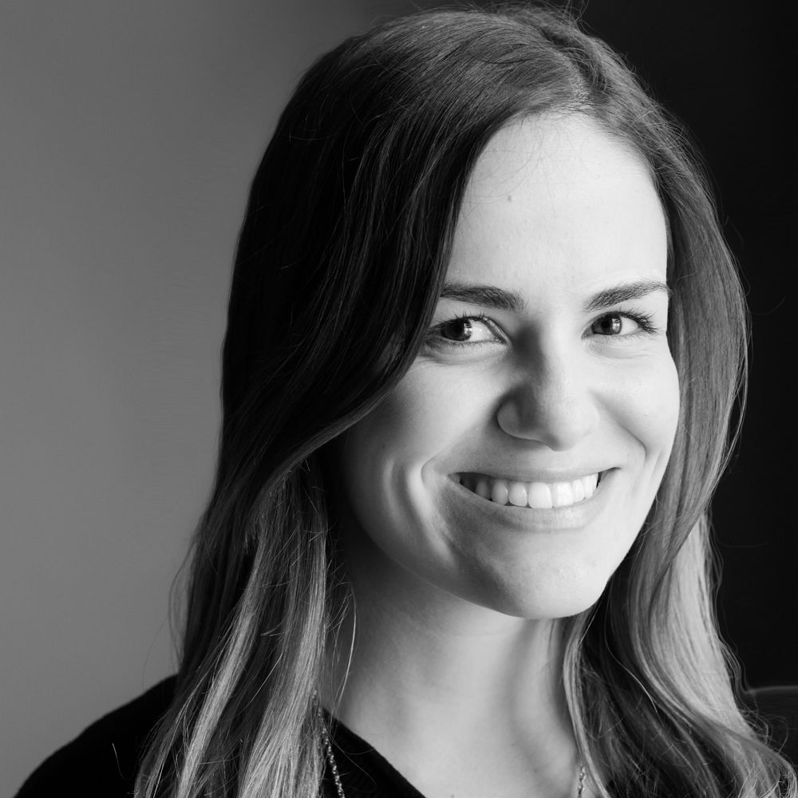

Ira Heilveil (Executive Producer), Ph.D., is a licensed clinical psychologist in three states (California, New Mexico, and Minnesota) and a board certified behavior analyst. He began his career as a clinical child psychologist and family therapist. In 1988 he created his own agency, which he grew to one of the largest providers of applied behavior analysis (ABA) services for children with autism in the U.S. During his tenure as that company's CEO, he also founded a school for children with autism in Armenia as a charitable NGO, which he still operates and is thriving today. Dr. Heilveil maintains his connection to academia through teaching at UCLA medical school, where he is assistant clinical professor of psychiatry. He also publishes scholarly articles, presents at conferences, and writes a blog on a variety of his interests. He is currently CEO of Touchstone Educational Consultants. He also holds a private pilot license.
