In Football We Trust Premieres on Independent Lens
Monday, February 1, 2016 on PBS

About the Filmmakers

Tony Vainuku (Director) comes from a culture of third world traditions and a family of athletes. His first career aspirations began on the field as a budding professional football player from Salt Lake City, UT. After high school, he spent some time in the corporate world before enrolling at Westminster College in Utah to study business marketing in order to launch businesses around his passions of directing, writing, and filmmaking. After graduating with a B.S. in business marketing, Vainuku founded Soulprofile Productions, a multimedia company specializing in the creation of web ads, promotional video content and music production. In 2011, Vainuku founded and launched Soulpro, a lifestyle apparel brand built on the philosophy of Passion is Purpose®. In its three years of business, Soulpro has grown across the western United States and been actively involved in collaborating with and promoting hundreds of musicians, artists, athletes, and entrepreneurs.
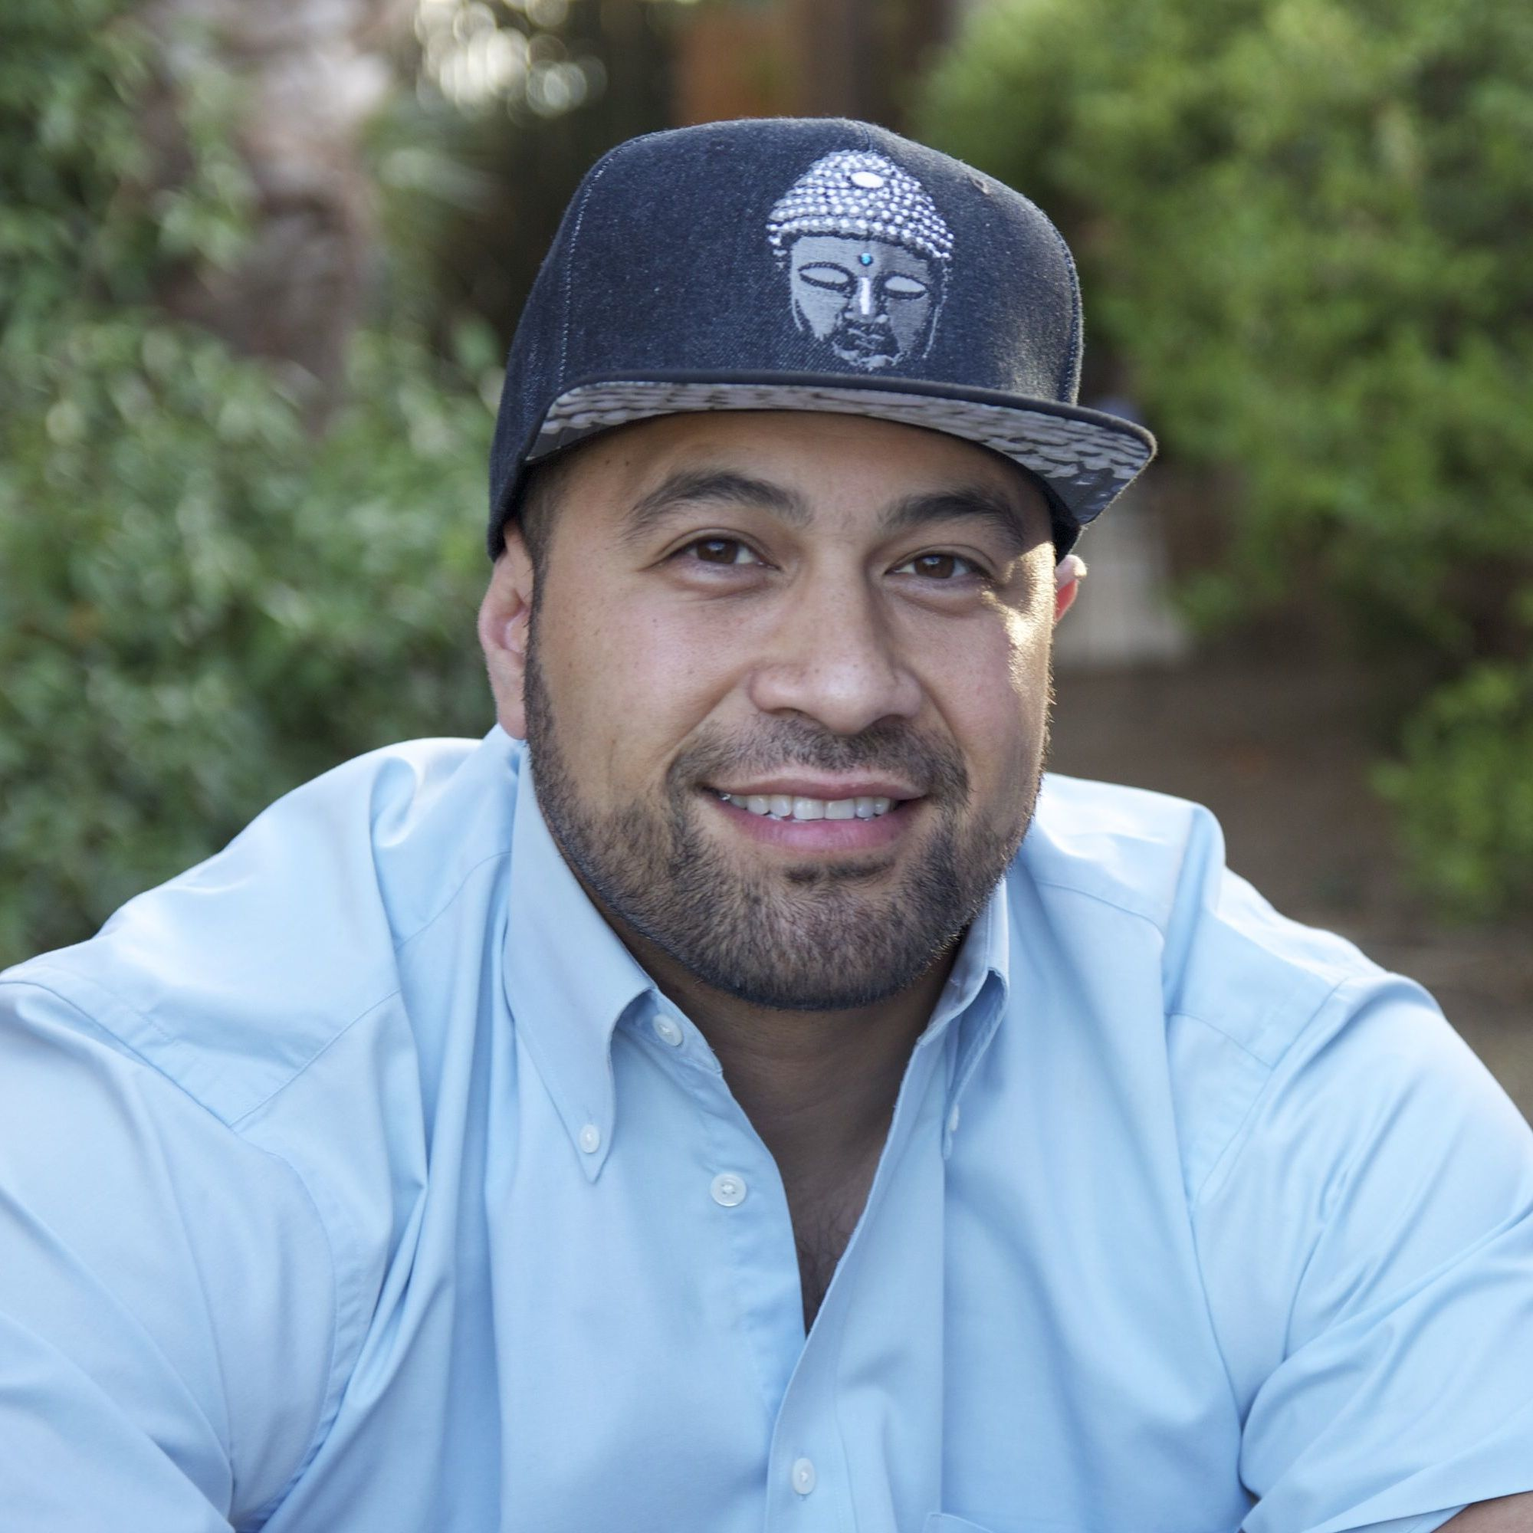

Erika Cohn (Producer and Co-Director) a native Utahan, grew up attending the Sundance Film Festival, where she first began her career. Although her films differ in place and time, religion and culture remain a recurring theme and her passion for social change the driving factor. In 2008, Cohn traveled to Cambodia where she shot Giant Steps, a documentary about the reinstitution of art after Khmer Rouge rule, which aired on PBS. In 2010, Cohn was associate producer for the FRONTLINE/AMERICAN EXPERIENCE co-production God in America, a six-part historical series exploring the intersection of religion and public life in the nation. Cohn has received numerous accolades for her work, including a Directors Guild of America award for When the Voices Fade, a narrative profile of the Lebanese-Israeli war of 2006, and was recently admitted into the CPB Producers Academy. Cohn has been a featured panelist/speaker on independent film financing at film festivals and university conferences and mentors youth filmmakers across the globe. She attended Chapman University in California, where she graduated with degrees in film production and Middle Eastern Studies. Cohn is an avid documentary photographer, shooting primarily the lives of women in conflict zones, and serves as a US Ambassadorial Film Scholar to Israel.


