A Ballerina’s Tale Premieres on Independent Lens
Monday, February 8, 2016 on PBS

About the Filmmakers

Nelson George (Director) is an author, filmmaker, television producer, and critic with a long career in analyzing and presenting the diverse elements of African American culture. Queen Latifah won a Golden Globe for playing the lead in his directorial debut, the HBO movie Life Support, a critically acclaimed drama that looked at the effects of HIV on a troubled black family in his native Brooklyn. He's published numerous non-fiction books on black music history as well as a series of novels using the music world as a backdrop, including The Lost Treasures of R&B. George has been on a roll since 2013 with completed documentary projects: VH1’s rock doc Finding the Funk, Showtime’s Brooklyn Boheme, ESPN’s The Announcement, and All Hail the Beat, a short film for the Focus Forward campaign.
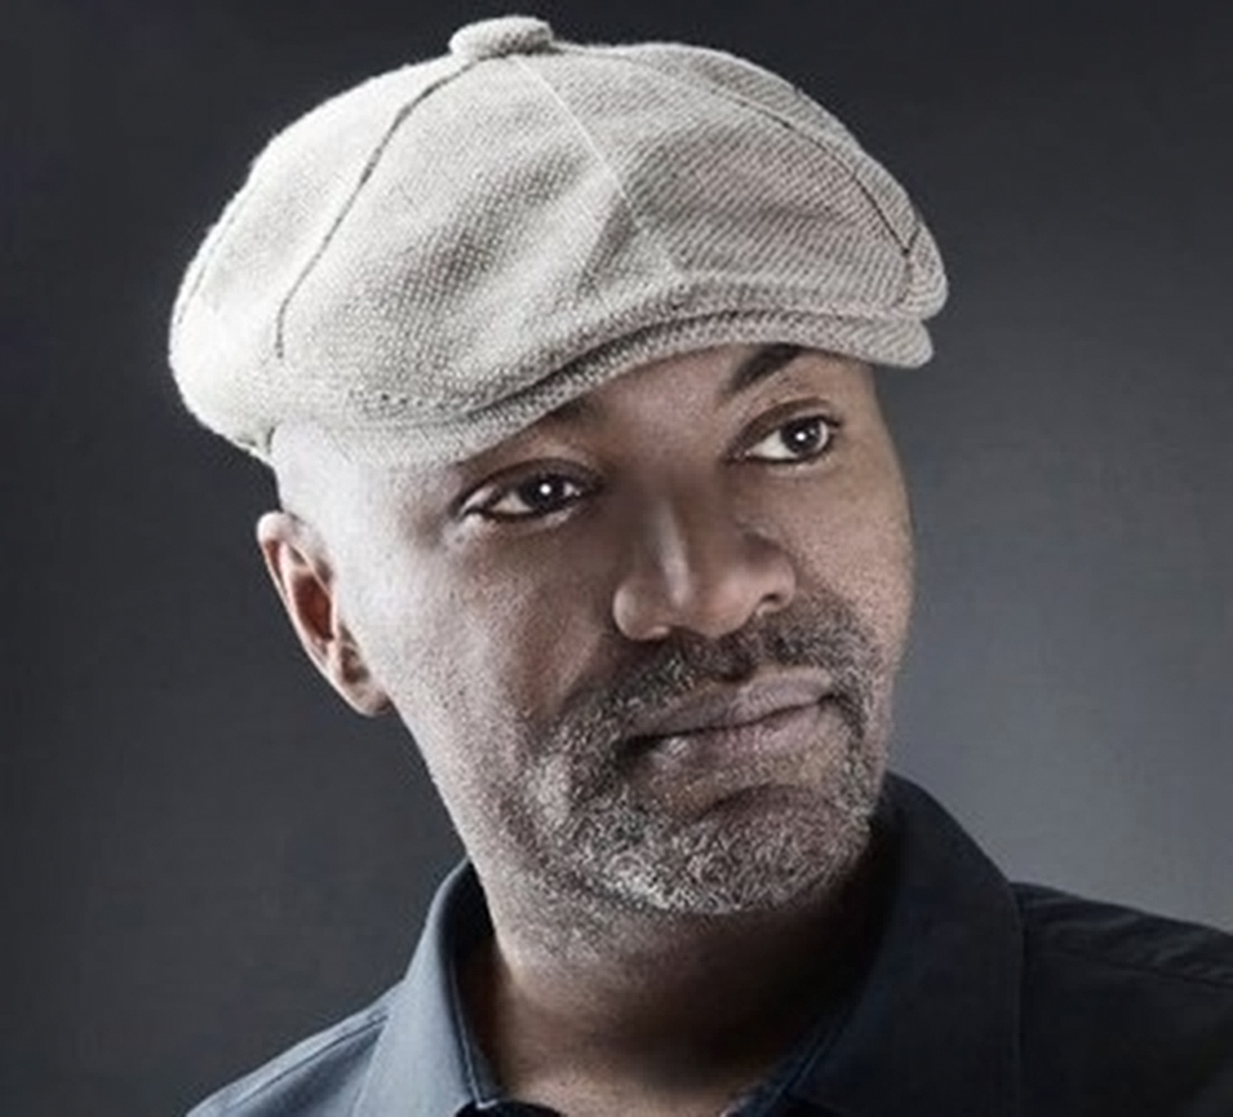
Credit: Susan Tang

Leslie Norville (Producer) is a Brooklyn-based producer from Toronto, Canada. Her films have screened at numerous film festivals and on television around the world. Her first feature-length documentary premiered at the 2010 International Documentary Film Festival Amsterdam and is distributed by 7th Art Releasing. Norville currently collaborates with Nelson George on projects such as Finding the Funk, an official selection at the 2013 SXSW and Hot Docs Film Festivals, and Disdain the Mundane, an ESPN “30 for 30” short. Prior to her work with George, Norville had the opportunity to work with Lee Hirsch on his multiple award-winning documentary Bully and on Jane Wells and JK Wasson’s Tricked. Norville is also the recipient of a Tribeca Documentary Fund and a Funding Exchange grant.

###

