FOR IMMEDIATE RELEASE

CONTACT
Lisa Tawil, ITVS 415-356-8383 lisa_tawil@itvs.org
Mary Lugo 770-623-8190 lugo@negia.net
Cara White 843-881-1480 cara.white@mac.com
For downloadable images, visit pbs.org/pressroom/
An Honest Liar Premieres on Independent Lens
Monday, March 28, 2016 on PBS

Portrait of James “The Amazing” Randi, the Extraordinary Magician Who Dedicated His Life to Exposing Hucksters and Frauds

“Magicians are the most honest people in the world. They tell you they’re gonna fool you, and then they do it.” – James Randi

(San Francisco, CA) — For the last half-century, James “The Amazing” Randi has entertained millions of people around the world with his remarkable feats of magic, escape, and trickery. But when he saw faith healers, fortunetellers, and psychics using his beloved magician’s tricks to steal money from innocent people and destroy lives, he dedicated his life to exposing frauds, using the wit and style of the great showman that he is. Part detective story, part biography, and a bit of a magic act itself, the award-winning An Honest Liar, directed and produced by Justin Weinstein and Tyler Measom, premieres on Independent Lens Monday, March 28, 2016,
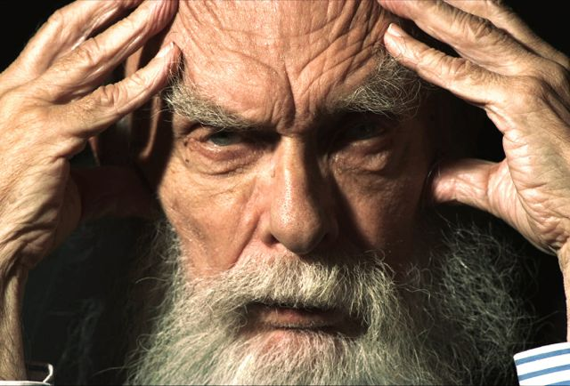
James "The Amazing" Randi.
Credit: Justin Weinstein, Tyler Measom
10:00-11:30 p.m. ET (check local listings) on PBS.

A self-described liar, cheat, and charlatan, Randi embarked on a mission for truth by perpetrating a series of unparalleled investigations and elaborate hoaxes. These grand schemes fooled scientists, the media, and a gullible public, but always with a deeper goal of demonstrating the importance of evidence and the dangers of magical thinking. In one of these acts, he transformed his partner, Jose Alvarez, into a fake guru named “Carlos” to show how easily people can be fooled. His work exposing faith healers won him a prestigious MacArthur “Genius” Grant in 1987.

When dealing with a master deceiver, the truth can often be hard to find. A sudden and shocking truth in Randi’s personal life is brought to light when the tale of multiple identities takes an unexpected and potentially devastating turn. And Randi – who spent his life exposing deception – may have either perpetrated another grand hoax or become the victim of a very personal one.

A film about the many faces of deception that’s full of unexpected twists and turns, An Honest Liar is told through interviews with Randi, vintage footage of his countless TV appearances, and interviews with Adam Savage, Penn & Teller, Bill Nye, Uri Geller (who Randi spent years debunking), Alice Cooper, and many others.

Visit the An Honest Liar page on Independent Lens, which features more information about the film.

About the Filmmakers

Justin Weinstein (Director/Producer) is a Brooklyn-based former scientist whose work includes documentary feature films and broadcast journalism. He is an executive producer of Bronx Obama, a documentary directed by Ryan Murdoch now available on Showtime and iTunes. He co-wrote and edited Being Elmo: A Puppeteers Journey, which won the Special Jury Prize at the 2011 Sundance Film Festival, premiered on Independent Lens, and was nominated for The Humanitas Prize. Prior to that, Weinstein produced numerous projects for ABC News, “Peter Jennings Reporting,” and PBS, including “Hot Politics” for FRONTLINE and the ABC News Primetime special “Last Days on Earth.”

Tyler Measom (Director/Producer) is the co-director/producer of Sons of Perdition, which tells the story of teenagers exiled from their polygamist Mormon community. The documentary premiered at the Tribeca Film Festival and was acquired by the Oprah Winfrey Network. He is the producer of the feature film Take (Tribeca Festival premiere) starring Minnie Driver and Jeremy Renner. He has written, produced, and directed nearly one hundred commercials, short documentaries, and industrials for a wide range of national and international clients. He won an Emmy for the PBS documentary Beehive Spirits and produced the Showtime documentary Jesus Town. He is currently in production on the documentary New Sensation, about the birth, rise and cultural effects of MTV. Tyler currently lives in Salt Lake City under the shade of giant oak tree.

CREDITS

Directed, Produced, and Filmed by Justin Weinstein
Tyler Measom
Executive Produced by Greg Henry
Stephanie Levy
Gary Schermerhorn
David Shadrack Smith
Barry Sonnenfeld
Vijay Vaidyanathan
Executive Produced for BBC Storyville by Nick Fraser
Written by Justin Weinstein
Greg O’Toole
Tyler Measom

An Honest Liar is a Left Turn Films & Pure Mutt production in association with BBC Storyville and Part2 Filmworks.

About Independent Lens

Independent Lens is an Emmy® Award-winning weekly series airing on PBS Monday nights at 10:00 p.m. ET. The acclaimed series features documentaries united by the creative freedom, artistic achievement, and unflinching visions of independent filmmakers. Presented by Independent Television Service, the series is funded by the Corporation for Public Broadcasting, a private corporation funded by the American people, with additional funding from PBS and the John D. and Catherine T. MacArthur Foundation. For more visit pbs.org/independentlens. Join the conversation: facebook.com/independentlens and on Twitter @IndependentLens.

###

