FOR IMMEDIATE RELEASE

CONTACT
Lisa Tawil, ITVS 415-356-8383 lisa_tawil@itvs.org
Mary Lugo 770-623-8190 lugo@negia.net
Cara White 843-881-1480 cara.white@mac.com
For downloadable images, visit pbs.org/pressroom/
Welcome to Leith Premieres on Independent Lens
Monday, April 4, 2016 on PBS

Small North Dakota Town Fights to Expel Notorious White Supremacist

“Could be the scariest film of the year. . . This cautionary tale couldn't be more timely or essential.”
— Los Angeles Times

(San Francisco, CA) – Welcome to Leith chronicles the attempted takeover of a small town in North Dakota by notorious white supremacist Craig Cobb. As his behavior becomes more threatening, tensions soar, and the residents desperately look for ways to expel their unwanted neighbor. An unsettling exploration of what happens to democratic principles when they’re pushed to the limit, the film asks: In a free society, how do we deal with people whose views we find abhorrent? Directed by Michael Beach Nichols and Christopher K. Walker, Welcome to Leith premieres on Independent Lens Monday, April 4, 2016, 10:00-11:30 PM ET (check local listings) on PBS.
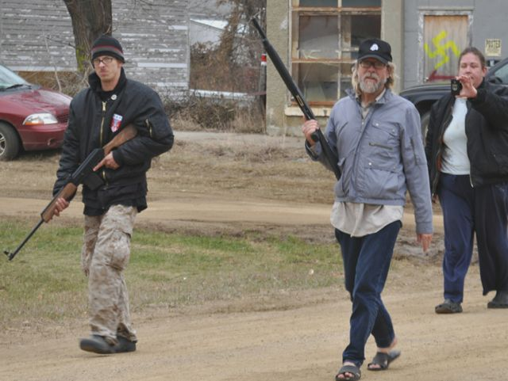
Credit: Gregory Bruce.

Leith, North Dakota, is home to 24 people, mostly farmers and ranchers living on a prairie backdrop of sky and wheat. In 2012, an outsider named Craig Cobb moved in and started buying up property. Residents initially welcomed the bearded stranger, figuring he’d moved to be closer to the oil fields, but Cobb had other motives. Posting on racist online forums that he’d found the perfect place to start an all-white enclave, Cobb implored other white supremacists to move to Leith and help take over the town’s government.

But far from the prairies of North Dakota, Ryan Lenz, an investigator from Montgomery, Alabama’s Southern Poverty Law Center, discovers Cobb’s posts and informs Leith’s mayor, Ryan Schock. Schock, a young rancher and family man who’d lived in Leith all his life, is stunned by the news — and the ensuing media firestorm. Cobb then invites the head of the largest neo-Nazi group in the U.S. to stage a town hall meeting, and nearly 300 people show up. Soon after, a family of fellow white supremacists from Oregon moves in to start fixing up Cobb’s properties.

As the town struggles to fight against one man’s extremist vision, Cobb and his followers ratchet up the intimidation tactics, disrupting city council meetings with shouts of “Sieg Heil” and posting residents’ names and home addresses on racist web sites. But when he takes to patrolling the streets with a loaded rifle and shotgun, residents decide they have had enough and proceed to take matters into their own hands.

Filmmakers Nichols and Walker wanted to tell the complete story of the unfolding events in Leith, and spent time with both the white supremacists and their neighbors. “Part of what was so fascinating about the story was that what Cobb and his followers were attempting was completely legal,” said Nichols. “Chris and I were captivated by Cobb’s motivations and the implications of his plan for Leith and what that could mean for other small towns in America if people started following in his footsteps.”

Visit the Welcome to Leith page on Independent Lens, which features more information about the film.

About the Filmmakers

Michael Beach Nichols (Director/Producer/Cinematographer) is an award-winning filmmaker and the recipient of Jerome Foundation and Rooftop Filmmaker grants. His acclaimed second feature film, Welcome to Leith, debuted at the 2015 Sundance Film Festival. His 2013 feature debut Flex is Kings was the opening night film in the Viewpoints section at the Tribeca Film Festival. Previously, he directed The New York Times Op-Doc Separatist, the Vimeo Staff Pick Delivery, the street dance web series BKLYN FLEX, and was part of the Peabody Award-winning producing team behind Sundance Channel’s 11-hour docuseries Brick City. He is a founding partner of No Weather.

Christopher K. Walker (Director/Producer/Editor) is an award-winning filmmaker whose directorial debut, Welcome to Leith, premiered at the 2015 Sundance Film Festival. He also edited and produced Flex is Kings, edited the Columbia duPont Award-winning Triangle: Remembering the Fire, and edited the Emmy-nominated Hard Times: Lost on Long Island for HBO. He recently directed The New York Times Op-Doc Separatist and edited Freeway: Crack in the System for acclaimed filmmaker Marc Levin. He is the recipient of Jerome Foundation and Rooftop Filmmaker grants and a Karen Schmeer Award for Documentary Editing. He is a founding partner of No Weather.

CREDITS

A film by Michael Beach Nichols & Christopher K. Walker

Produced and Directed by Michael Beach Nichols & Christopher K. Walker
Produced by Jenner Furst
Producers Joey Carey
Joshua Woltermann
Executive Produced by Julia Willoughby Nason
Executive Produced by Stefan Nowicki
Edited by Christopher K. Walker
Cinematograpy by Michael Beach Nichols
Original Music by T. Griffin

Welcome to Leith is a co-production of No Weather Films, The Cinemart and Sundial Pictures, produced in association with the Independent Television Service (ITVS), with funding provided by the Corporation for Public Broadcasting (CPB).

About Independent Lens

Independent Lens is an Emmy® Award-winning weekly series airing on PBS Monday nights at 10:00 PM. The acclaimed series features documentaries united by the creative freedom, artistic achievement, and unflinching visions of independent filmmakers. Presented by Independent Television Service, the series is funded by the Corporation for Public Broadcasting, a private corporation funded by the American people, with additional funding from PBS and the John D. and Catherine T. MacArthur Foundation. For more visit pbs.org/independentlens. Join the conversation: facebook.com/independentlens and on Twitter @IndependentLens.

###

