Welcome to Leith Premieres on Independent Lens
Monday, April 4, 2016 on PBS

About the Filmmakers

Michael Beach Nichols (Director/Producer/Cinematographer) is an award-winning filmmaker and the recipient of Jerome Foundation and Rooftop Filmmaker grants. His acclaimed second feature film, Welcome to Leith, debuted at the 2015 Sundance Film Festival. His 2013 feature debut Flex is Kings was the opening night film in the Viewpoints section at the Tribeca Film Festival. Previously, he directed The New York Times Op-Doc Separatist, the Vimeo Staff Pick Delivery, the street dance web series BKLYN FLEX, and was part of the Peabody Award-winning producing team behind Sundance Channel’s 11-hour docuseries Brick City. He is a founding partner of No Weather.
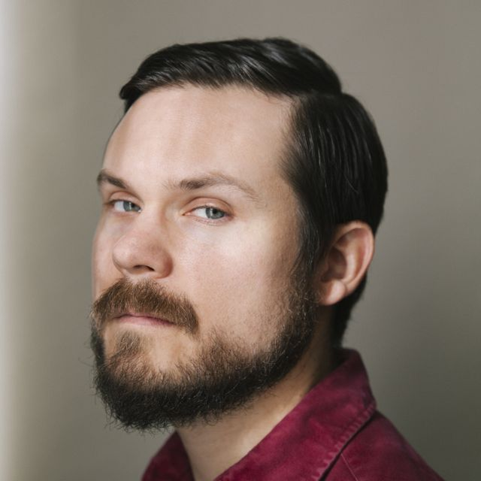
Credit: Joshua Simpson

Christopher K. Walker (Director/Producer/Editor) is an award-winning filmmaker whose directorial debut, Welcome to Leith, premiered at the 2015 Sundance Film Festival. He also edited and produced Flex is Kings, edited the Columbia duPont Award-winning Triangle: Remembering the Fire, and edited the Emmy-nominated Hard Times: Lost on Long Island for HBO. He recently directed The New York Times Op-Doc Separatist and edited Freeway: Crack in the System for acclaimed filmmaker Marc Levin. He is the recipient of Jerome Foundation and Rooftop Filmmaker grants and a Karen Schmeer Award for Documentary Editing. He is a founding partner of No Weather.
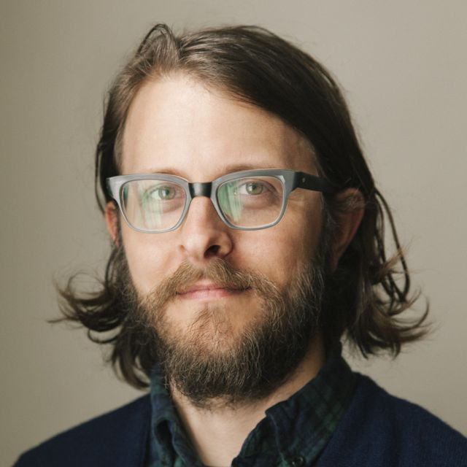
Credit: Joshua Simpson

###

