Democrats Premieres on Independent Lens
Monday, April 18, 2016 on PBS

About the Filmmakers

Camilla Nielsson (Director), based in Copenhagen, studied documentary filmmaking at the Tisch School of the Arts and holds an M.A. in visual anthropology from New York University. She directed the trilogy Good Morning Afghanistan (2003), Durga (2004), and The Children of Darfur (2005); and Mumbai Disconnected (2009), part of the Cities on Speed series. Since 2007, she has collaborated with Israeli video artist Yael Bartana on the trilogy And Europe Will Be Stunned (Venice Biennale 2011) and Re:Constructed Landscapes.
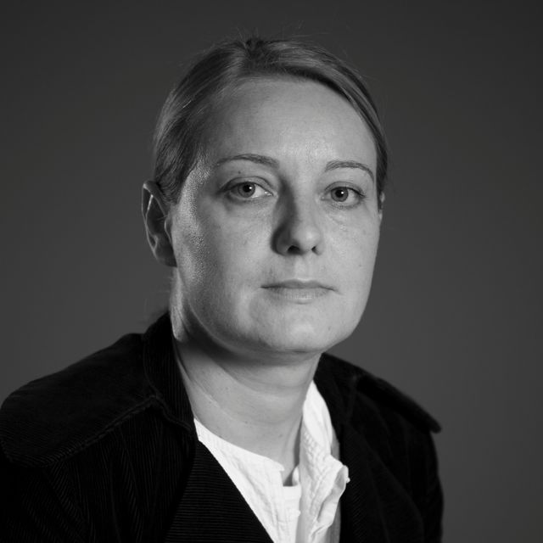

Henrik Veileborg (Producer) was born in Copenhagen, educated as a film producer at the National Film School of Denmark, and has more than twenty years of experience in the film industry. Since 2006, he has been managing director at Upfront Films. The company has worked with many of Denmark’s most prominent documentary filmmakers and earned film and TV awards domestically and abroad. The company's track record includes Love on Delivery and Ticket to Paradise (both by Janus Metz), Mumbai Disconnected (by Camilla Nielsson and Frederik Jacobi), Bogotá Change (by Andreas M. Dalsgaard), and Copenhagen Dreams (by Max Kestner). Upfront Films is a member of the Danish Producers Association and the European Documentary Network.


Photo Credits: Steen Møller Rasmussen

