FOR IMMEDIATE RELEASE

CONTACT
Lisa Tawil, ITVS 415-356-8383 lisa_tawil@itvs.org
Mary Lugo 770-623-8190 lugo@negia.net
Cara White 843-881-1480 cara.white@mac.com
For downloadable images, visit pbs.org/pressroom/
Democrats Premieres on Independent Lens
Monday, April 18, 2016 on PBS

Film Chronicles Zimbabwe’s Quest to Create a Constitution

“This portrait of passionate people struggling to improve their government is urgent, vivid and satisfactory. Both inspiring and upsetting, ‘Democrats’ is, finally, a film that deserves to be called ‘necessary.’” – Glenn Kenny, The New York Times

(San Francisco, CA) – In the wake of long-time leader Robert Mugabe’s contentious 2008 presidential win, Zimbabwe took a historic step forward by convening a bipartisan constitutional committee in an effort to transition the country away from its corrupt, authoritarian leadership. Two men from rival political parties were appointed to the committee: Paul Mangwana and Douglas Mwonzora. Should they fail at securing maximum influence for their respective parties on the provisions in the new constitution, dire consequences will loom for each. Filmed over the course of three years with unprecedented access to the two political rivals overseeing the committee, this riveting, first-hand account of a country’s challenging first steps towards democracy plays at once like an intimate political thriller and unlikely buddy film. Directed by Camilla Nielsson and winner of the Best Documentary Feature Award at the 2015 Tribeca Film Festival, Democrats premieres on Independent Lens on Monday, April 18, 2016, 10:00-12:00 PM ET (check local listings) on PBS.
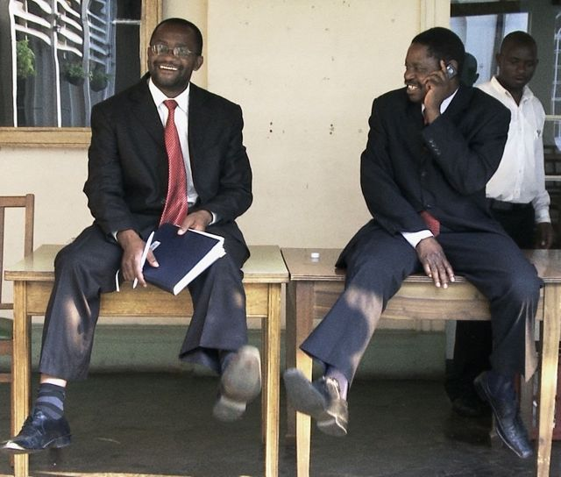
Douglas Mwonzora and Paul Mangwana
Credit: Henrik Bohn Ipsen

Following a bitter war of liberation, Robert Mugabe became president of Zimbabwe in 1980. Under his leadership, the country made educational and economic progress but Mugabe soon proved a dictatorial leader as opponents were put down and civil rights were restricted. In 1999, in light of rising demands for reform, a new party, the Movement for Democratic Change (MDC), rose up to challenge Mugabe and his ZANU-PF party. After a decade of strife, in 2009 the two parties formed a coalition government with Mugabe agreeing to share power with the leader of the MDC, Prime Minister Morgan Tsvangirai. With constitutional reform at the forefront of the national agenda, it was up to their two representatives, Paul Mangwana and Douglas Mwonzora, to rise to the daunting challenge of creating a constitution that will lead their nation to prosperity and freedom. By documenting the contentious process of drafting a new constitution, Democrats offers a fascinating insider look at the political mechanics of a modern African country as it struggles toward democratic change.

Visit the Democrats page on Independent Lens, which features information about the film.

About the Filmmakers

Camilla Nielsson (Director), based in Copenhagen, studied documentary filmmaking at the Tisch School of the Arts and holds an M.A. in visual anthropology from New York University. She directed the trilogy Good Morning Afghanistan (2003), Durga (2004), and The Children of Darfur (2005); and Mumbai Disconnected (2009), part of the Cities on Speed series. Since 2007, she has collaborated with Israeli video artist Yael Bartana on the trilogy And Europe Will Be Stunned (Venice Biennale 2011) and Re:Constructed Landscapes.

Henrik Veileborg (Producer) was born in Copenhagen, educated as a film producer at the National Film School of Denmark, and has more than twenty years of experience in the film industry. Since 2006, he has been managing director at Upfront Films. The company has worked with many of Denmark’s most prominent documentary filmmakers and earned film and TV awards domestically and abroad. The company's track record includes Love on Delivery and Ticket to Paradise (both by Janus Metz), Mumbai Disconnected (by Camilla Nielsson and Frederik Jacobi), Bogotá Change (by Andreas M. Dalsgaard), and Copenhagen Dreams (by Max Kestner). Upfront Films is a member of the Danish Producers Association and the European Documentary Network.

CREDITS

Directed by Camilla Nielsson
Produced by Henrik Veileborg
Cinematographer Henrik Bohn Ipsen
Film Editor Jeppe Bødskov
Idea and Research Peter Tygesen
Composer Kristian Eidnes Andersen
Sound Design and Mix Thomas Jæger

About Independent Lens

Independent Lens is an Emmy® Award-winning weekly series airing on PBS Monday nights at 10:00 PM. The acclaimed series features documentaries united by the creative freedom, artistic achievement, and unflinching visions of independent filmmakers. Presented by Independent Television Service, the series is funded by the Corporation for Public Broadcasting, a private corporation funded by the American people, with additional funding from PBS and the John D. and Catherine T. MacArthur Foundation. For more visit pbs.org/independentlens. Join the conversation: facebook.com/independentlens and on Twitter @IndependentLens.

###

