My Nazi Legacy
Premieres on Independent Lens
Monday, May 2, 2016 on PBS

About the Filmmakers
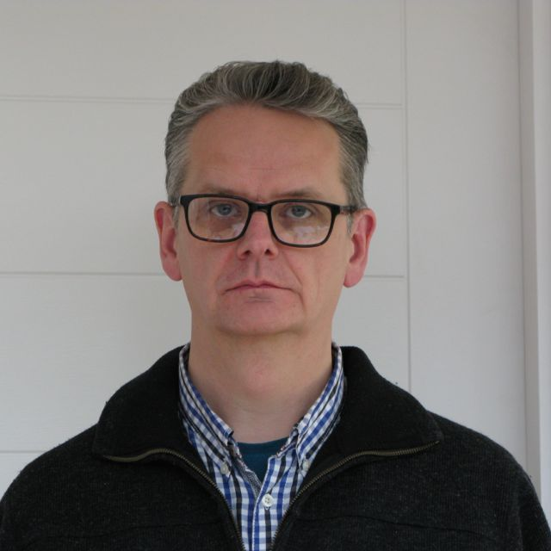
Credit: Courtesy of David Evans


Credit: Courtesy of Philippe Sands
David Evans (Director) was born in Wolverhampton, England, in 1962. He is an Emmy-nominated, multi-award-winning director of film and television. His previous documentary work includes a BAFTA Award-winning film about the English author Angela Carter and a profile of radical feminist Andrea Dworkin. He directed the feature film Fever Pitch, starring Colin Firth, for which Nick Hornby adapted his best-selling book of the same name, and is now established as a leading director of British TV drama with credits including Shameless, Downton Abbey, and Russell T. Davies' Cucumber.

As an eminent barrister, Philippe Sands (Writer) has been involved in many of the great international cases of recent years concerning genocide in Yugoslavia, the London proceedings against Chilean dictator General Augusto Pinochet, and proceedings against Colonel Gaddafi's son Saif at the International Criminal Court. He is also a journalist and author whose non-fiction books include The Lawless World and Torture Team. His latest book, East West Street: On the Origins of "Genocide" and "Crimes Against Humanity,” will be published by Knopf in May 2016.

###

