FOR IMMEDIATE RELEASE

CONTACT
Lisa Tawil, ITVS 415-356-8383 lisa_tawil@itvs.org
Mary Lugo 770-623-8190 lugo@negia.net
Cara White 843-881-1480 cara.white@mac.com
For downloadable images, visit pbs.org/pressroom/
My Nazi Legacy
Premieres on Independent Lens
Monday, May 2, 2016 on PBS

A Jewish Human Rights Lawyer Explores the Past with Sons of
Two High-Ranking Nazis Implicated in Mass Murders of Holocaust

(San Francisco, CA) – A powerful and unsettling account of the toll of inherited guilt, My Nazi Legacy explores the relationship between two men, each of whom are the sons of high-ranking Nazi officials, and the eminent human rights lawyer Philippe Sands, whose family perished at the hands of the Nazis. As the three men travel together on an emotional journey throughout Europe and the past, the film explores the different ways that each man copes with his devastating legacy. Directed by David Evans, My Nazi Legacy premieres on Independent Lens Monday, May 2, 2016, 10:00-11:30 PM ET (check local listings) on PBS in conjunction with Holocaust Remembrance Day (May 5) and the 70th anniversary of the Nuremberg Trials.
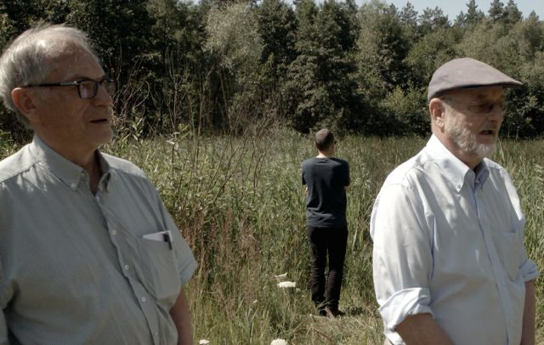
Horst Von Wächter, Philippe Sands (background) and Niklas Frank at the site of a mass grave outside Zolkiew, Ukraine.
Credit: Sam Hardy

Niklas Frank has no qualms about denouncing his father, Hans Frank, who was convicted of war crimes at Nuremberg and executed in 1945. After a stint as Hitler's personal lawyer, Hans Frank became Nazi Germany's chief jurist in occupied Poland and was directly responsible for the mass murder of Jews and Poles. In the film, Niklas shares old photos and never-before-seen home movies and visits Poland’s Wawel Castle, where a da Vinci painting stolen by his father still hangs.

For Horst von Wachter, the extent of his father’s guilt is less clear-cut; despite evidence to the contrary, he insists his father was a decent man caught up in an intolerable situation. An Austrian lawyer, Otto von Wachter served as governor of Krakow, Poland, and Galicia, Ukraine, during the war. But unlike Hans Frank, von Wachter was never charged with his crimes.

Philippe Sands met both men while researching a book on the origins of international law. Sands’ family were Ukrainian Jews, many of whom were killed as a direct result of Hans Frank and Otto von Wachter’s actions, and, to Sands, the guilt of the fathers of both men is undeniable.

As the last remaining generation to grow up during the atrocities of the Nazi era ages and passes, My Nazi Legacy offers an unforgettable look into the hearts of men who have lived their lives in the shadow of inherited guilt, denial, and shame.

Visit My Nazi Legacy page on Independent Lens, which features more information about the film.

About the Filmmakers

David Evans (Director) was born in Wolverhampton, England, in 1962. He is an Emmy-nominated, multi-award-winning director of film and television. His previous documentary work includes a BAFTA Award-winning film about the English author Angela Carter and a profile of radical feminist Andrea Dworkin. He directed the feature film Fever Pitch, starring Colin Firth, for which Nick Hornby adapted his best-selling book of the same name, and is now established as a leading director of British TV drama with credits including Shameless, Downton Abbey, and Russell T. Davies' Cucumber.

As an eminent barrister, Philippe Sands (Writer) has been involved in many of the great international cases of recent years concerning genocide in Yugoslavia, the London proceedings against Chilean dictator General Augusto Pinochet, and proceedings against Colonel Gaddafi's son Saif at the International Criminal Court. He is also a journalist and author whose non-fiction books include The Lawless World and Torture Team. His latest book, East West Street: On the Origins of "Genocide" and "Crimes Against Humanity,” will be published by Knopf in May 2016.

CREDITS

Directed by David Evans
Written by Philippe Sands
Edited by David Charap
Directors of Photography Sam Hardy
Philipp Blaubach
Matt Gray
Sound Recordist Matthew Powell
Music by Malcolm Lindsay
Produced by Finola Dwyer
Amanda Posey
Executive Producers Philippe Sands
David Evans
Nick Fraser
Associate Producer Josephine Davies

An Oscilloscope Laboratories and BFI and BBC Storyville presentation of a Wildgaze Films production in association with Willow Films.

About Independent Lens

Independent Lens is an Emmy® Award-winning weekly series airing on PBS Monday nights at 10:00 PM. The acclaimed series features documentaries united by the creative freedom, artistic achievement, and unflinching visions of independent filmmakers. Presented by Independent Television Service, the series is funded by the Corporation for Public Broadcasting, a private corporation funded by the American people, with additional funding from PBS and the John D. and Catherine T. MacArthur Foundation. For more visit pbs.org/independentlens. Join the conversation: facebook.com/independentlens and on Twitter @IndependentLens.

###

