Trapped Premieres on Independent Lens
FOR IMMEDIATE RELEASE

CONTACT
Lisa Tawil, ITVS 415-356-8383 lisa_tawil@itvs.org
Mary Lugo 770-623-8190 lugo@negia.net
Cara White 843-881-1480 cara.white@mac.com
For downloadable images, visit pbs.org/pressroom/
Monday, June 20, 2016 on PBS

Timely Documentary Examines Controversial New Abortion Laws
at Center of Current Supreme Court Case

(San Francisco, CA) — Trapped, a new documentary from filmmaker Dawn Porter, goes to the front lines of the controversial battle currently being waged over so-called TRAP laws — Targeted Regulation of Abortion Providers — which reproductive rights advocates believe are designed to restrict access to abortion. Told through the eyes of doctors, clinic owners, and staff in Alabama and Texas who are fighting to keep their facilities open, the film reveals the impact of the hundreds of new laws passed since 2011 that set additional standards and regulations for abortion providers. Compliance often requires costly facility modifications or staffing requirements and has resulted in the closure of many clinics. Proponents of these laws, most of which have been passed in Southern states, maintain that they are necessary to protect women’s health. Opponents believe that the regulations are unnecessary and designed to limit access to abortion. The current case before the U.S. Supreme Court, Whole Women’s Health v. Hellerstedt, will decide whether these laws are constitutional. Trapped, winner of the Special Jury Award for Social Impact Filmmaking at the 2016 Sundance Film Festival, premieres on Independent Lens Monday, June 20, 2016, 10:00-11:30 PM ET (check loca3l listings) on PBS.
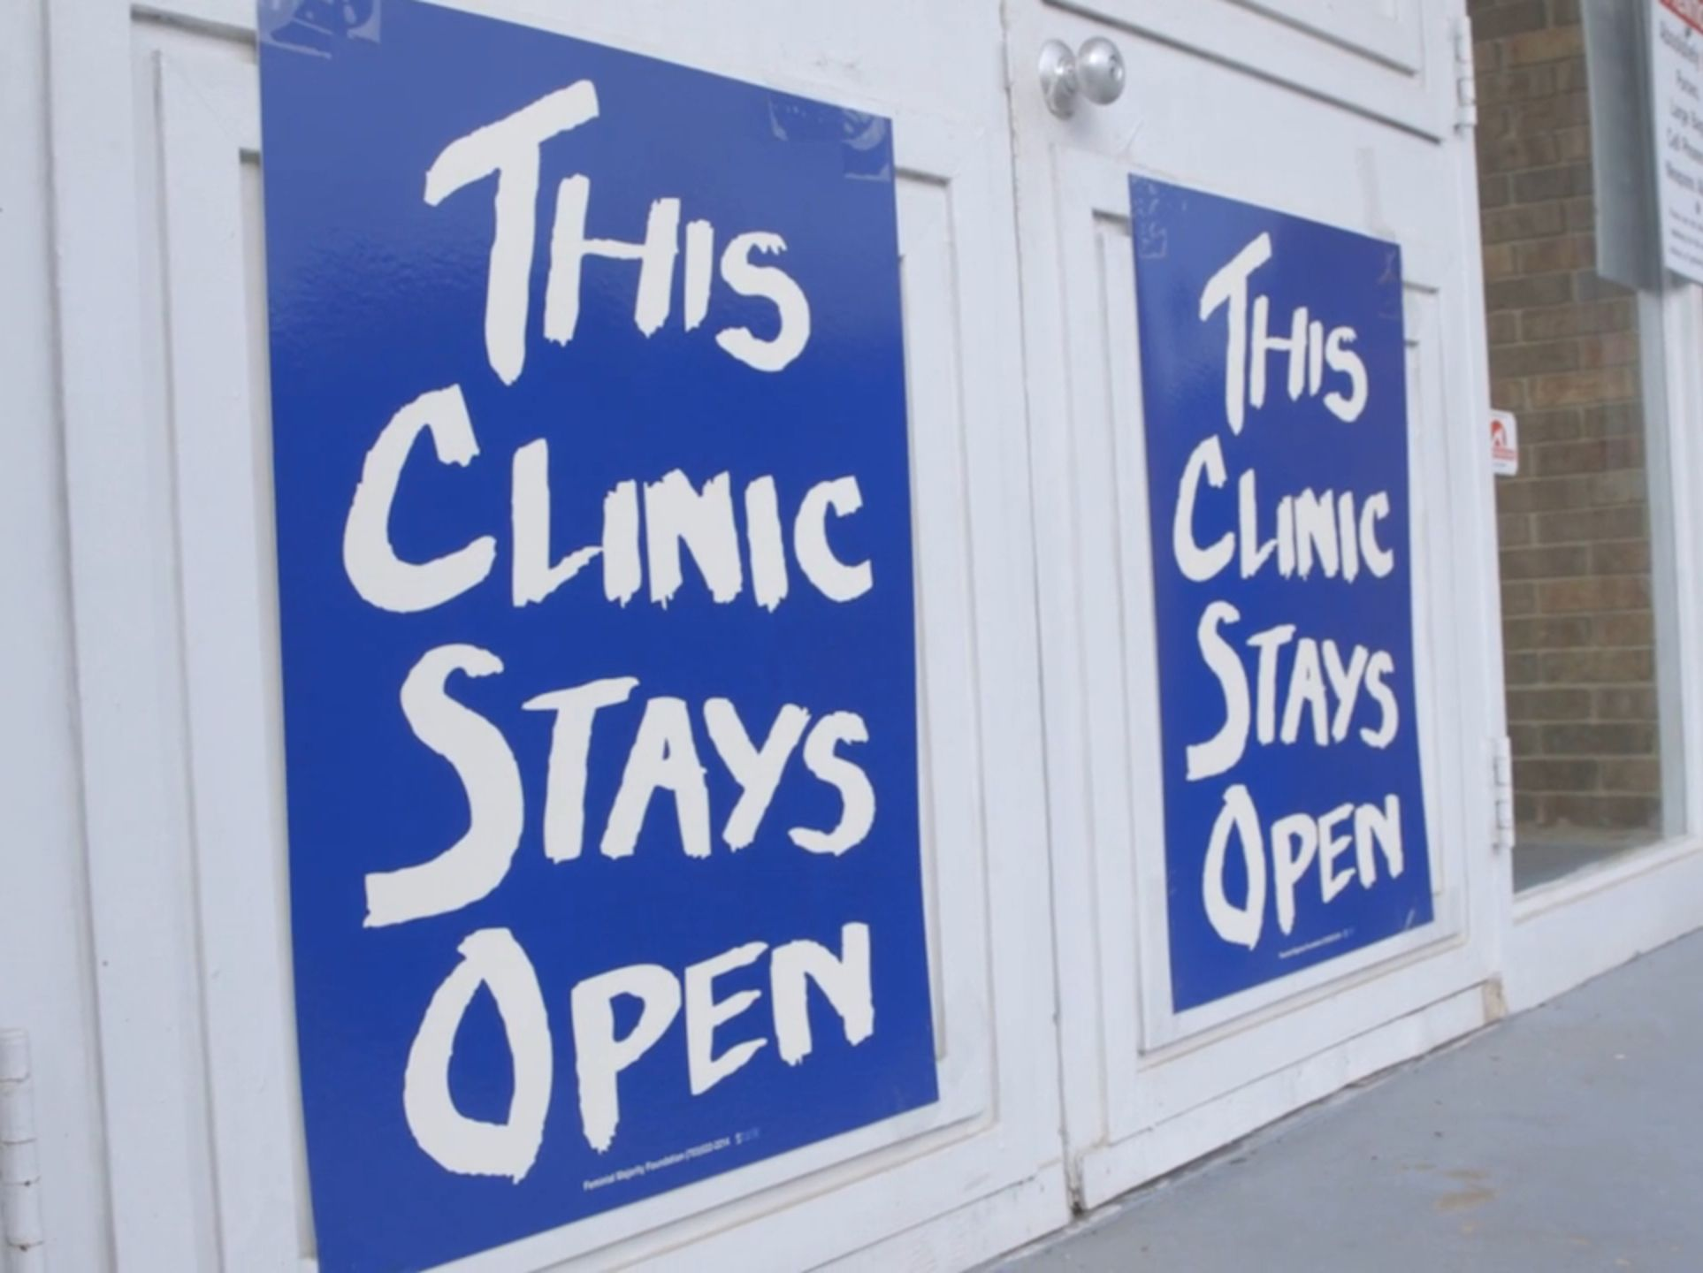
Credit: Chris Hilleke

Trapped also includes interviews with the legal team arguing before the Supreme Court that TRAP laws are designed to undermine and circumvent the right to choose granted under Roe v. Wade. In Texas, more than half of the clinics open in 2013 have closed; the handful remaining in Alabama are struggling, and only one remains in Mississippi. Trapped provides an on-the-ground, up-to-the minute look at the latest battle in America’s ongoing struggle over abortion rights.

Visit the Trapped page on Independent Lens, which features more information about the film.

About the Participants, in Alphabetical Order:

June Ayers is owner and director of Montgomery-based Reproductive Health Services, one of the few remaining abortion providers in Alabama. In 2015, Ayers was awarded the Roger N. Baldwin Medal of Liberty by the ACLU for her work to keep reproductive services available in her community.

Gloria Gray is owner and director of the West Alabama Women’s Center, located in Tuscaloosa. Gray opened the clinic in 1993 and estimates that 80 percent of her patients are at or below the poverty level.

Dalton Johnson is owner of Alabama Women’s Center, the only abortion provider in northern Alabama. Johnson opened the clinic 14 years ago and has since encountered opposition from activists, legislators, and lawyers. In 2014, he was forced to move the clinic in order to comply with new legislation.

Amy Hagstom Miller is founder and CEO of Whole Woman’s Health, a group of eight reproductive health clinics that operate in five states, including several in Texas. Miller is the lead plaintiff in Whole Woman’s Health v. Hellerstedt, the legal challenge against the state’s abortion law that is being heard by the Supreme Court in 2016.

Nancy Northup is President and CEO of The Center for Reproductive Rights, a New York-based organization that has used constitutional and international law to secure women’s reproductive freedom — including abortion rights — in 60 countries. Northup graduated from Columbia Law School and was the founding director of the Democracy Program at the Brennan Center for Justice at NYU School of Law.

Dr. Willie Parker is a longtime physician and abortion provider who refocused his career to offer reproductive health services to women in the South. For years, he has travelled to clinics in Alabama, Georgia, and Mississippi to provide care where no one else would. He works and lives in the South and is a faculty member at the Feinberg School of Medicine of Northwestern University. In addition to his M.D., Dr. Parker holds advanced degrees from Harvard and the University of Michigan.

Marva Sadler is director of clinical services at Whole Woman’s Health.

About the Filmmakers

Dawn Porter (Producer/Director/Writer) is an award-winning filmmaker whose 2013 documentary Gideon’s Army won the Sundance Film Festival Editing Award, the Tribeca All Access Creative Promise Award, and was nominated for an Independent Spirit Award and an Emmy. The film broadcast on HBO in July 2013 and has been used to engage local communities about indigent defense, the U.S. justice system and socioeconomic influences on crime.

Porter’s other films include Spies of Mississippi, which aired on Independent Lens in 2014, and Rise: The Promise of My Brother’s Keeper, a documentary chronicling President Obama’s program to help young men and boys of color succeed. The film aired on the Discovery Channel and OWN in 2015.

Her latest film, Trapped premiered at the 2016 Sundance Film Festival where it won the Special Jury Award for Social Impact Filmmaking. During the Festival, Mashable named Porter to its list of “10 Female Directors to Watch in 2016,” along with Jodie Foster, Angelina Jolie, and Niki Caro.

Porter is a Keppler Speaker. Prior to her work as a filmmaker, she was director of standards and practices at ABC News and vice president of standards and practices at A&E. She graduated from Swarthmore College and Georgetown Law Center and practiced law at the firm of Baker & Hostetler for five years.

Marilyn Ness (Producer) is a two-time Emmy, DuPont, and Peabody Award-winning documentary producer. Most recently, Ness produced Katy Chevigny and Ross Kauffman’s feature documentary E-Team, which premiered at the 2014 Sundance Film Festival, was acquired by Netflix Originals, and earned an Emmy nomination. She also produced Johanna Hamilton’s 1971, which premiered at the 2014 Tribeca Film Festival and was broadcast on Independent Lens in 2015. She directed and produced the documentary feature Bad Blood: A Cautionary Tale, which broadcast nationally on PBS in 2011. Previously, Ness spent four years as a producer for director Ric Burns, collaborating on four award-winning PBS films, including Ansel Adams, New York: Center of the World and Andy Warhol.

CREDITS

Directed, written and produced by Dawn Porter
Edited and written by Sari Gilman
Produced by Marilyn Ness
Executive Producer Cindy Meehl
Executive Producers Lois Vossen
Sally Jo Fifter
Co-Executive Producers Diane L. Max
Audrey Rosenberg
Co-Editor Katie Flint
Associate Editor Matthew Cowan
Music by Paul Brill and Elizabeth Ziman
Co-Producer Summer Damon
Directors of Photography Nadia Hallgren
Chris Hilleke

About Independent Lens

Independent Lens is an Emmy® Award-winning weekly series airing on PBS Monday nights at 10:00 PM. The acclaimed series features documentaries united by the creative freedom, artistic achievement, and unflinching visions of independent filmmakers. Presented by Independent Television Service, the series is funded by the Corporation for Public Broadcasting, a private corporation funded by the American people, with additional funding from PBS, the John D. and Catherine T. MacArthur Foundation, Wyncote Foundation, and the National Endowment for the Arts. For more visit pbs.org/independentlens. Join the conversation: facebook.com/independentlens and on Twitter @IndependentLens.

###

