T-Rex: Her Fight for Gold Premieres on Independent Lens
Tuesday, August 2, 2016 on PBS

About the Filmmakers

Zackary Canepari and Drea Cooper (Directors) have been working together since 2009. They’ve produced and directed the award-winning online short documentary series California Is a place. With over ten million views online, the films have screened at film festivals around the world, including Sundance. Their compelling visual style and deeply personal storytelling has earned Cooper and Canepari award nominations from IDFA DocLab for Best Digital Storytelling and Documentary Project of the Year by POYi (Pictures of the Year International). The directing duo landed on Filmmaker Magazine’s Top 25 New Filmmakers to Watch list. They’re also an accomplished commercial directing team.
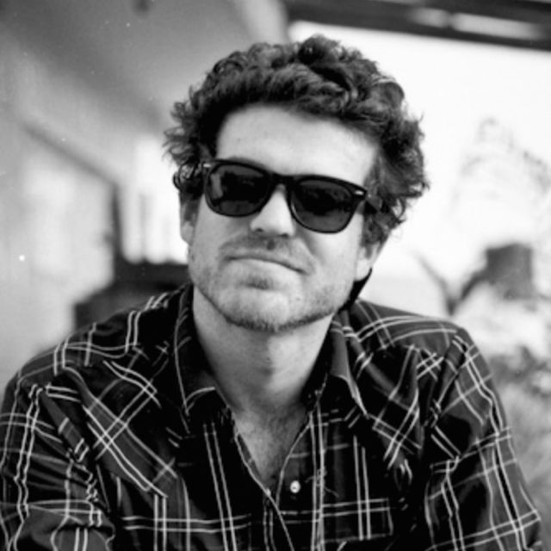
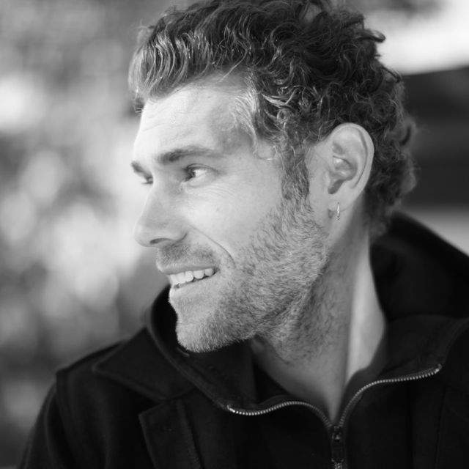
Top: Zackary Canepari.
Bottom: Drea Cooper.

Sue Jaye Johnson (Producer) began documenting Shields in 2011 at her first elite boxing tournament. She then spearheaded an unprecedented collaboration between The New York Times, NPR and WNYC to document the first women to box in the Olympics. “Teen Contender,” the feature radio documentary she co-produced with Radio Diaries, followed Claressa’s journey to the Olympics and won a Peabody Award.

