FOR IMMEDIATE RELEASE

CONTACT
Lisa Tawil, ITVS 415-356-8383 lisa_tawil@itvs.org
Mary Lugo 770-623-8190 lugo@negia.net
Cara White 843-881-1480 cara.white@mac.com
For downloadable images, visit pbs.org/pressroom/
T-Rex: Her Fight for Gold Premieres on Independent Lens
Tuesday, August 2, 2016 on PBS

Broadcast of Documentary About Claressa Shields and Her Journey to Become First American Woman to Win Boxing Gold Medal Timed to Coincide with Her Return to the 2016 Summer Olympics

(San Francisco, CA) – T-Rex: Her Fight for Gold is the coming-of-age story of boxing phenom Claressa “T-Rex” Shields from Flint, Michigan. Shields was just 17 years old when she won the gold medal for women’s boxing in 2012 — the first time women were allowed to box in the Olympic games. Directed by Drea Cooper and Zackary Canepari and produced by Sue Jaye Johnson, the film’s broadcast is timed to coincide with Claressa’s return to the Olympic boxing ring at the Rio de Janeiro games this summer. The film premieres on Independent Lens Tuesday, August 2, 2016, 10:00-11:30 PM ET (check local listings) on PBS.
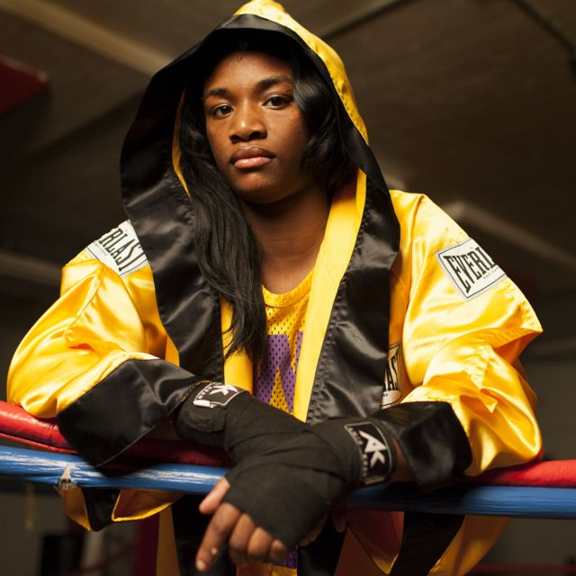
Claressa “T-Rex” Shields
Credit: Sue Jaye Johnson

Claressa Shields was 13 years old when it was announced that women would be allowed to box in the 2012 Olympics. Although she’d only been boxing for two years, her coach, Jason Crutchfield, predicted she would be there — and that she would win gold. It was an audacious dream for Shields, whose prior aspirations included having ten kids by the time she was 26.

Growing up, Claressa’s father was in prison, her mother struggled with addiction, and Claressa bounced between homes. To accomplish her dream, she would need a stable life. Coach Jason and his family took her in, housed her, and kept her focused.

Co-directors Drea Cooper and Zackary Canepari and producer Sue Jaye Johnson met Shields and Crutchfield before she qualified for the Olympics and filmed them for the next two years as they navigated the pressure of Olympic competition, family drama, and Claressa’s attempts to find love and support in the neglected city of Flint.

When Claressa stands on top of the podium in London, clutching her gold medal and laughing uncontrollably, she, like many around her, thought her struggles were behind her. But back home, as Claressa and Jason watch fellow athletes receive recognition and endorsements, no one comes forward to support her, raising questions about race, class and gender bias. Agents suggest she should soften her image. “She’s not going to do that,” says co-director Zackary Canepari. “She’s raw and honest. And stubborn. She wants to succeed on her own terms.”

The team continued to document Shields and her coach for six months after their return from the Olympics as even their close father-daughter bond strained under the pressure. “It was a huge challenge,” says co-director Drea Cooper. “Even for Claressa, with all her talent and determination, it was a struggle not to give up.”

“Claressa’s story is universal,” adds producer Sue Jaye Johnson. “But there is also this great girl angle. She is pushing the boundaries of what is acceptable for girls everywhere.”

To date, Claressa has lost only once. With a record of 69-1, she is ranked number one in the world heading into her second Olympic competition.

Visit the T-Rex: Her Fight for Gold page on Independent Lens, which features more information about the film.

About the Team

Zackary Canepari and Drea Cooper (Directors) have been working together since 2009. They’ve produced and directed the award-winning online short documentary series California Is a place. With over ten million views online, the films have screened at film festivals around the world, including Sundance. Their compelling visual style and deeply personal storytelling has earned Cooper and Canepari award nominations from IDFA DocLab for Best Digital Storytelling and Documentary Project of the Year by POYi (Pictures of the Year International). The directing duo landed on Filmmaker Magazine’s Top 25 New Filmmakers to Watch list. They’re also an accomplished commercial directing team.

Sue Jaye Johnson (Producer) began documenting Shields in 2011 at her first elite boxing tournament. She then spearheaded an unprecedented collaboration between The New York Times, NPR and WNYC to document the first women to box in the Olympics. “Teen Contender,” the feature radio documentary she co-produced with Radio Diaries, followed Claressa’s journey to the Olympics and won a Peabody Award.

CREDITS

Directed by Drea Cooper and Zackary Canepari
Produced by Sue Jaye Johnson
Additional Producers Bianca Darville
Gary Kout
Zackary Canepari
Drea Cooper
Edited by Jean Kawahara
Drea Cooper
Original Music by Matthew Joynt
Nathan Sandberg
Cinematography by Zackary Canepari
Drea Cooper

About Independent Lens

Independent Lens is an Emmy® Award-winning weekly series airing on PBS Monday nights at 10:00 PM. The acclaimed series features documentaries united by the creative freedom, artistic achievement, and unflinching visions of independent filmmakers. Presented by Independent Television Service, the series is funded by the Corporation for Public Broadcasting, a private corporation funded by the American people, with additional funding from PBS, the John D. and Catherine T. MacArthur Foundation, Wyncote Foundation, and the National Endowment for the Arts. For more visit pbs.org/independentlens. Join the conversation: facebook.com/independentlens and on Twitter @IndependentLens.

###

