Best of Enemies Premieres on Independent Lens
Monday, October 3, 2016 on PBS

About the Filmmakers

Morgan Neville (Director/Producer) is a documentary filmmaker whose films focus on culture. His acclaimed film 20 Feet From Stardom won the 2014 Academy Award for Best Documentary as well as a Grammy Award for Best Music Film in 2015. His documentary, Best of Enemies, was shortlisted for the 2016 Academy Award and nominated for an Independent Spirit Award for Best Documentary. Neville has been nominated for three additional Grammys for his films: Respect Yourself: The Stax Records Story, Muddy Waters Can’t Be Satisfied and Johnny Cash’s America; and won an Emmy Award for his film Hank Williams: Honky Tonk Blues. Neville’s non-music films include The Cool School and Beauty Is Embarrassing. Recent projects include Chelsea Does, a four-part documentary series, and Keith Richards: Under the Influence, both for Netflix. His latest film, The Music of Strangers: Yo-Yo Ma and The Silk Road Ensemble, was released by The Orchard and HBO in June 2016.

Credit: Tremolo Productions

Robert Gordon (Director/Producer) is a Grammy Award-winning writer and filmmaker. His work has focused on the music, art, and politics of the American south. His films include William Eggleston’s Stranded in Canton, Respect Yourself: The Stax Records Story, and the verité shocker, Very Extremely Dangerous. His work has been broadcast on PBS, A&E, and numerous international networks, and has been exhibited at the Whitney, LACMA, Haus Der Kunst (Munich) and many other international museums. His first book was It Came From Memphis and his latest is Respect Yourself: Stax Records and the Soul Explosion.
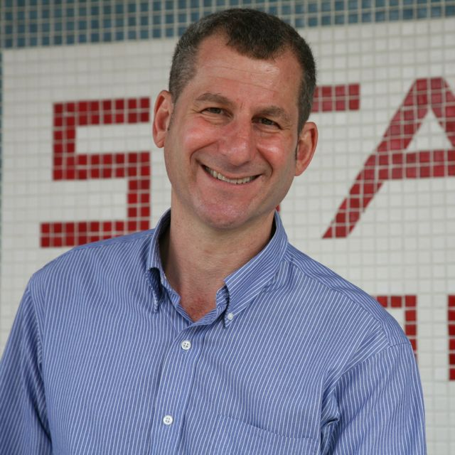
Credit: Media Ranch

###

