Ovarian Psycos Premieres on Independent Lens
Monday, March 27, 2017 on PBS

About the Filmmakers
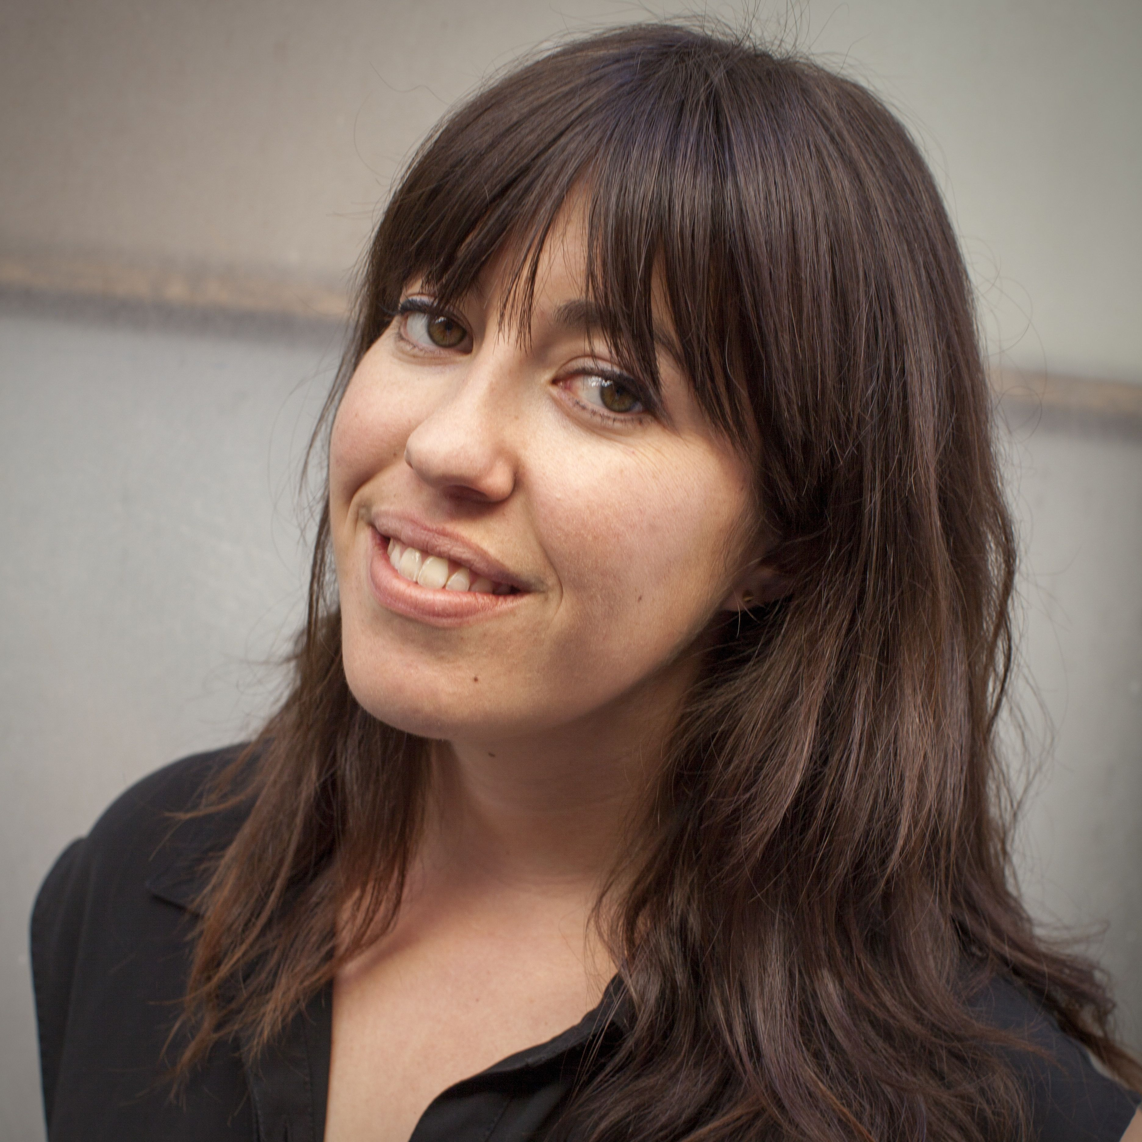
Credit: Michael Rains
Joanna Sokolowski (Director/Producer) is an Emmy® Award-winning documentary filmmaker. She co-produced the HBO film Very Semi Serious (2015), a feature-length documentary about New Yorker cartoonists that premiered at the Tribeca Film Festival. She has worked as a producer at Walking Iris Media and Open Studio Productions. Her short film, Still Time (2012), chronicles life after serving 20 years in prison. She holds a BA in Community Development & Urban Planning and received her MA in Social Documentation at the University of California, Santa Cruz, where she was the recipient of the Human Rights Center fellowship.
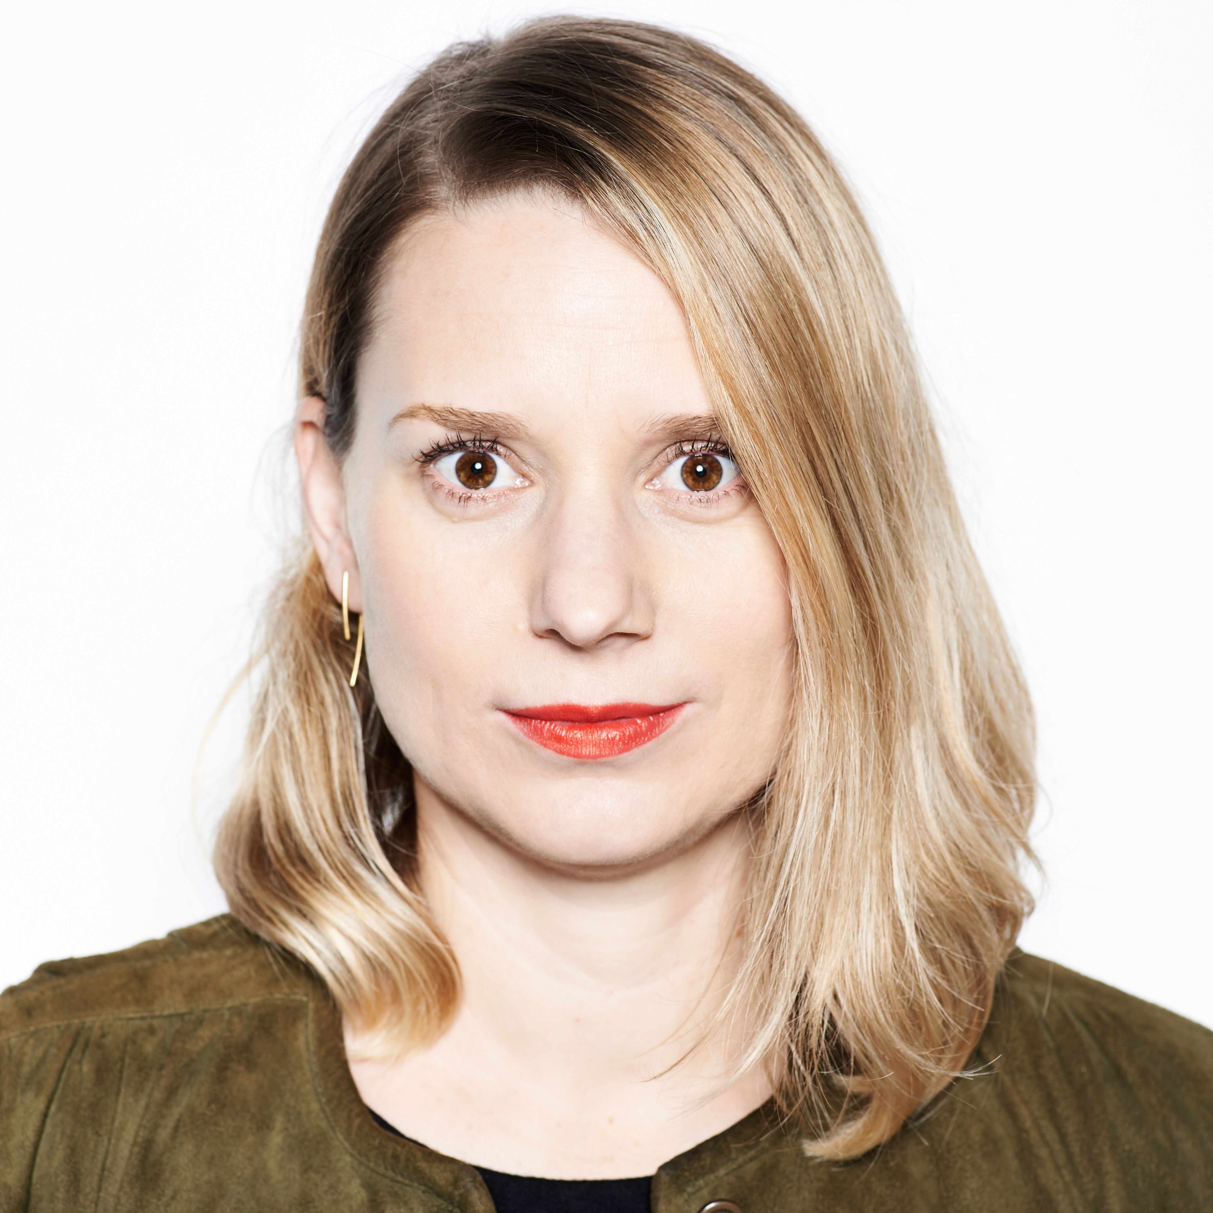
Credit: Michael Rains

Kate Trumbull-LaValle (Director/Producer) is an award-winning independent documentary filmmaker who first began in the field of social justice media as an educator and media maker for the Media Arts Center San Diego and the San Diego Latino Film Festival. She was associate producer and assistant editor for Renee Tajima-Peña’s No Más Bebés (2015), which profiles the history of Latina women coercively sterilized at Los Angeles County-USC Medical Center during the late 1960s and 1970s, and aired on Independent Lens. She directed the short documentary, Abaayo/Sister (2012), an intimate portrait of two Somali friends caught in a cultural tug-of-war and is a UC Berkeley Human Rights Fellow (2010) and graduated with an M.A. from the Social Documentation Program at the University of California, Santa Cruz.

###

