Ovarian Psycos Premieres on Independent Lens
FOR IMMEDIATE RELEASE

CONTACT
Lisa Tawil, ITVS 415-356-8383 lisa_tawil@itvs.org
Mary Lugo 770-623-8190 lugo@negia.net
Cara White 843-881-1480 cara.white@mac.com
For downloadable images, visit pbs.org/pressroom/
Monday, March 27, 2017 on PBS

Online Streaming Begins March 28

Young women of color take to the streets of East L.A. – on bicycles – to confront racism and violence and create safe spaces for women

(San Francisco, CA) — Ovarian Psycos is a documentary about a new generation of young women of color from the Eastside of Los Angeles who are confronting injustice, building community, and redefining identity through a raucous, irreverently named bicycle crew: The Ovarian Psycos Cycle Brigade. Produced and directed by Joanna Sokolowski and Kate Trumbull-LaValle, Ovarian Psycos premieres on Independent Lens Monday, March 27, 2017, 10:00-11:00 PM ET (check local listings) on PBS.
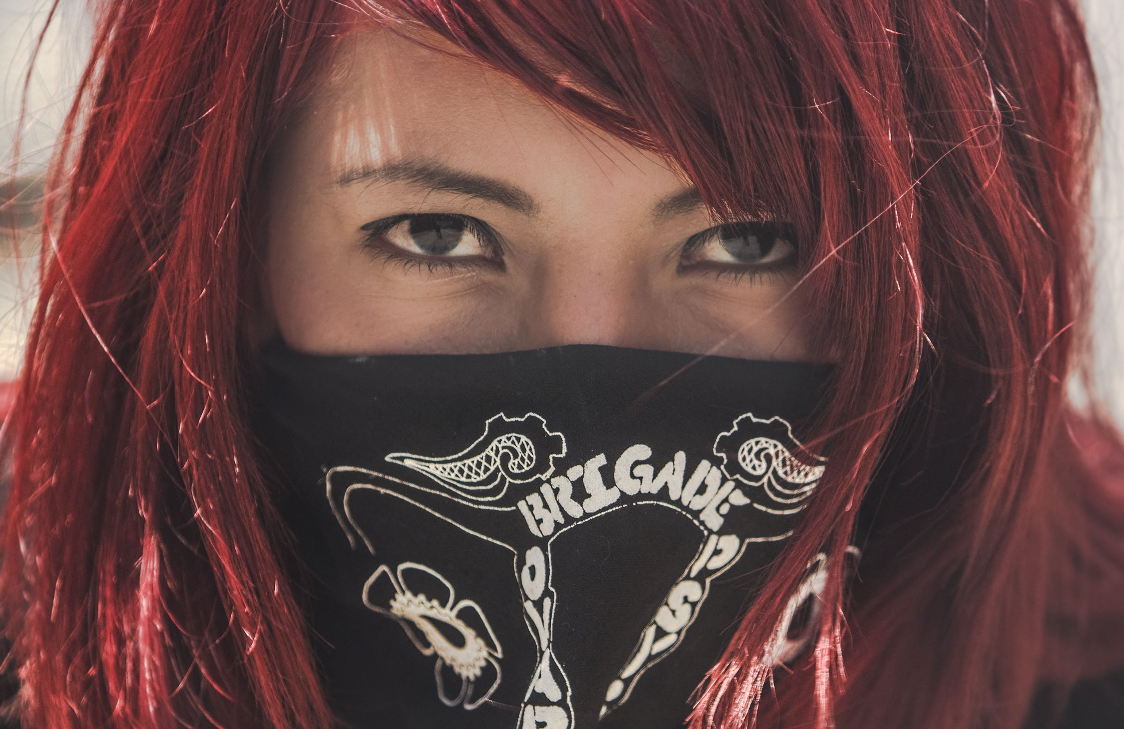
Andi of the Ovarian Psycos.
Credit: Michael Rains

“We were inspired to make this film because the women who make up the Ovarian Psycos collective are fierce, unapologetic, feminist women of color,” state co-directors Joanna Sokolowski and Kate Trumbull-LaValle. “They are brilliant strategists and have crafted an image and politics that centers their own voices and stories as women of color emerging from Eastside Los Angeles – a deeply activist community with a long legacy of resistance – to fight against personal and collective gendered violence.”

Through the personal stories of the crew’s rabble-rousing founder, Xela de la X; street artist and original Ovarian Psyco, Andi Xoch; and a bright-eyed young woman from the neighborhood, Evelyn (Evie), the film traces how the “Ovas” emerged from the diverse, youthful, Latino, working class, immigrant neighborhoods of Boyle Heights and East Los Angeles, a community situated within the historic legacy of the Chicano/a Civil Rights Movement.

“Funded by ITVS, the Ovarian Psycos remind us of the Chicano Power movement that emerged from L.A. in the late 1960s,” said Lois Vossen, Independent Lens executive producer. “The cinematography of the rides helps us see why these women feel most protected and free while riding together. They challenge the stereotypical expectations of femininity as they confront the sexism, racism, and violence in their lives.”

Visit the Ovarian Psycos page on Independent Lens, which features more information about the film. Ovarian Psycos, which premiered at the 2016 South by Southwest Film Festival, will be available for online viewing on the site beginning March 28.

About the Filmmakers

Joanna Sokolowski (Director/Producer) is an Emmy® Award-winning documentary filmmaker. She co-produced the HBO film Very Semi Serious (2015), a feature-length documentary about New Yorker cartoonists that premiered at the Tribeca Film Festival. She has worked as a producer at Walking Iris Media and Open Studio Productions. Her short film, Still Time (2012), chronicles life after serving 20 years in prison. She holds a BA in Community Development & Urban Planning and received her MA in Social Documentation at the University of California, Santa Cruz, where she was the recipient of the Human Rights Center fellowship.

Kate Trumbull-LaValle (Director/Producer) is an award-winning independent documentary filmmaker who first began in the field of social justice media as an educator and media maker for the Media Arts Center San Diego and the San Diego Latino Film Festival. She was associate producer and assistant editor for Renee Tajima-Peña’s No Más Bebés (2015), which profiles the history of Latina women coercively sterilized at Los Angeles County-USC Medical Center during the late 1960s and 1970s, and aired on Independent Lens. She directed the short documentary, Abaayo/Sister (2012), an intimate portrait of two Somali friends caught in a cultural tug-of-war and is a UC Berkeley Human Rights Fellow (2010) and graduated with an M.A. from the Social Documentation Program at the University of California, Santa Cruz.

CREDITS

Directed and Produced by Joanna Sokolowski & Kate Trumbull-LaValle
Editor Victoria Chalk
Additional Editor Susan Metzger
Director of Photography Michael Raines
Composer Jimmy LaValle

About Independent Lens
Independent Lens is an Emmy® Award-winning weekly series airing on PBS Monday nights at 10:00 PM. The acclaimed series, with Lois Vossen as executive producer, features documentaries united by the creative freedom, artistic achievement, and unflinching visions of independent filmmakers. Presented by ITVS, the series is funded by the Corporation for Public Broadcasting, a private corporation funded by the American people, with additional funding from PBS, the John D. and Catherine T. MacArthur Foundation, Wyncote Foundation, and the National Endowment for the Arts. For more visit pbs.org/independentlens. Join the conversation: facebook.com/independentlens and on Twitter @IndependentLens.

###

