Newtown Premieres on Independent Lens
During 2016-17 Season on PBS

TCA Panelists
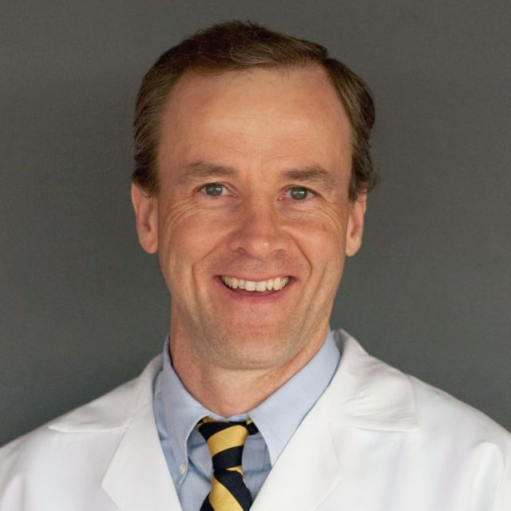

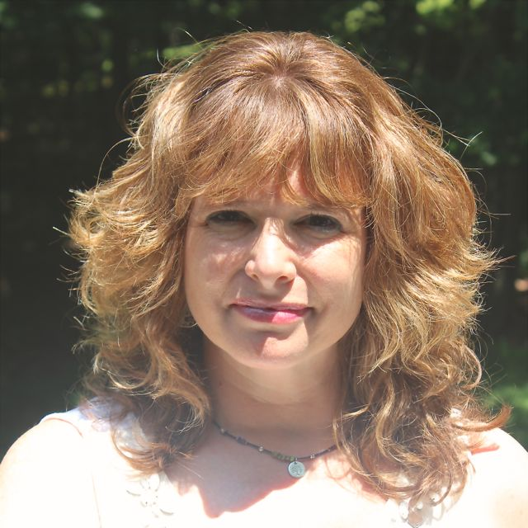

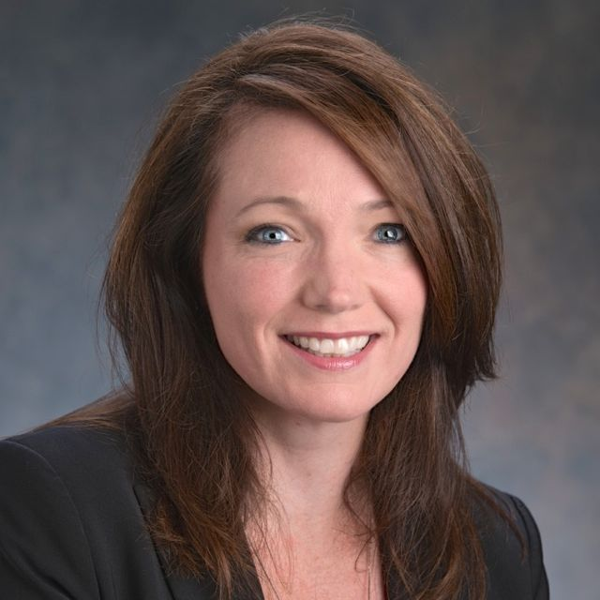
Dr. William Begg is an emergency room doctor at Danbury Hospital in Connecticut. On December 14, 2012, the day of the shooting at Sandy Hook Elementary School, he was the doctor on duty and treated victims of the tragedy. He has since testified before the U.S. Senate Judiciary Committee on a proposed assault weapons ban. Dr. Begg, who lives in Newtown, is vice chair of emergency medicine and EMS medical director for the greater Newtown, Connecticut, area.

Abbey Clements was a second grade teacher at Sandy Hook Elementary School for 11 years. She and her students survived the shooting on December 14, 2012, which took the lives of 20 first graders and six educators. Since the shooting, Clements has become a gun violence prevention activist; she is both a Survivor Fellow with Everytown for Gun Safety and an Everytown Survivor Engagement Lead for the state of Connecticut. Clements taught at Sandy Hook School for two-and-a-half years after the tragedy and has just completed her first year teaching fourth grade at another Newtown elementary school.

Nicole Hockley is managing director of Sandy Hook Promise (SHP), a gun violence prevention organization that she and Mark Barden helped create after the death of their first-grade sons in the Sandy Hook Elementary School tragedy of December 2012. Overseeing SHP’s strategic direction and communications, Hockley focuses on enabling social change, searching for mental health and gun safety solutions and bringing people together in dialogue. As of June 2016, SHP has educated and trained more than 865,000 youths and educators in 50 states about ways to prevent gun violence. Hockley’s work has resulted in the prevention of a school shooting and numerous suicides, and a reduction in threats, bullying and firearms being brought into schools around the country. She has extensive prior experience in strategic marketing and communications for companies in both the United States and the United Kingdom. Hockley’s family also created and runs Dylan’s Wings of Change, to honor her son Dylan and help other children with autism and related conditions achieve full potential.

Director/producer Kim A. Snyder’s most recent film, Newtown, premiered in competition at the 2016 Sundance Film Festival and was hailed in Entertainment Weekly as among the “Best of Sundance.” The film will continue to screen at premiere festivals worldwide and is poised to have a theatrical release in September 2016, followed by a national broadcast on Independent Lens in early 2017. Snyder’s last feature documentary, Welcome to Shelbyville, was also nationally broadcast on Independent Lens. In 2007, Snyder co-founded the BeCause Foundation to direct and produce a series of socially conscious documentaries that have won numerous awards, with campaigns furthering the work of the social innovators they highlight. Her award-winning directorial debut feature documentary, I Remember Me, was theatrically distributed by Zeitgeist Films. In 1994, she associate produced the Academy Award-winning short film Trevor, directed by Peggy Rajski. Snyder graduated with a Masters in international affairs from the Johns Hopkins School of Advanced International Studies and resides in New York City.
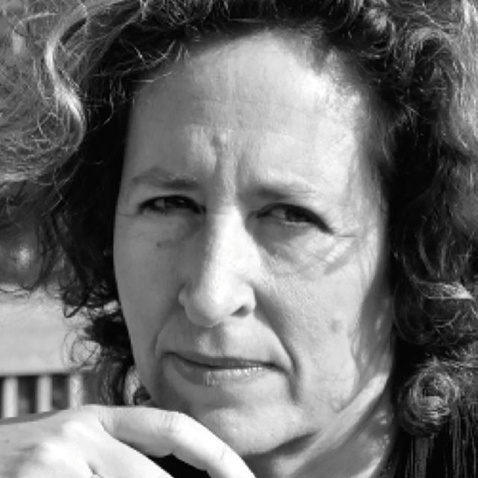

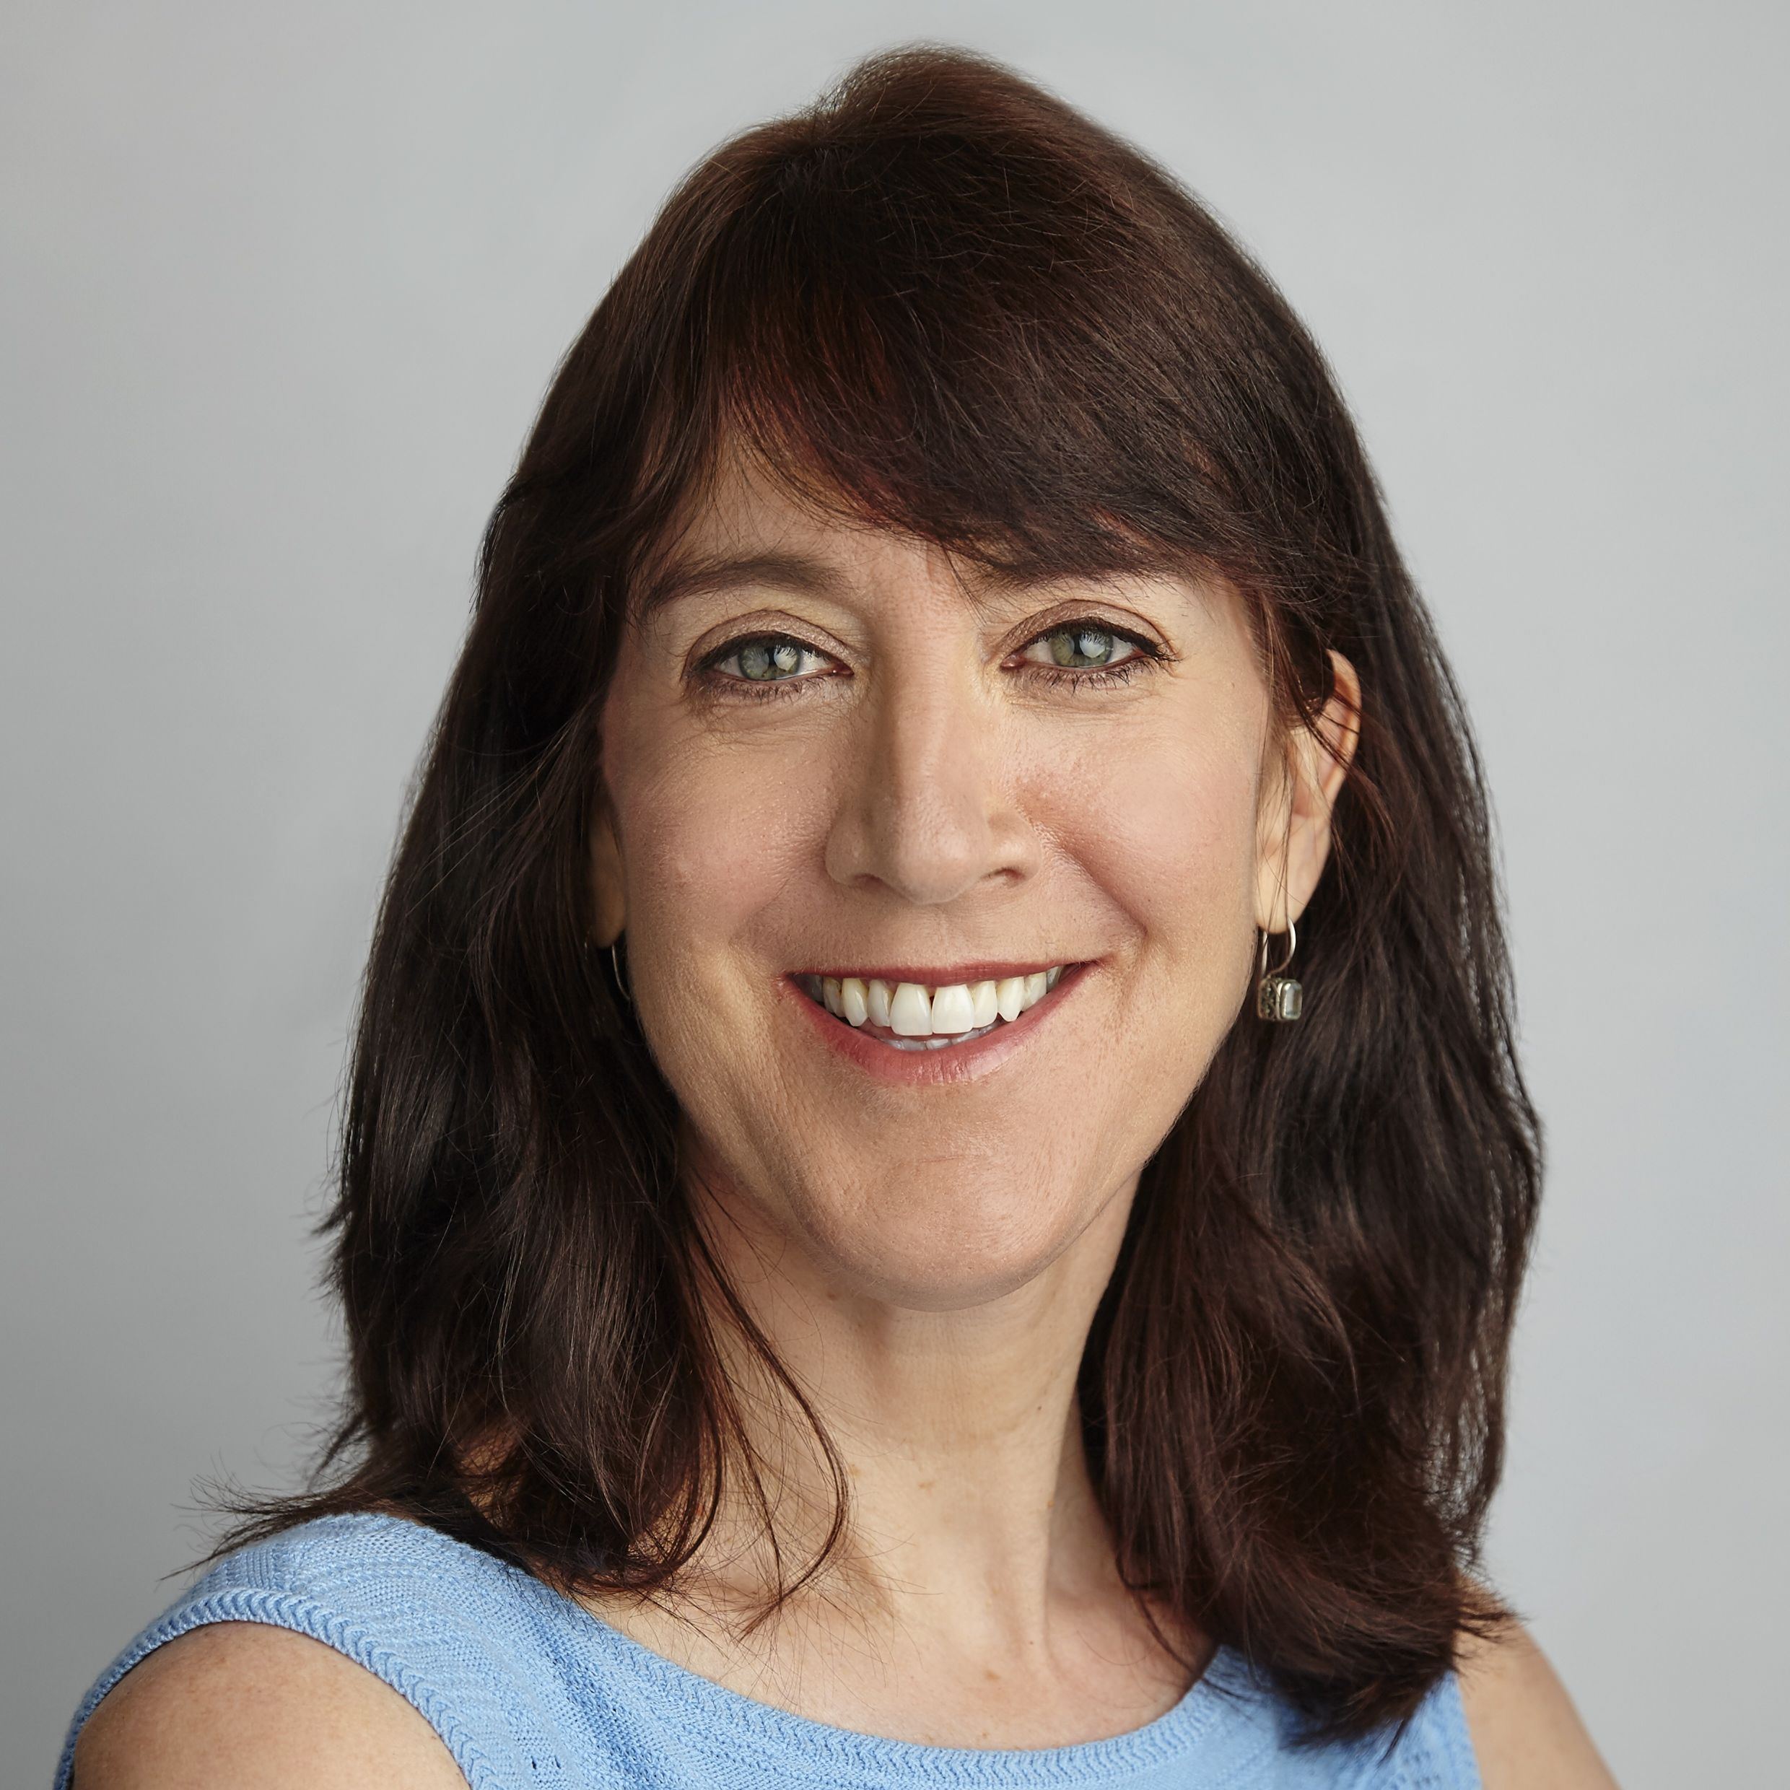

Lois Vossen (founder and executive producer of Independent Lens) is responsible for commissioning new work, curating the series and working closely with ITVS and Independent Lens-funded filmmakers to provide creative feedback and editorial support related to broadcast standards. Independent Lens films have received 10 News & Documentary Emmy Awards, two Primetime Emmys, 15 George Foster Peabody Awards, five Alfred I. duPont-Columbia Journalism Awards and seven Academy Award nominations. The series is the 2015 winner of the IDA Award for Best Continuing Series — its third consecutive win. Previously, Vossen was associate managing director of the Sundance Film Festival and Sundance Labs. She serves on the Documentary Peer Panel for the Television Academy and has been a juror at SXSW, DOC New Zealand, Toronto International, New Orleans and Palm Springs International film festivals, among others.

