SEED: The Untold Story Premieres on Independent Lens
Monday, April 17, 2017 on PBS

About the Filmmakers

Taggart Siegel (Producer/Director) has produced and directed Emmy-nominated, award-winning documentaries including Queen of the Sun: What are the Bees Telling Us? and The Real Dirt on Farmer John (Independent Lens). Both received critical acclaim during their theatrical release and garnered over 40 international awards. Siegel is a Fledgling Outreach and Engagement Lab Fellow and was selected to pitch at Britdoc’s GoodPitch for SEED: The Untold Story. His previous PBS films include Split Horn (Independent Lens), Between Two Worlds, Blue Collar and Buddha and Heart Broken in Half. Collectively, they capture the struggle of refugees and immigrants in America. He produced the National Geographic film Disenchanted Forest about orangutans in Borneo. Taggart is the founder and Executive Director of Collective Eye Films, a nonprofit media production and distribution organization based in Portland, Oregon.
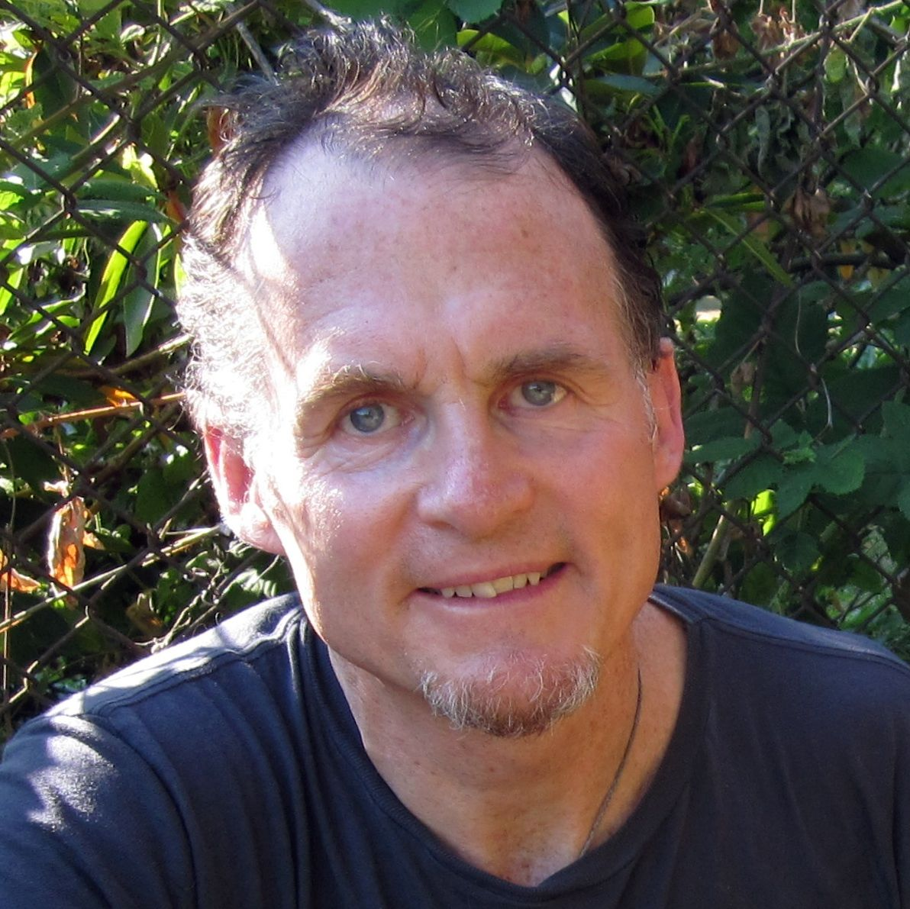
Credit: Collective Eye Films
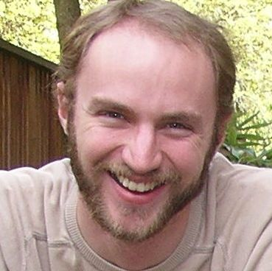
Credit: Collective Eye Films

Jon Betz (Producer/Director) is an award-winning independent documentary filmmaker. He was the producer and editor for Queen of the Sun: What Are the Bees Telling Us? (2010). His previous film, Memorize You Saw It (2008), journals his experience as an aid worker living with former child soldiers in Eastern Uganda. Betz is a Fledgling Outreach and Engagement Lab Fellow, a Britdoc’s GoodPitch alumni and a graduate of the Rhode Island School of Design. He is the director of Collective Eye Films.

Marc Turtletaub (Executive Producer) has served as a producer on numerous independent films including the Academy Award-winning Little Miss Sunshine. Recent releases include Sam Mendes’ Away We Go, starring Maya Rudolph and John Krasinski, Christine Jeffs’ Sunshine Cleaning, starring Amy Adams and Emily Blunt, and John Crowley’s Is Anybody There?, starring Michael Caine. Turtletaub also produced Liev Schrieber’s Everything Is Illuminated. Other producing credits include Jack Goes Boating, Laws of Attraction, The Honeymooners, and the documentary Lucky by Jeffrey Blitz.

Phil Fairclough (Executive Producer) was intimately involved as executive producer and producer on several of Werner Herzog’s documentaries, including the acclaimed Grizzly Man, the Oscar-nominated Encounters at the End of the World, and Cave of Forgotten Dreams. He was a network executive at Discovery Channel and EVP of Development and Production for NHNZ. Before working at Discovery, Phil held senior positions at the BBC and ITV and had extensive production experience in the UK, including the acclaimed BBC Natural History Unit where he was an executive producer and head of the commercial production unit.

